
PROJECT PROPOSAL PROFORMA The signed Project Proposal Proforma is attached as a separate institutional annex submitted with this report.



ACKNOWLEDGEMENT
I would like to express my sincere gratitude to everyone who supported me during the analysis, design, development and documentation of my MCA project, SmartCart – Web-Based E-Commerce Management System.
I am thankful to my project guide, Mr. Yadhu Krishnan T, for the guidance, suggestions and encouragement provided throughout the project. The guidance helped me to approach the work in a structured manner, from understanding the requirements of a supermarket business to designing the database, implementing the application and preparing this report.
I am grateful to Indira Gandhi National Open University and the School of Computer and Information Sciences for providing the academic framework and the opportunity to undertake this project, and to the staff of my Regional Centre / Study Centre SH College, Thevara for their academic support.
I also acknowledge the official documentation and learning resources published for ASP.NET Core, PostgreSQL, Bootstrap and related technologies, which were valuable references during development.

Muhammed Faris MP
Enrolment No.: 2400837459

ABSTRACT
Small and medium supermarkets increasingly need an online channel through which customers can browse products and place orders, while the store itself still has to manage a large catalogue, frequent stock intake from suppliers and the processing of customer orders. Maintaining these activities through walk-in sales, manual registers and disconnected spreadsheets makes stock information unreliable and limits the store’s reach.
SmartCart is a web-based e-commerce and management system designed for a single supermarket store (referred to in this report as SmartCart Now). It provides a customer-facing storefront and an employee administration panel within one ASP.NET Core 8 MVC application backed by a relational database. On the storefront, registered customers can browse the catalogue by category, brand and price, view product details and pack-size variants (SKUs), maintain a wishlist and a shopping cart, check out with a saved delivery address using Cash on Delivery, view their order history and cancel orders that are still in an early status.
The administration panel allows store employees to manage categories, sub-categories, brands, products, SKUs, variant attributes and product media; to maintain suppliers and record purchases that create batch-wise stock; to adjust inventory; to process customer orders through confirmation, shipping, delivery or cancellation; to manage homepage banners and featured items; and to manage employees, roles and permissions. Online visibility is controlled per product and per SKU.
Customer storefront operations (shop, cart, wishlist, auth, checkout and customer orders) use PostgreSQL stored procedures executed through Dapper, where business rules such as stock availability, online-sale eligibility and payment-method checks are enforced in the database. Administrative modules, including admin order processing, use Entity Framework Core (Npgsql) without migrations; the schema is created and updated through versioned PostgreSQL build and patch scripts under Database-Postgres. Customers and employees are authenticated through separate JWT cookies, passwords are hashed, and admin actions are protected by role-based, permission-level access control.
Online payment, multi-store and multi-zone operation, advanced analytics, recommendations and a mobile application are not part of the current implementation; they are presented as future scope (SmartCart Then), for which the current architecture provides a foundation.
Keywords: E-Commerce, Supermarket, ASP.NET Core MVC, PostgreSQL, Stored Procedures, Dapper, Entity Framework Core, Inventory Management, Role-Based Access Control, JWT.
TABLE OF CONTENTS
CHAPTER 1: INTRODUCTION AND PROJECT OVERVIEW 11
1.1 Background 11
1.2 E-Commerce Context 11
1.3 Motivation for SmartCart 11
1.4 Introduction to SmartCart 12
1.5 SmartCart Now 12
1.6 SmartCart Then / Future Expansion 12
1.7 Problem Statement 13
1.8 Need for the Proposed System 13
1.9 Objectives 14
1.10 Project Goals 15
1.11 Expected Benefits 15
1.12 Project Characteristics 16
1.13 Key Features 16
1.14 Project Overview Summary 17
CHAPTER 2: EXISTING SYSTEM, PROBLEM AND REQUIREMENTS 18
2.1 Existing Shopping System 18
2.2 Existing Manual / Traditional Processes 18
2.3 Limitations 18
2.4 Problems Identified 19
2.5 Challenges Faced by Small Retail Businesses 19
2.6 Proposed System 20
2.7 Proposed Solution Overview 20
2.8 Functional Requirements 21
2.9 Customer Functional Requirements 22
2.10 Admin Functional Requirements 23
2.11 Non-Functional Requirements 24
2.12 Hardware Requirements 25
2.13 Software Requirements 25
2.14 Functional vs Non-Functional Requirement Table 26
CHAPTER 3: LITERATURE REVIEW AND FEASIBILITY 27
3.1 Overview 27
3.2 E-Commerce Systems 27
3.3 Existing E-Commerce Platforms 28
3.4 General Architecture Patterns 28
3.5 Technology Review 29
3.6 ASP.NET Core 29
3.7 SQL Database / Stored Procedure Approach 30
3.8 HTML/CSS/JavaScript/Frontend Technologies 30
3.9 Security Concepts 31
3.10 Authentication and Authorization 31
3.11 Feasibility Study 32
3.12 Literature Review Summary 33
3.13 Gap Analysis 33
CHAPTER 4: PROJECT PLANNING AND METHODOLOGY 34
4.1 Development Approach 34
4.2 Project Phases 34
4.3 Requirement Analysis Phase 35
4.4 Design Phase 35
4.5 Development Phase 35
4.6 Database Development 36
4.7 Backend Development 36
4.8 Frontend Development 36
4.9 Testing Phase 37
4.10 Deployment / Release Preparation 37
4.11 Development Methodology 38
4.12 Project Schedule 39
4.13 PERT Chart 40
4.14 Project Planning Summary 41
CHAPTER 5: SYSTEM ANALYSIS 42
5.1 System Overview 42
5.2 Actors 42
5.3 Use Case Analysis 43
5.4 Customer Use Cases 44
5.5 Administrator Use Cases 45
5.6 Context-Level DFD 46
5.7 Level 0 DFD 47
5.8 Level 1 DFD — Customer Flow 48
5.9 Level 1 DFD — Admin Flow 49
5.10 Order Processing Data Flow 50
5.11 Authentication Data Flow 51
5.12 System Analysis Summary 52

CHAPTER 6: SYSTEM ARCHITECTURE AND DESIGN 53
6.1 Design Overview 53
6.2 Design Principles 53
6.3 System Architecture 54
6.4 Application Layer Structure 55
6.5 Backend Structure 55
6.6 Frontend Structure 56
6.7 API / Request Flow 57
6.8 Authentication Architecture 58
6.9 Customer Shopping Workflow 59
6.10 Order Lifecycle 60
6.11 System Design Summary 61
CHAPTER 7: DATABASE DESIGN 62
7.1 Database Overview 62
7.2 Database Technology 62
7.3 Database Design Principles 63
7.4 Normalization 63
7.5 Entity Relationship Diagram 64
7.6 Core Tables Overview 65
7.7 User / Authentication Tables 66
7.8 Product / Category Tables 67
7.9 Cart / Wishlist Tables 68
7.10 Order / Order Item Tables 69
7.11 Inventory / Stock Tables 70
7.12 Relationships and Foreign Keys 71
7.13 Stored Procedure Architecture 72
7.14 Database Design Summary 73
CHAPTER 8: MODULE DESIGN AND FUNCTIONAL SPECIFICATION 74
8.1 Module Overview 74
8.2 Authentication Module 75
8.3 Customer Registration Module 76
8.4 Customer Login Module 77
8.5 Product Catalogue Module 78
8.6 Product Search and Filtering 79
8.7 Product Details 80
8.8 Shopping Cart 81
8.9 Wishlist 82
8.10 Checkout 83
8.11 Order Placement 84
8.12 Order History 85
8.13 Customer Order Details / Tracking 86
8.14 Admin Authentication 87
8.15 Admin Dashboard 88
8.16 Product Management 89
8.17 Category Management 90
8.18 Order Management 91
8.19 Inventory / Additional Admin Features 92
CHAPTER 9: USER INTERFACE AND SCREENSHOTS 93
9.1 UI Design Overview 93
9.2 Navigation / Header 94
9.3 Home Page 95
9.4 Product Listing 96
9.5 Product Details 97
9.6 Search / Filter 98
9.7 Cart 99
9.8 Wishlist 100
9.9 Checkout 101
9.10 Order Confirmation 102
9.11 Customer Order History 103
9.12 Admin Dashboard 104
9.13 Product Management 105
9.14 Category / Inventory Management 106
9.15 Order Management 107
9.16 Additional Screens / Error Messages 108
CHAPTER 10: IMPLEMENTATION AND CODE STRUCTURE 109
10.1 Implementation Overview 109
10.2 Development Environment 109
10.3 Backend Implementation 110
10.4 Database Implementation 111
10.5 Authentication Implementation 112
10.6 API / Business Logic Implementation 113
10.7 Frontend Implementation 114
10.8 Code Organization 115
10.9 Implementation Summary 115

CHAPTER 11: TESTING AND RESULTS 116
11.1 Testing Strategy 116
11.2 Testing Types 116
11.3 Test Case Design 117
11.4 Authentication Testing 118
11.5 Product Testing 118
11.6 Cart Testing 118
11.7 Wishlist Testing 119
11.8 Order Testing 119
11.9 Admin Testing 119
11.10 Testing Summary 120
11.11 Test Evidence 120
CHAPTER 12: SECURITY, LIMITATIONS AND FUTURE SCOPE 121
12.1 Authentication 121
12.2 Authorization 121
12.3 Input Validation 121
12.4 SQL Injection Protection 121
12.5 Session/Token Security 121
12.6 Access Control 121
12.7 Current Limitations 122
12.8 FUTURE SCOPE 123
CHAPTER 13: CONCLUSION, BIBLIOGRAPHY AND APPENDICES 124
13.1 Project Conclusion 124
13.2 Achievements 124
13.3 Learning Outcomes 124
BIBLIOGRAPHY 124
APPENDICES 125
13.4 Appendix A — Important Screenshots 125
13.5 Appendix B — Database Reference 125
13.6 Appendix C — Important Code Snippets 125
13.7 Appendix D — Additional Information 125

LIST OF FIGURES
Figure 1.1: High-Level Overview of SmartCart 17
Figure 4.1: Gantt Chart of SmartCart Development 39
Figure 4.2: PERT Network Diagram of SmartCart Development 40
Figure 5.1: Overall Use Case Diagram of SmartCart 43
Figure 5.2: Customer Use Case Diagram 44
Figure 5.3: Administrator Use Case Diagram 45
Figure 5.4: Context-Level Data Flow Diagram 46
Figure 5.5: Level 0 Data Flow Diagram 47
Figure 5.6: Level 1 DFD – Customer Flow 48
Figure 5.7: Level 1 DFD – Admin Flow 49
Figure 5.8: Order Processing Data Flow Diagram 50
Figure 5.9: Authentication Data Flow Diagram 51
Figure 6.1: SmartCart System Architecture 54
Figure 6.2: Request Flow for Product Browsing 57
Figure 6.3: Authentication and Authorisation Architecture 58
Figure 6.4: Customer Shopping Workflow 59
Figure 6.5: Order Lifecycle State Diagram 60
Figure 7.1: Entity Relationship Diagram of SmartCart 64
Figure 7.2: Stock Flow at SKU Level 70
Figure 7.3: Relationship Diagram of Core Tables 71
Figure 8.1: SmartCart Customer Registration Interface 76
Figure 8.2: SmartCart Customer Login Interface 77
Figure 8.3: SmartCart Product Listing Interface 78
Figure 8.4: SmartCart Product Search and Filter Interface 79
Figure 8.5: SmartCart Product Details Interface 80
Figure 8.6: SmartCart Shopping Cart Interface 81
Figure 8.7: SmartCart Wishlist Interface 82
Figure 8.8: SmartCart Checkout Interface 83
Figure 8.9: SmartCart Order Placement Confirmation 84
Figure 8.10: SmartCart Customer Order History Interface 85
Figure 8.11: SmartCart Customer Order Details Interface 86
Figure 8.12: SmartCart Admin Login Interface 87
Figure 8.13: SmartCart Admin Dashboard 88
Figure 8.14: SmartCart Admin Product Management Interface 89
Figure 8.15: SmartCart Admin Category Management Interface 90
Figure 8.16: SmartCart Admin Order Management Interface 91
Figure 8.17: SmartCart Admin Inventory and Purchase Interface 92
Figure 9.1: SmartCart Storefront – Overview 93
Figure 9.2: SmartCart Header and Navigation 94
Figure 9.3: SmartCart Home Page 95
Figure 9.4: SmartCart Product Listing Interface 96
Figure 9.5: SmartCart Product Details Interface 97
Figure 9.6: SmartCart Search and Filter Interface 98
Figure 9.7: SmartCart Cart Interface 99
Figure 9.8: SmartCart Wishlist Interface 100
Figure 9.9: SmartCart Checkout Interface 101
Figure 9.10: SmartCart Order Confirmation 102
Figure 9.11: SmartCart Customer Order History 103
Figure 9.12: SmartCart Admin Dashboard 104
Figure 9.13: SmartCart Admin Product Management 105
Figure 9.14: SmartCart Admin Category and Inventory Management 106
Figure 9.15: SmartCart Admin Order Management 107
Figure 9.16: SmartCart Access Denied Screen 108
Figure 9.17: SmartCart Validation and Feedback Messages 108
Figure 11.1: Sample Test Evidence 120
Figure 13.1: Additional SmartCart Screen 125

LIST OF TABLES
Table 1.1: SmartCart Now vs SmartCart Then 12
Table 1.2: Project Characteristics 16
Table 2.1: Problems Identified in the Existing System 19
Table 2.2: Proposed Solution Components 20
Table 2.3: Functional Requirement Groups 21
Table 2.4: Customer Functional Requirements 22
Table 2.5: Admin Functional Requirements 23
Table 2.6: Non-Functional Requirements 24
Table 2.7: Recommended Hardware Requirements 25
Table 2.8: Software Requirements 25
Table 2.9: Consolidated Requirement Traceability 26
Table 3.1: Technologies Used in SmartCart 29
Table 3.2: Authentication vs Authorisation in SmartCart 31
Table 3.3: Existing System vs Proposed System 33
Table 4.1: Project Phases and Deliverables 34
Table 4.2: Development Order of Main Modules 36
Table 4.3: Release Checklist 37
Table 4.4: Characteristics of the Methodology Applied 38
Table 4.5: Project Activity Schedule 39
Table 4.6: Risk Register and Mitigation 41
Table 5.1: Actors of the System 42
Table 5.2: Customer Use Cases 44
Table 5.3: Administrator Use Cases 45
Table 5.4: Mapping of Processes to Data Stores 52
Table 6.1: Project Folder Structure 55
Table 6.2: Frontend Structure 56
Table 6.3: Storefront Shop Request Flow 57
Table 6.4: Order Status Transitions 60
Table 6.5: Key Design Decisions 61
Table 7.1: Database Table Groups 65
Table 7.2: User and Authentication Tables 66
Table 7.3: Product and Category Tables 67
Table 7.4: Cart and Wishlist Tables 68
Table 7.5: Cart and Wishlist Stored Procedures 68
Table 7.6: Order Tables 69
Table 7.7: Order Stored Procedures 69
Table 7.8: Purchasing and Stock Tables 70
Table 7.9: Principal Relationships 71
Table 7.10: Stored Procedures Used by the Application 72
Table 7.11: Tables Present but Not Used by the Current Application 73
Table 7.12: Database Scripts 73
Table 8.1: Module Inventory and Status 74
Table 8.2: Customer vs Employee Authentication 75
Table 8.3: Additional Admin Modules 92
Table 10.1: Development Environment 109
Table 10.2: Main Backend Components 110
Table 10.3: Examples of JSON Endpoints 113
Table 10.4: Conventions Followed in the Code 115
Table 11.1: Testing Types Applied 116
Table 11.2: Test Case Template and Account Test Cases 117
Table 11.3: Authentication, Product and Cart Test Cases 118
Table 11.4: Wishlist, Order and Admin Test Cases 119
Table 11.5: Test Summary 120
Table 12.1: Future Scope (SmartCart Then) 123

LIST OF ABBREVIATIONS
API – Application Programming Interface
COD – Cash on Delivery
CRUD – Create, Read, Update, Delete
CSS / SCSS – Cascading Style Sheets / Sassy CSS
DBML – Database Markup Language
DFD – Data Flow Diagram
DI – Dependency Injection
DTO – Data Transfer Object
EF Core – Entity Framework Core
ERD – Entity–Relationship Diagram
IGNOU – Indira Gandhi National Open University
JSON – JavaScript Object Notation
JWT – JSON Web Token
MCA – Master of Computer Applications
MRP – Maximum Retail Price
MVC – Model–View–Controller
ORM – Object–Relational Mapping
PERT – Program Evaluation and Review Technique
POS – Point of Sale
RBAC – Role-Based Access Control
SKU – Stock Keeping Unit
SP – Stored Procedure
SQL – Structured Query Language
UI – User Interface
UPI – Unified Payments Interface

IMPORTANT TERMINOLOGY
SmartCart Now: The current, implemented single-store system.
SmartCart Then: Future multi-store / multi-zone direction is documented as planned enhancement after the current single-store system, which is complete and working for the MCA project scope.
SKU: A sellable variant of a product (e.g. 1 kg pack) with its own price and stock.
SellOnline: Flag deciding whether a product/SKU is visible and orderable online.
Soft delete: Marking a record Cancelled instead of physically deleting it.
Written notes (already filled from the project where possible). – written information
Project data notes (already filled from source code where verified). – actual project data
Test-case result rows (TC-01 to TC-26). Run the tests, then write Pass/Fail. – test evidence
Bibliography (already aligned to ASP.NET Core and PostgreSQL). – references
Signature boxes on the certificate pages (sign on the printed copy). – certificates / signatures
Student/guide personal details (already filled on the front pages). – personal / institution details

CHAPTER 1: INTRODUCTION AND PROJECT OVERVIEW

1.1 Background
Supermarkets sell a wide range of everyday goods — groceries, packaged food, household items and personal care products — usually in several pack sizes and from many brands. Traditionally, customers visit the store, select items physically and pay at a billing counter. Behind the counter, the store purchases goods from suppliers, records stock, monitors shelf availability and reorders items that are running low.
Many small and medium stores still perform these activities with manual registers, standalone billing software or spreadsheets. Such methods are adequate for walk-in trade but provide no channel for customers who prefer to order from home, and they make it difficult to keep an accurate, up-to-date picture of stock across hundreds of items.

1.2 E-Commerce Context
Business-to-consumer (B2C) e-commerce allows a retailer to publish its catalogue on the web and accept orders online. For a supermarket, an e-commerce system must go beyond a simple product list: products exist in multiple variants (for example 500 g and 1 kg packs), each variant has its own price and stock, items must be hidden when they are not meant to be sold online, and orders must be fulfilled from actual stock. The online storefront and the store’s back-office therefore have to share the same catalogue and inventory data.

1.3 Motivation for SmartCart
The motivation for SmartCart is to provide a single, integrated system in which the store’s administrative data — catalogue, suppliers, purchases and stock — directly drives what customers see and can order online. Instead of maintaining the online catalogue separately from inventory, SmartCart uses one database so that a purchase entry increases available stock, an order reduces it, and a cancelled order restores it.

1.4 Introduction to SmartCart
SmartCart is a web-based e-commerce management system implemented as a single ASP.NET Core 8 MVC application with two areas: a public storefront for customers and an admin panel for store employees. Both areas share one relational database.

1.5 SmartCart Now
Current Architecture / SmartCart Now is a single-store supermarket system. One store operates the platform, one catalogue is maintained, stock is held for that store only and customers place Cash on Delivery orders. There is no multi-store, zone or tenant model in the running application.

1.6 SmartCart Then / Future Expansion
Future Architecture / SmartCart Then describes optional later extensions (for example multiple stores or branches, zone-wise administration and per-location inventory). The current SmartCart system is a complete, working single-store supermarket platform for the MCA project, including catalogue, stock, storefront shopping, COD/Razorpay checkout, order processing and ratings & reviews.
Table 1.1: SmartCart Now vs SmartCart Then
Aspect | SmartCart Now (Current) | SmartCart Then (Future Scope)
Store Model | Single supermarket store | Multiple stores / branches on one platform
Users | Customers (Users) and admin employees (AdminUsers) | Adds store- and zone-level administrators
Administration | Central admin panel with role–permission access | Store-level and zone-level administration
Database Scope | One database; no store, zone or tenant column | Store/zone-aware schema
Inventory | Batch stock rows per SKU for one store | Stock maintained per store / location
Scalability | Single ASP.NET Core MVC web host | Scalable, possibly service-based deployment
Payment | Cash on Delivery and Razorpay online payment are supported by place_order; unsupported methods are rejected with a clear message. | Online payment gateway and UPI
Deployment | Local development / demonstration host | Production hosting for multiple stores
Analytics | Dashboard implemented (authorised KPI/summary views) | Live KPIs and advanced analytics
Future Integrations | Location API used for supplier address forms | Payment, logistics, notifications, AI, mobile app

1.7 Problem Statement
A supermarket that relies on walk-in trade and manual or disconnected record-keeping faces the following problems:
- Customers cannot view the product range, prices or availability without visiting the store.
- There is no channel for customers to place orders remotely and track their status.
- Stock is recorded manually or in separate files, so the quantity available for sale is often inaccurate.
- Purchases from suppliers are not linked to the stock available for sale.
- Products with several pack sizes and prices are difficult to manage consistently.
- Access to administrative functions is not controlled per employee or per task.
- Order processing (confirmation, dispatch, delivery, cancellation) is not recorded in a structured way.
The problem addressed by this project is therefore: to design and develop a web-based system that lets a single supermarket publish its catalogue online, accept and process customer orders, and manage catalogue, purchases and stock from a secure, role-controlled administration panel using one consistent database.

1.8 Need for the Proposed System
The need for SmartCart arises from the gap between the store’s internal operations and its customers’ expectations. An integrated system is needed so that (i) the online catalogue reflects the actual catalogue and stock, (ii) orders are validated against available stock before they are accepted, (iii) employees work through defined permissions, and (iv) every order passes through a clear set of statuses. A database-centred design with business rules enforced close to the data was required to keep stock and orders consistent.

1.9 Objectives
The objectives of the SmartCart project are:
- To develop a customer storefront for browsing products by category, brand and price, with product detail and SKU (pack-size) selection.
- To provide customer registration and login with securely hashed passwords and token-based authentication.
- To implement a wishlist and a shopping cart that validate product availability and online-sale eligibility.
- To implement a checkout process using saved delivery addresses and Cash on Delivery.
- To allow customers to view their order history and cancel orders that are still in an early status.
- To develop an admin panel for managing categories, sub-categories, brands, products, SKUs, variant attributes and media.
- To manage suppliers and purchases so that each purchase creates batch-wise stock for the relevant SKU.
- To allow authorised employees to adjust inventory and to process orders through confirm, ship, deliver and cancel actions.
- To control online visibility of each product and SKU independently of its active status.
- To manage homepage banners, featured categories and featured products.
- To implement role-based access control with module-wise permissions for employees.
- To maintain the database through versioned build and patch scripts and enforce key business rules in stored procedures.
- To design the system so that it can later be extended towards multi-store operation (SmartCart Then).

1.10 Project Goals
Beyond the functional objectives, the project pursued the following goals:
- Consistency: one source of truth for catalogue, stock and orders.
- Correctness: stock deduction and restocking tied to order actions so that inventory remains accurate.
- Security: separate identities for customers and employees, hashed passwords and permission checks on every admin action.
- Maintainability: a clear folder and layer structure (controllers, interfaces, repositories, database scripts).
- Extensibility: a structure that can later accommodate additional stores, payment methods and integrations.

1.11 Expected Benefits

For customers
- View the store’s range, prices and pack sizes online.
- Maintain a wishlist and a cart and place orders from home.
- Track the status of orders and cancel early-stage orders.

For store employees
- Manage the catalogue and media from one panel.
- Record purchases and see stock by SKU.
- Process orders through well-defined status transitions.

For management
- Control which employee can perform which action.
- Decide which products and SKUs are sold online.
- Obtain a foundation for future expansion.

1.12 Project Characteristics
Table 1.2: Project Characteristics
Characteristic | Description
Project category | Web-based e-commerce and management application
Business model | Single-store supermarket (SmartCart Now)
Application type | Server-rendered ASP.NET Core 8 MVC application with AJAX/JSON endpoints
User areas | Customer storefront and employee admin panel in one web host
Database | Relational database (PostgreSQL) with stored procedures for storefront flows
Data access | Dapper + stored procedures; Entity Framework Core for selected admin modules
Security | JWT cookie authentication, hashed passwords, role–permission authorisation
Payment | Cash on Delivery

1.13 Key Features
Legend: ✓ Implemented and verified → Planned / Future scope (beyond current MCA delivery)
✓ Customer registration, login and logout
✓ Product listing with category, brand and price filters; product details with SKU selection
✓ Wishlist and shopping cart (login required)
✓ Checkout with saved address and Cash on Delivery; order history and customer cancellation
✓ Admin catalogue: category, sub-category, brand, product, SKU, variant axes/values, product and SKU media
✓ Suppliers, purchases (batch stock) and inventory adjustment
✓ Order management: confirm, ship, deliver, cancel with restock
✓ Homepage management; employees; user roles and permissions
✓ Admin dashboard (page present; KPI figures load from Dashboard endpoints)
✓ Online payment / UPI, billing and invoices, ratings and reviews
→ Multi-store and multi-zone operation (SmartCart Then)

1.14 Project Overview Summary
SmartCart connects the customer-facing storefront with the store’s administrative operations through a single database. Administrators build the catalogue and record purchases; the storefront shows only products and SKUs that are active, not cancelled and marked for online sale; customer orders consume stock and are processed by employees; and cancellations return stock. Figure 1.1 shows the high-level overview.
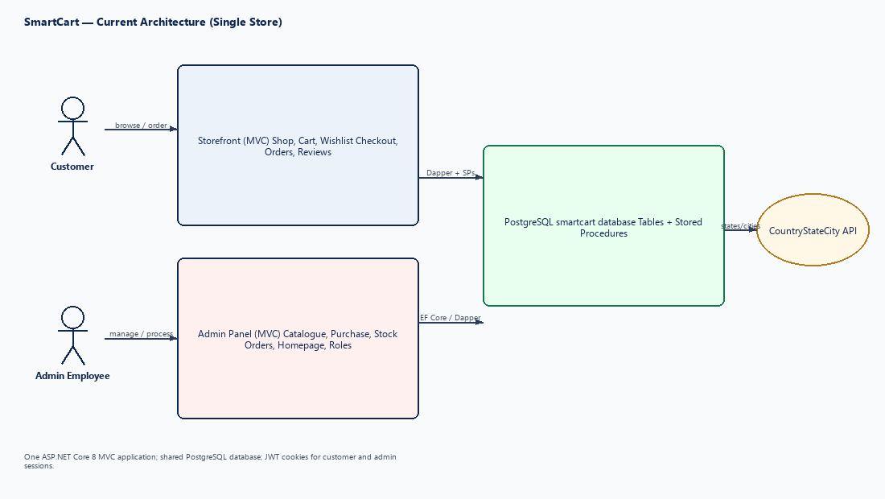

Figure 1.1: High-Level Overview of SmartCart
The remainder of this report analyses the existing system and requirements (Chapter 2), reviews related technologies and feasibility (Chapter 3), and describes planning, analysis, design, database, modules, user interface, implementation, testing, security and future scope in the subsequent chapters.

CHAPTER 2: EXISTING SYSTEM, PROBLEM AND REQUIREMENTS

2.1 Existing Shopping System
In the existing arrangement considered for this project, customers buy from the supermarket in person. They select products from the shelves and pay at the counter. Information about products, offers and availability is available only inside the store or by telephone. Orders placed by telephone, where accepted, are written down manually.

2.2 Existing Manual / Traditional Processes
- Purchasing: goods received from suppliers are recorded against supplier invoices in registers or spreadsheets.
- Stock: quantities are counted periodically; the relationship between purchases, sales and current stock is not maintained automatically.
- Catalogue: product names, pack sizes and prices are maintained informally or only in billing software.
- Orders: remote orders, if any, are recorded manually and their status is communicated by phone.
- Access: any staff member with access to the records can change them; there is no per-task authorisation.

2.3 Limitations
- No online presence or self-service ordering for customers.
- Inaccurate and delayed stock information.
- Duplicate data entry between purchase records, stock records and price lists.
- No structured order lifecycle or history.
- No audit of who changed what and no role-based restrictions.
- Difficult to scale as the product range grows.

2.4 Problems Identified
Table 2.1: Problems Identified in the Existing System
No. | Problem | Impact
1 | Catalogue not available online | Customers must visit or call the store to know what is available.
2 | Stock not linked to purchases and orders | Items may be promised to customers when they are out of stock.
3 | Variants handled informally | Wrong price or pack size may be quoted or billed.
4 | No order status tracking | Customers and staff cannot see where an order stands.
5 | Uncontrolled access to records | Errors and unauthorised changes cannot be prevented.
6 | No control over what is sold online | Items unsuitable for delivery cannot be excluded selectively.

2.5 Challenges Faced by Small Retail Businesses
Small retailers typically have limited budgets and technical staff. They need a system that is simple for employees to use, runs on commonly available infrastructure, and does not require separate products for the online shop and the back-office. They also need flexibility: not every item is suitable for online sale, and prices and pack sizes change frequently. At the same time, they must protect customer data and prevent unauthorised changes to prices and stock.
SmartCart addresses these challenges by combining storefront and administration in one application, by providing per-product and per-SKU online visibility, and by enforcing permissions for every administrative action.

2.6 Proposed System
The proposed system, SmartCart, is a web-based application that serves both customers and employees of a single supermarket. The storefront lets customers find products, choose a SKU, add it to the cart and place an order. The admin panel lets employees maintain all master data and process orders. Business rules that protect stock and order integrity are implemented in stored procedures so that they apply regardless of which screen triggers them.

2.7 Proposed Solution Overview
Table 2.2: Proposed Solution Components
Component | Responsibility | Status
Storefront | Home page, shop listing and filters, product details, wishlist, cart, checkout, orders, account | ✓ Implemented
Admin catalogue | Category, sub-category, brand, product, SKU, variant axes and values, media | ✓ Implemented
Purchasing & stock | Suppliers, purchases creating stock batches, inventory adjustment | ✓ Implemented
Order processing | List, detail, confirm, ship, deliver, cancel with restock | ✓ Implemented
Homepage management | Banners, featured categories, featured products | ✓ Implemented
Security | Employees, user roles, module permissions, JWT authentication | ✓ Implemented
Dashboard | Admin landing page; live KPI figures not yet available | ✓ Implemented
Online payment / billing | Online payment, UPI collection, invoices | ✓ Implemented

The proposed system replaces manual records with structured tables, links purchases to stock and orders, and introduces controlled, auditable workflows through defined status transitions and permissions.

2.8 Functional Requirements
Functional requirements describe what the system must do. They were derived from the store’s operational needs and are grouped by user area. Each requirement is given an identifier used later for traceability in testing (Chapter 11) and results.
Table 2.3: Functional Requirement Groups
Group | Area | Description
FR-A | Customer — Account | Registration, login, logout and access to protected pages.
FR-B | Customer — Catalogue | Home page, listing, search, filtering, sorting and product detail.
FR-C | Customer — Shopping | Wishlist, cart, checkout and order placement.
FR-D | Customer — Orders | Order history, order detail and cancellation.
FR-E | Admin — Access | Employee login, permission-based menus and actions.
FR-F | Admin — Catalogue | Categories, sub-categories, brands, products, SKUs, variants, media.
FR-G | Admin — Inventory | Suppliers, purchases, stock and inventory adjustment.
FR-H | Admin — Orders | Order list, detail and status actions.
FR-I | Admin — Content & Security | Homepage content, employees, roles and permissions.

The detailed customer and admin requirements are listed in Sections 2.9 and 2.10. Requirements that are not part of the current implementation are explicitly marked as planned.

2.9 Customer Functional Requirements
Table 2.4: Customer Functional Requirements
ID | Requirement | Status
FR-A1 | Register an account with name, e-mail, phone and password. | ✓
FR-A2 | Log in with e-mail and password; log out. | ✓
FR-B1 | Browse products on the home page and shop listing. | ✓
FR-B2 | Search products by text. | ✓
FR-B3 | Filter products by category, brand and price. | ✓
FR-B4 | View product details, images and available SKUs with MRP and selling price. | ✓
FR-C1 | Add or remove products in the wishlist. | ✓
FR-C2 | Add SKUs to the cart, update quantity and remove items. | ✓
FR-C3 | Checkout with a delivery address and Cash on Delivery. | ✓
FR-C4 | Receive an order number after successful order placement. | ✓
FR-D1 | View order history and order details. | ✓
FR-D2 | Cancel an order while it is in an early status (Placed/Pending). | ✓
FR-C5 | Pay online (card/UPI). | ✓
FR-C6 | Shop as a guest without logging in. | ✓
FR-D3 | Rate and review products. | ✓

2.10 Admin Functional Requirements
Table 2.5: Admin Functional Requirements
ID | Requirement | Status
FR-E1 | Employee login with username and password; logout; access-denied handling. | ✓
FR-E2 | Show menu items and action buttons according to the employee’s permissions. | ✓
FR-F1 | Create, edit, list and soft-delete categories and sub-categories (with images). | ✓
FR-F2 | Manage brands. | ✓
FR-F3 | Manage products, including SellOnline and active status. | ✓
FR-F4 | Manage SKUs: SKU code, barcode, MRP, selling price, unit, maximum order quantity. | ✓
FR-F5 | Manage variant axes and values and assign them to SKUs. | ✓
FR-F6 | Upload product images/video and SKU images. | ✓
FR-G1 | Manage suppliers (with state/city selection). | ✓
FR-G2 | Record purchases; each line creates stock for the SKU. | ✓
FR-G3 | Adjust inventory for a SKU. | ✓
FR-H1 | List and view orders; confirm, mark shipped, deliver or cancel. | ✓
FR-I1 | Manage homepage banners, featured categories and featured products. | ✓
FR-I2 | Manage employees, user roles and role permissions. | ✓
FR-E3 | Dashboard with live figures. | ✓
FR-I3 | Customer management screen. | ✓
FR-I4 | Reports. | ✓
FR-H2 | Create orders or edit order lines from admin; billing/invoices. | ✓

2.11 Non-Functional Requirements
Table 2.6: Non-Functional Requirements
Attribute | Requirement | How SmartCart addresses it
Security | Only authenticated users access protected pages; employees only perform permitted actions; passwords are not stored in plain text. | Separate JWT cookies for customers and employees; ASP.NET Identity password hasher; RequirePermission filter; admin middleware on /admin and /api/admin.
Performance | Listing pages respond quickly for a typical supermarket catalogue. | Server-side paging, searching and sorting; indexed keys and slugs; stored procedures for storefront queries.
Usability | Simple, consistent screens for customers and employees. | Storefront layout with filters; admin template with modals, toasts, empty states and searchable selects.
Maintainability | Code and database are easy to understand and change. | Controller–interface–repository structure; module-wise folders; build and patch scripts; project context documentation.
Scalability | Catalogue and orders can grow without redesign. | Normalised schema; SKU-level stock; future multi-store expansion identified.
Reliability / Integrity | Stock and orders remain consistent. | Rules in stored procedures; soft delete; unique constraints on SKU, barcode, slug and e-mail.
Availability | System available during store operating hours. | Demonstration hosting: local workstation running ASP.NET Core (Kestrel) against PostgreSQL on localhost. No public cloud host or uptime SLA is claimed for this academic demonstration.

Demonstration hosting: local machine. The application is run with ASP.NET Core (Kestrel) against PostgreSQL on localhost. It is not published to a public cloud host for this academic demonstration. No uptime SLA is claimed.

2.12 Hardware Requirements
Table 2.7: Recommended Hardware Requirements
Item | Development / Server (recommended) | Client
Processor | Dual-core 2 GHz or higher | Any modern processor
Memory (RAM) | 8 GB or more | 4 GB or more
Storage | 20 GB free space (application, database, uploads) | —
Network | Broadband connection for package restore and APIs | Internet connection
Display | 1366 × 768 or higher | Desktop, laptop or mobile browser

Development/test machine: Windows 11 PC; multi-core CPU; 16 GB RAM; SSD with ≥20 GB free for .NET SDK, PostgreSQL data and uploads. Used for coding, database patching and full demonstration of SmartCart.

2.13 Software Requirements
Table 2.8: Software Requirements
Category | Software
Operating system | Windows 11 (development and demonstration)
Runtime / SDK | .NET SDK 8.0 or later
Framework | ASP.NET Core 8 MVC with Razor views
Database | PostgreSQL (local development; connection key PostgresConnection)
Data access | Dapper 2.1.35, Npgsql 8.0.6, Npgsql.EntityFrameworkCore.PostgreSQL 8.0.11
Security libraries | JWT Bearer 8.0.11; ASP.NET Core Identity password hasher
Front-end | HTML5, CSS3, JavaScript; Bootstrap 5.3 and Mantis admin template; SCSS
Build tools | Node.js and npm (Bootstrap SCSS); AspNetCore.SassCompiler
IDE / tools | Visual Studio / VS Code, PostgreSQL (psql), Git
Browser | Current Chrome, Edge or Firefox

2.14 Functional vs Non-Functional Requirement Table
Table 2.9 consolidates the principal requirements, their type and the module that satisfies them. It is used as the traceability base for testing and for the requirement achievement summary.
Table 2.9: Consolidated Requirement Traceability
Req. ID | Requirement | Type | Module | Status
FR-A1/A2 | Customer registration and login | Functional | Customer Account | ✓
FR-B1–B4 | Browse, filter and view product details | Functional | Shop | ✓
FR-C1 | Wishlist | Functional | Wishlist | ✓
FR-C2 | Cart | Functional | Cart | ✓
FR-C3/C4 | Checkout and order placement (COD) | Functional | Checkout / Orders | ✓
FR-D1/D2 | Order history and cancellation | Functional | Customer Orders | ✓
FR-E1/E2 | Employee login and permissions | Functional | Admin Auth / Roles | ✓
FR-F1–F6 | Catalogue management | Functional | Admin Catalogue | ✓
FR-G1–G3 | Suppliers, purchases, stock | Functional | Admin Inventory | ✓
FR-H1 | Order processing | Functional | Admin Orders | ✓
FR-I1/I2 | Homepage content; employees and roles | Functional | Admin Content / Security | ✓
NFR-1 | Authentication and authorisation | Non-functional | All | ✓
NFR-2 | Data integrity of stock and orders | Non-functional | Database / SPs | ✓
NFR-3 | Paged, searchable admin lists | Non-functional | Admin lists | ✓
NFR-4 | Maintainable layered structure | Non-functional | All | ✓
FR-C5 | Online payment | Functional | Checkout | ✓

Reviewed vs code: shop/search/cart/wishlist/COD/Razorpay/orders/reviews IMPLEMENTED; admin catalogue/inventory/purchases/orders/homepage/employees/roles/POS/review moderation/dashboard IMPLEMENTED. Multi-store remains future scope.. Search (FR-B2) is IMPLEMENTED. Requirement statuses in Table 2.9 reflect the implemented SmartCart application (catalogue, stock, storefront, cart/wishlist, checkout, orders, admin processing, RBAC, and order-item ratings & reviews).

CHAPTER 3: LITERATURE REVIEW AND FEASIBILITY

3.1 Overview
This chapter reviews the concepts and technologies relevant to SmartCart: the structure of e-commerce systems, common architectural patterns, the technologies used to build the system and the security concepts applied. It then assesses the feasibility of the project and identifies the gap that SmartCart fills.

3.2 E-Commerce Systems
An e-commerce system allows a seller to present products, accept orders and manage fulfilment through the internet. A typical B2C system consists of: a catalogue (products, categories, prices, images), a customer account module, a cart and checkout process, an order management module for the seller, inventory control and payment handling. For grocery and supermarket retail, additional characteristics are important:
- Variants and units: the same product is sold in several pack sizes or weights, each with its own price and stock.
- Stock accuracy: high item counts and frequent replenishment make real-time stock important.
- Selective online sale: some items may be sold in-store only.
- Local fulfilment: delivery from a nearby store, often with cash payment on delivery.
SmartCart models these characteristics directly: products have SKUs with units and prices, stock is maintained per SKU, and the SellOnline flag controls online availability at both product and SKU level.

3.3 Existing E-Commerce Platforms
Existing approaches available to a supermarket can be grouped into three categories. (1) Hosted marketplace or delivery platforms, where the store lists its products on a third-party platform; these provide reach but limited control over data, catalogue structure and fees. (2) General-purpose e-commerce software, which provides online shop features but often requires separate back-office or inventory tools and customisation for pack-size variants and purchases. (3) Stand-alone billing or inventory software, which supports in-store operations but has no customer-facing channel.
This review is limited to these general categories; no claims are made about the features, pricing or performance of specific commercial products.

3.4 General Architecture Patterns
- Model–View–Controller (MVC): separates request handling (controllers), data (models) and presentation (views). SmartCart uses ASP.NET Core MVC with Razor views.
- Repository pattern: isolates data-access code behind interfaces, allowing controllers to remain thin. SmartCart uses interface + repository pairs for each module.
- Layered architecture: presentation, application and data layers with clear dependencies.
- Database-centred business rules: rules implemented in stored procedures so that they are enforced consistently at the data layer.
- Token-based authentication: a signed token identifies the user on each request without server-side session storage.
SmartCart combines MVC, repositories and database-centred rules within a single deployable web application, which suits the size and budget of a single store.

3.5 Technology Review
The technologies were selected for stability, documentation quality, suitability for a data-intensive business application and the developer’s familiarity. Table 3.1 summarises the technologies actually used.
Table 3.1: Technologies Used in SmartCart
Layer | Technology | Use in SmartCart
Framework | ASP.NET Core 8 MVC | Controllers, Razor views, routing, middleware, dependency injection
Database | PostgreSQL | Relational storage, stored procedures, constraints
Data access | Dapper (micro-ORM) | Executing stored procedures for storefront and admin orders
Data access | Entity Framework Core 8 | Admin catalogue, suppliers, purchases, stock, employees, roles (no migrations)
Security | JWT Bearer, Identity PasswordHasher | Token cookies and password hashing
UI | Razor, HTML5, CSS3, JavaScript | Storefront pages and AJAX calls
UI | Bootstrap 5.3, Mantis template, SCSS | Admin panel layout and components
Integration | CountryStateCity API | State and city lists on supplier forms

3.6 ASP.NET Core
ASP.NET Core is Microsoft’s cross-platform, open-source framework for building web applications. Its MVC model maps URLs to controller actions that return views or JSON. The request pipeline is composed of middleware components, which SmartCart uses for global exception handling, request logging and admin session enforcement. Built-in dependency injection is used to register interfaces and repositories, and the authentication framework supports JWT bearer tokens, which SmartCart reads from cookies.

3.7 SQL Database / Stored Procedure Approach
A relational database is appropriate for SmartCart because its data is highly structured and related: categories contain sub-categories, products belong to sub-categories and brands, SKUs belong to products, stock rows belong to SKUs and purchase lines, and orders reference customers, products and SKUs. Referential integrity, unique constraints and transactions are required to keep these relationships consistent.
Stored procedures encapsulate SQL logic inside the database. In SmartCart they are used for storefront operations (shop listing, product detail, cart, wishlist, customer authentication, checkout and orders) and for admin order processing. Placing rules such as “only active, non-cancelled, SellOnline items can be ordered” and “stock must cover the ordered quantity” in procedures ensures they are applied consistently. Procedures are created with CREATE OR ALTER so that patch scripts can be re-run safely.
Other admin modules use Entity Framework Core mapped to the same tables. The schema itself is not generated by EF migrations; it is maintained by versioned build and patch SQL scripts.

3.8 HTML/CSS/JavaScript/Frontend Technologies
- Razor views generate HTML on the server for both areas (shared layouts _Layout, _AdminLayout and _AdminAuthLayout).
- Storefront styling uses custom style sheets (storefront, shop listing and bag styles).
- Admin UI uses the Mantis Bootstrap template; SCSS is compiled to CSS during the .NET build using AspNetCore.SassCompiler and Bootstrap sources from npm.
- JavaScript performs AJAX requests (fetch) to controller actions that return JSON, for example product lists and admin list pages.
- Shared admin components include a toast notification system and an empty-state handler.
Single-page application frameworks were not used; server-rendered pages with targeted AJAX calls were considered sufficient for the project’s scope.

3.9 Security Concepts
Web applications handling customer data and business operations must address confidentiality, integrity and availability. Relevant concepts include: protecting credentials through one-way password hashing; preventing SQL injection through parameterised queries; validating all inputs on the server; restricting file uploads by type and size; avoiding disclosure of internal error details; and ensuring that users can access only the data and functions appropriate to their role.

3.10 Authentication and Authorization
Authentication establishes who the user is. SmartCart uses JSON Web Tokens (JWT): after a successful login the server issues a signed token that is stored in an HTTP cookie and validated on subsequent requests. Customers and employees are separate identities stored in different tables and use different cookies and token audiences.
Authorization determines what an authenticated user may do. SmartCart implements role-based access control for employees: each role is mapped to a set of permission codes (for example, Module.Action) grouped by module; each admin action declares the permission it requires; and the permission set is re-read from the database on the request rather than trusted from the client.
Table 3.2: Authentication vs Authorisation in SmartCart
Aspect | Customer | Admin Employee
Identity store | Users table | AdminUsers table
Login entry | /Account/Login | /admin/login
Token | JWT in customer cookie (user audience) | JWT in admin cookie (admin audience)
Authorisation | Must be logged in for cart, wishlist, checkout, orders | Role → permissions; RequirePermission on actions

3.11 Feasibility Study

Technical feasibility
The project uses mature, well-documented technologies (ASP.NET Core, PostgreSQL, Bootstrap) available at no licence cost for development. The developer had access to the required tools, and the architecture — a single web application and one database — is within the capability of one developer. The system is therefore technically feasible.

Economic feasibility
Development tools and frameworks used are free for development (.NET SDK, PostgreSQL, Node.js, open-source libraries). The main costs are the developer’s time and, for production, hosting and a domain. Because one application serves both the storefront and the back-office, the cost of separate systems is avoided.
Cost: development tools used (.NET SDK 8, PostgreSQL, Node.js, Bootstrap/Mantis, open-source libraries) have no licence fee for this academic project. The demonstration uses a local host, so no production hosting or domain cost is incurred for the MCA submission.

Operational feasibility
The admin panel follows familiar patterns (lists, search, forms in modals, clear action buttons) and restricts each employee to permitted functions, which reduces training needs and errors. Customers use a conventional shopping flow. The system is operationally feasible.

Schedule feasibility
The work was divided into phases (Chapter 4) that could be completed within the MCA project period. Features beyond the core scope were deliberately deferred to future scope to keep the schedule realistic.

3.12 Literature Review Summary
The review shows that an e-commerce system for a supermarket must handle variant-level pricing and stock, selective online availability, reliable order processing and secure, role-restricted administration. MVC with repositories provides a maintainable application structure; a relational database with stored procedures provides consistency for stock and orders; and JWT-based authentication with permission-based authorisation provides the necessary security.

3.13 Gap Analysis
Table 3.3: Existing System vs Proposed System
Aspect | Existing System | Proposed SmartCart System
Customer access | In-store or telephone only | Online storefront with registration and login
Catalogue | Informal lists / billing software | Structured categories, brands, products and SKUs
Variants | Handled manually | SKU with MRP, selling price, unit and attributes
Online visibility | Not applicable | SellOnline flag per product and per SKU
Stock | Periodic manual counts | Batch stock rows from purchases and adjustments
Orders | Manual notes, no status | Order number and status lifecycle with restock on cancel
Access control | Unrestricted | Employees with roles and module permissions
Payment | Cash at counter | Cash on Delivery (online payment is future scope)
Scalability | Limited | Single-store now; multi-store identified as future scope

Validated: SmartCart adds online catalogue, SKU stock, COD orders and RBAC versus manual processes. Do not claim payment-gateway or multi-store benefits as current features. Check that each “Existing System” entry reflects the store scenario you studied during fact finding.

CHAPTER 4: PROJECT PLANNING AND METHODOLOGY

4.1 Development Approach
SmartCart was planned as a sequence of phases, starting with requirement analysis and database design, followed by module-wise development of the storefront and the admin panel, integration, testing and documentation. Modules were developed incrementally so that each could be tested before the next was built on it — for example, the catalogue had to exist before the cart and orders could be implemented.

4.2 Project Phases
Table 4.1: Project Phases and Deliverables
Phase | Main Activities | Deliverable
1. Requirement analysis | Study of store operations, identification of actors and requirements | Requirement list, scope
2. System design | Architecture, modules, DFDs, use cases | Design diagrams
3. Database design | Tables, keys, relationships, procedures, scripts | Build and patch scripts
4. Backend development | Controllers, repositories, stored procedures, authentication | Working APIs and pages
5. Frontend development | Storefront views, admin views, scripts and styles | User interfaces
6. Integration | Connect modules; catalogue → cart → order → stock | Integrated application
7. Testing | Functional, negative and role-based testing | Test cases and results
8. Documentation | Project report and context documentation | Final report

The phases overlapped where appropriate; database scripts, for instance, were extended through patch files as new modules were developed.

4.3 Requirement Analysis Phase
The requirement analysis phase identified the two user groups — customers and store employees — and the operations each group performs. Existing manual processes for purchasing, stock and order handling were studied, and the scope of the current version was fixed as a single-store system with Cash on Delivery. Features such as online payment and multi-store operation were recorded as future scope.
Fact-finding for this report used SmartCart source code, Database-Postgres scripts, appsettings and Ecommerce/context/. Live retail-store interviews: not conducted. Requirements were taken from the project problem definition and from the implemented SmartCart application. Describe the fact-finding techniques you actually used (observation of a store, discussion with store staff, study of existing apps, questionnaires) and the key findings. Do not include techniques you did not use.

4.4 Design Phase
In the design phase the overall architecture (single ASP.NET Core MVC application with storefront and admin areas), the module structure, the data flows and the use cases were defined. Decisions made in this phase include keeping customers and employees as separate identities, maintaining stock at SKU level, and enforcing order rules in stored procedures.

4.5 Development Phase
Development proceeded module by module. For each module the database objects were created first, then the repository and interface, then the controller actions and finally the views and scripts. Admin list pages follow a common pattern — a Razor index page plus an AJAX endpoint returning paged, searchable results — which reduced development effort for later modules.

4.6 Database Development
The database was developed through SQL scripts organised in folders: table scripts (01_Tables), stored procedures grouped by area (02_Procedures/01_Admin, 02_Users, 03_Common) and seed data (05_Seed). A full PostgreSQL build script (Database-Postgres/Database.sql via psql) creates tables, seed data and procedures; patch scripts apply incremental changes with CREATE OR REPLACE for procedures.

4.7 Backend Development
The backend consists of MVC controllers for the storefront (Controllers/) and the admin area (Controllers/Admin/), interfaces and repositories for data access, helpers for list normalisation, authentication and image handling, middleware for exceptions, request logging and admin sessions, and a permission filter. Services and repositories are registered through a dependency-injection extension method called from Program.cs.

4.8 Frontend Development
The storefront pages (Home, Shop, Cart, Wishlist, Checkout, Orders, Account) were built with Razor views and custom CSS, with JavaScript for listing, filtering and cart interactions. The admin panel was built on the Mantis Bootstrap template with one index page per module, modal forms, shared pagination, toast notifications, empty states and permission-aware buttons.
Table 4.2: Development Order of Main Modules
Order | Module group
1 | Database foundation, admin authentication, roles and permissions
2 | Catalogue: category, sub-category, brand, product, SKU, variants, media
3 | Suppliers, purchases and stock
4 | Storefront: shop, product details, customer account
5 | Wishlist, cart, checkout and customer orders
6 | Admin order processing; homepage management

Inferred development order: database scripts/seed → admin catalogue/auth (EF) → storefront shop/cart/wishlist/auth (Dapper) → checkout/orders → admin orders/inventory/purchases → homepage → POS sales/returns → documentation. Adjust Table 4.2 to the order in which you actually developed the modules.

4.9 Testing Phase
Testing was carried out module-wise during development and again after integration. Test cases were designed from the requirements in Chapter 2 and the business rules implemented in the stored procedures, covering valid inputs, invalid inputs, permission restrictions and status transitions. The testing approach and test case templates are presented in Chapter 11; actual results are recorded there as evidence.

4.10 Deployment / Release Preparation
Release preparation involves restoring .NET and npm packages, building the application (which also compiles the admin SCSS), creating or patching the database with the build or patch scripts, configuring the connection string and JWT settings, and ensuring that the uploads folder is writable. Development secrets (such as the development JWT key and API keys) must be replaced for any production deployment.
Demonstration environment: local ASP.NET Core host + local PostgreSQL database smartcart (connection key PostgresConnection / DatabaseSettings). State the actual environment used to run SmartCart for evaluation: machine/server, OS, database edition, URL (if hosted). Do not state hosting details that have not been set up.

Table 4.3: Release Checklist
Step | Action
1 | npm install (Bootstrap sources for admin SCSS)
2 | dotnet restore and dotnet build
3 | Run the database build script (new database) or patch script (existing database)
4 | Configure connection string key “PostgresConnection” and JWT settings in appsettings
5 | Seeded admin login and role permissions were exercised during testing
6 | Run the application and perform smoke tests

4.11 Development Methodology
An iterative and incremental approach is described here as the working method: the system was built in increments (modules), each passing through design, implementation and testing, and later increments reused the patterns and database foundations established by earlier ones. Requirements discovered during development — for example, the need to control online visibility per SKU — were incorporated in subsequent iterations through patch scripts.
Methodology: incremental module-wise development inside a phased academic plan (requirements → design → database → implementation → integration → testing → documentation). The project followed iterative/incremental delivery inside a phased academic plan (requirements → design → database → implementation → integration → testing → documentation), matching the module-wise build order used in SmartCart. Include iteration lengths or sprint details only if they are real.

Table 4.4: Characteristics of the Methodology Applied
Characteristic | Application in SmartCart
Incremental delivery | Modules delivered one after another on a shared foundation
Early database design | Core tables designed first; extended through patches
Continuous testing | Each module tested before integration
Documentation alongside development | Context files (project, architecture, database, rules, future) kept in the repository
Controlled scope | Unfinished items moved explicitly to “planned / future scope”

This approach suited a single-developer academic project in which requirements were refined while building, and it kept the implemented scope clearly separated from future work.

4.12 Project Schedule
Table 4.5 lists the project activities with their dependencies. Table 4.5 lists activities A–J with dependencies. Figure 4.1 presents the Gantt chart as relative project weeks derived from that dependency order for academic scheduling.
Table 4.5: Project Activity Schedule
ID | Activity | Depends on | Start | End | Duration
A | Requirement analysis | —
B | System design | A
C | Database design and scripts | B
D | Admin authentication and security | C
E | Admin catalogue and inventory | C, D
F | Storefront and customer account | E
G | Cart, wishlist, checkout, orders | F
H | Admin orders and homepage | G
I | Integration and testing | H
J | Documentation | I

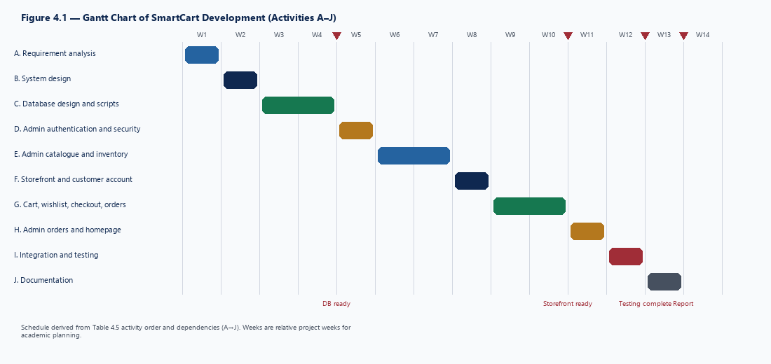

Figure 4.1: Gantt Chart of SmartCart Development

4.13 PERT Chart
The Program Evaluation and Review Technique (PERT) chart represents activities as a network, showing their dependencies and the critical path. It is derived from the dependency column of Table 4.5.
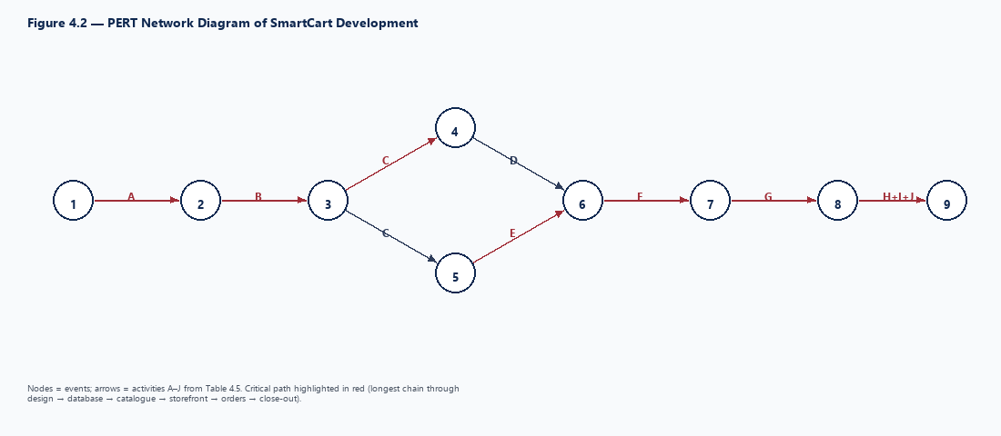

Figure 4.2: PERT Network Diagram of SmartCart Development
Figure 4.2 presents the PERT network and critical path from the Table 4.5 activity dependency order used for project planning.. The activity order in Table 4.5 is the planning basis; Figure 4.2 presents the PERT network and critical path from the Table 4.5 activity dependency order used for project planning.. Figure 4.2 shows the activity network and critical path from the Table 4.5 dependency order.

4.14 Project Planning Summary
The project was organised into eight phases and ten scheduled activities. Planning emphasised building the database and security foundation first, then the catalogue and inventory on which the storefront depends, and finally the customer purchasing and order-processing flows. Risks were identified and mitigated as shown in Table 4.6.
Table 4.6: Risk Register and Mitigation
Risk | Likelihood | Impact | Mitigation
Scope growth beyond project period | Medium | High | Fixed single-store scope; deferred features to future scope
Stock inconsistency between orders and inventory | Medium | High | Stock checks and deduction in stored procedures; restock on cancel
Unauthorised admin actions | Low | High | Role–permission model; permission re-read per request
Schema changes breaking existing data | Medium | Medium | Re-runnable patch scripts with existence checks
Upload of unsafe or oversized files | Medium | Medium | Allowed extensions and size limits in image service
Loss of development data | Low | High | Version control (Git) and Database-Postgres build/patch scripts
Technology learning curve | Medium | Medium | Use of official documentation; incremental development

Risks and mitigation (verified): stock consistency is enforced in stored procedures (deduction/restock); authentication uses password hashing and JWT; permission misuse is blocked by RequirePermission; PostgreSQL and local uploads were available throughout testing. Residual probability for stock/auth/permission issues is treated as Low after mitigation. No critical defect remained open at submission.

CHAPTER 5: SYSTEM ANALYSIS

5.1 System Overview
System analysis examines how SmartCart’s users interact with the system and how data moves between processes and data stores. SmartCart has two interacting sub-systems: the storefront, through which customers find products and place orders, and the admin panel, through which employees maintain the catalogue and stock and process orders. Both operate on the same database, so actions in one sub-system are immediately reflected in the other.

5.2 Actors
Table 5.1: Actors of the System
Actor | Type | Description | Status
Customer | Primary | Registered shopper stored in the Users table; browses, maintains wishlist and cart, places and cancels orders. | Current
Admin Employee | Primary | Store staff stored in AdminUsers with a user role; performs actions allowed by the role’s permissions. | Current
System Administrator | Primary (role) | Employee with the seeded Admin system role holding all permissions; manages employees, roles and permissions. | Current
Visitor (guest) | Secondary | Unauthenticated user who can browse the shop but must log in to use cart, wishlist or checkout. | Current
CountryStateCity API | External system | Supplies state and city lists for supplier forms. | Current
Store / Zone Administrator | Primary | Would manage a specific store or zone. | Future (SmartCart Then)
Payment Gateway | External system | Would process online payments. | Future (SmartCart Then)

Only the actors marked “Current” exist in the implemented system. The future actors are listed to show where SmartCart Then would extend the analysis.

5.3 Use Case Analysis
Use case analysis captures the goals each actor achieves through the system. Figure 5.1 presents the overall use case diagram combining customer and employee use cases; Sections 5.4 and 5.5 detail each actor’s use cases.
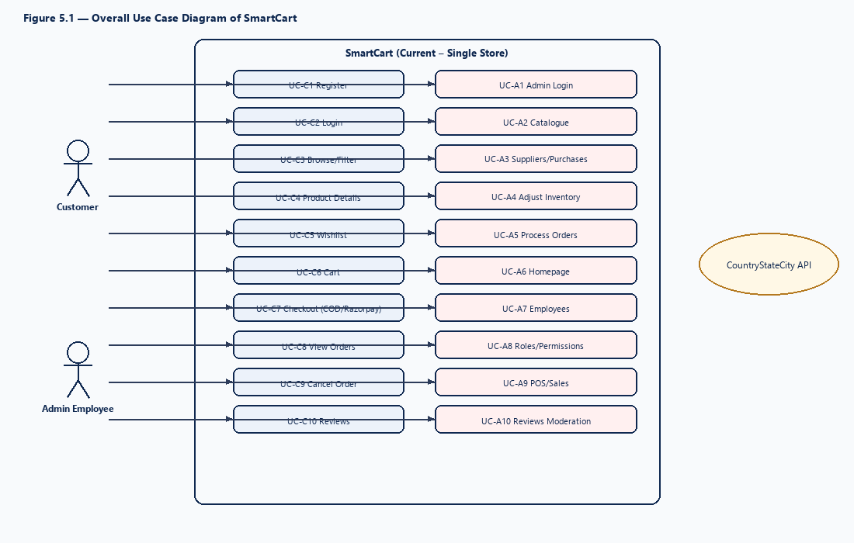

Figure 5.1: Overall Use Case Diagram of SmartCart

5.4 Customer Use Cases
Table 5.2: Customer Use Cases
UC ID | Use case | Pre-condition | Outcome
UC-C1 | Register | E-mail not already registered | Customer account created
UC-C2 | Login / Logout | Account exists | Customer cookie issued / cleared
UC-C3 | Browse and filter products | — | List of online-sellable products
UC-C4 | View product details | Product is active and SellOnline | Product, SKUs and media shown
UC-C5 | Manage wishlist | Logged in | Product added / removed
UC-C6 | Manage cart | Logged in; SKU sellable and in stock | Cart updated
UC-C7 | Checkout (COD) | Cart not empty; valid address | Order placed with order number
UC-C8 | View orders | Logged in | Order list and details
UC-C9 | Cancel order | Order in early status | Order cancelled; stock restored

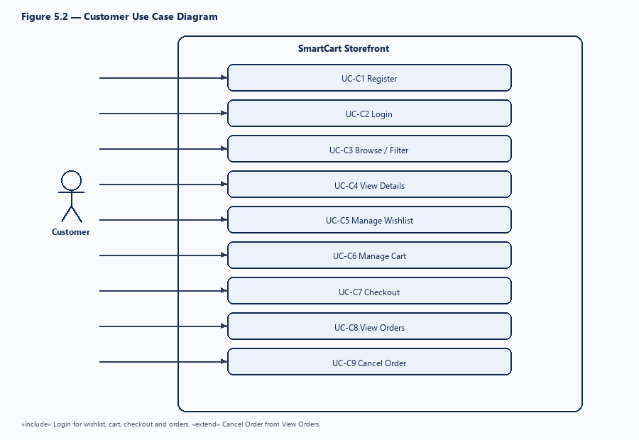

Figure 5.2: Customer Use Case Diagram

5.5 Administrator Use Cases
Table 5.3: Administrator Use Cases
UC ID | Use case | Permission required
UC-A1 | Login / Logout, access denied handling | — (authentication)
UC-A2 | Manage categories and sub-categories | Categories / SubCategories permissions
UC-A3 | Manage brands | Brands permissions
UC-A4 | Manage products, SKUs, variants and media | Products permissions
UC-A5 | Manage suppliers | Suppliers permissions
UC-A6 | Record purchases (creates stock) | Purchases permissions
UC-A7 | Adjust inventory | Stock.View
UC-A8 | Process orders (confirm, ship, deliver, cancel) | Orders permissions
UC-A9 | Manage homepage content | Homepage.View
UC-A10 | Manage employees, roles and permissions | Employees / UserRoles permissions

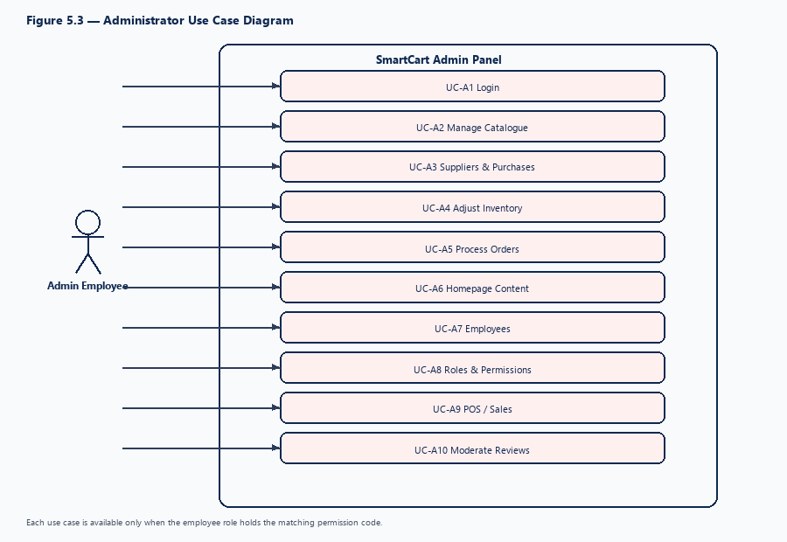

Figure 5.3: Administrator Use Case Diagram

5.6 Context-Level DFD
The context-level data flow diagram treats SmartCart as a single process and shows its data exchanges with external entities.
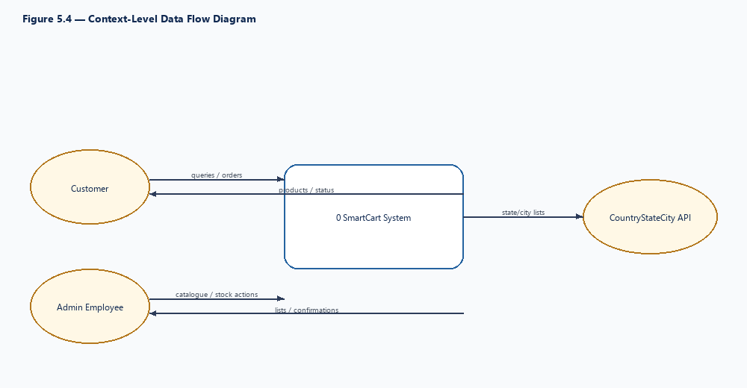

Figure 5.4: Context-Level Data Flow Diagram
Notation: Use Gane–Sarson or Yourdon–DeMarco notation consistently across all DFDs in this chapter.

5.7 Level 0 DFD
The Level 0 DFD decomposes SmartCart into its major processes and the data stores they use. Data store names correspond to actual database tables.
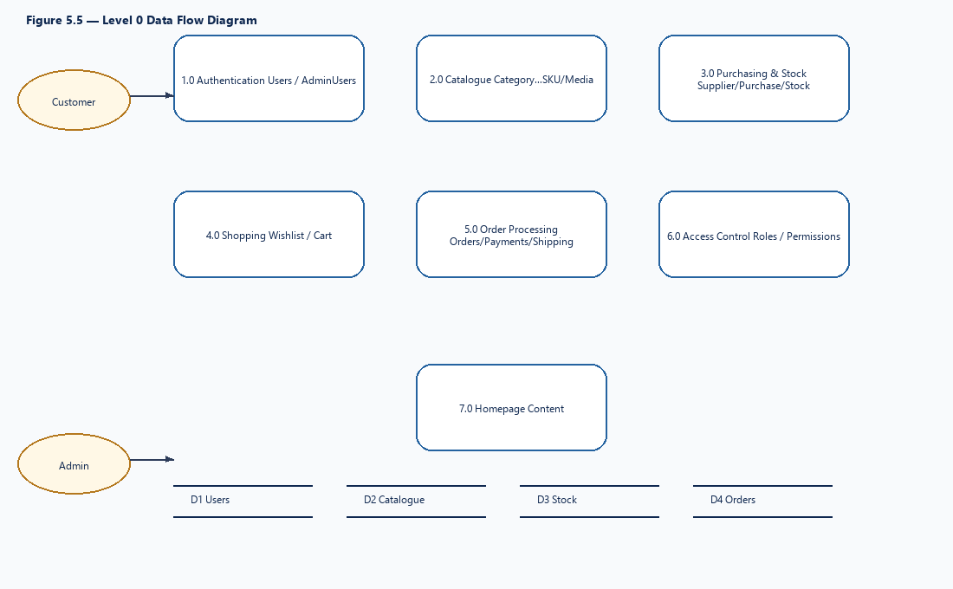

Figure 5.5: Level 0 Data Flow Diagram

5.8 Level 1 DFD — Customer Flow
This diagram expands the customer-facing processes from registration to order cancellation.
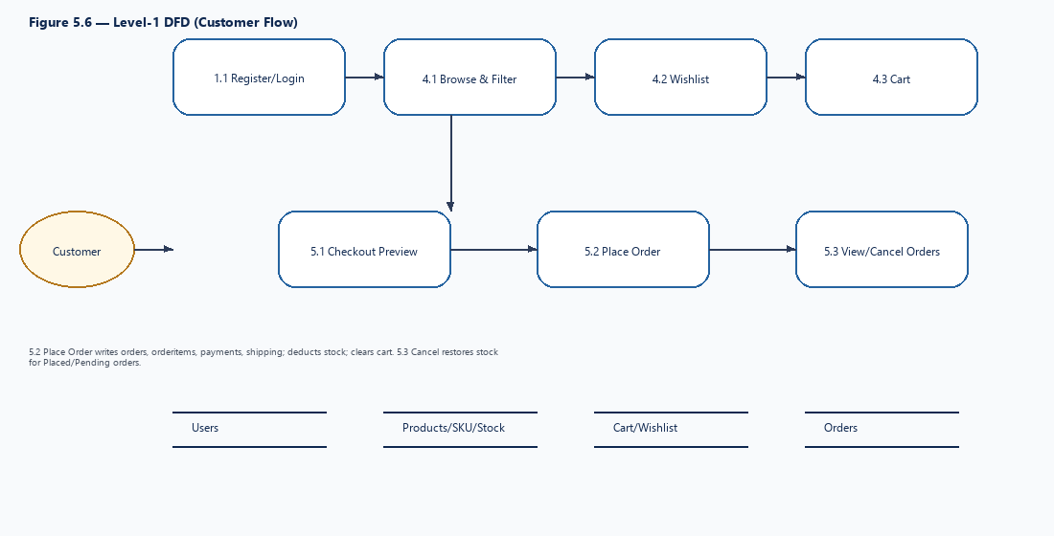

Figure 5.6: Level 1 DFD – Customer Flow

5.9 Level 1 DFD — Admin Flow
This diagram expands the administrative processes used by employees.
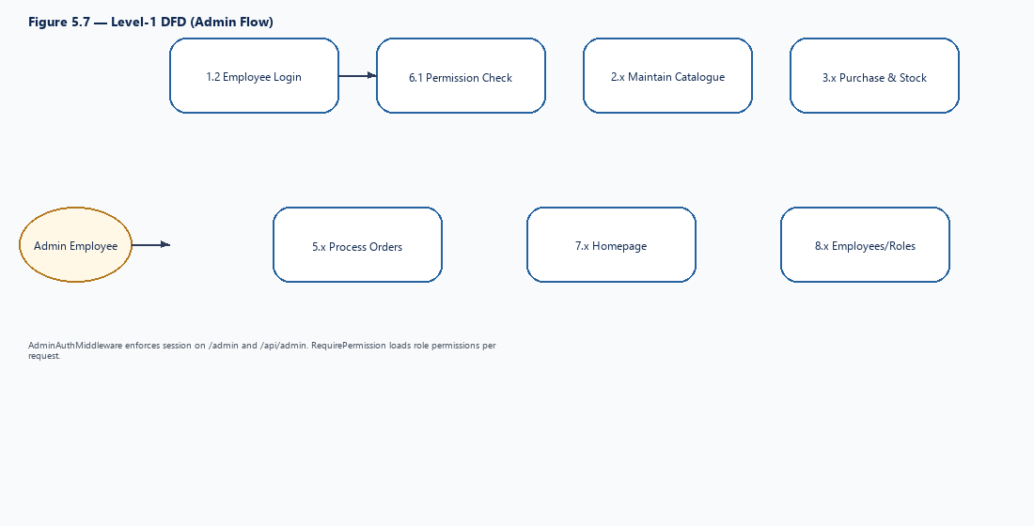

Figure 5.7: Level 1 DFD – Admin Flow

5.10 Order Processing Data Flow
Order processing spans both sub-systems: the customer creates the order and the employee moves it through its statuses. Stock is deducted when the order is placed and restored if it is cancelled.
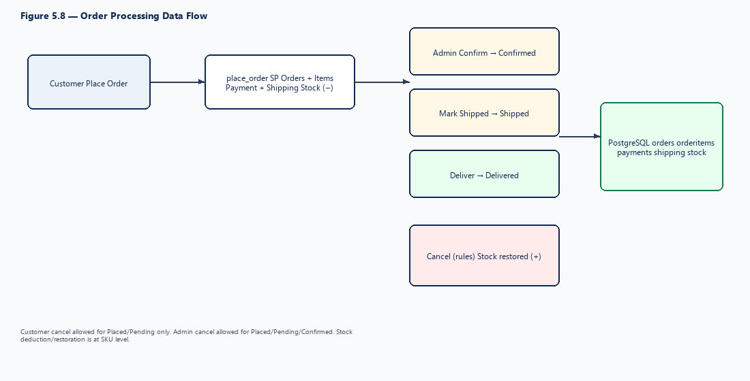

Figure 5.8: Order Processing Data Flow Diagram

5.11 Authentication Data Flow
Customers and employees authenticate through separate flows and receive separate cookies. Admin requests are additionally checked for permissions on every protected action.
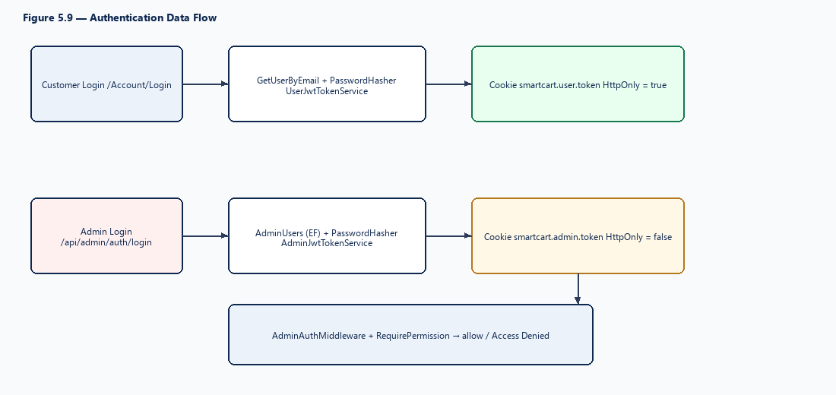

Figure 5.9: Authentication Data Flow Diagram

5.12 System Analysis Summary
The analysis identified two current primary actors — the customer and the admin employee — and a supporting external service, together with future actors that belong to SmartCart Then. The use cases cover the full customer purchasing cycle and the store’s administrative operations. The DFDs show that all processes share a single database, that orders both consume and restore stock, and that authentication and authorisation are applied separately to customers and employees.
Table 5.4: Mapping of Processes to Data Stores
Process | Main data stores (tables)
Authentication | Users, AdminUsers
Access control | UserRoles, Modules, Permissions, UserRolePermissions
Catalogue | Category, SubCategory, Brand, Products, ProductVariants, Variants, VariantValues, ProductVariantAttributes
Media | ProductMedia, SkuMedia (files in wwwroot/uploads)
Purchasing & stock | Supplier, Purchase, PurchaseDetail, Stock
Shopping | Wishlist, WishlistItems, Cart, CartItems, UserAddresses
Orders | Orders, OrderItems, Payments, Shipping
Homepage content | homepage_banners, homepage_banner_categories, homepage_categories, homepage_products

These findings form the basis for the architecture and design in Chapter 6 and the database design in Chapter 7.

CHAPTER 6: SYSTEM ARCHITECTURE AND DESIGN

6.1 Design Overview
The design of SmartCart translates the requirements and analysis into an application structure. The system is designed as one ASP.NET Core 8 MVC web application containing both the storefront and the admin panel, with a single relational database. This design suits a single store: it is simple to deploy and maintain, and it keeps customer and administrative data consistent. This chapter describes Current Architecture / SmartCart Now; future architecture is addressed only in Chapter 12.

6.2 Design Principles
- Separation of concerns: controllers handle requests, repositories handle data access, views handle presentation.
- Thin controllers: controllers validate input, call a repository and return a view or JSON.
- Programming to interfaces: each repository implements an interface registered for dependency injection.
- Rules close to the data: stock, online-sale and order-status rules are enforced in stored procedures.
- Separate identities: customers and employees have different tables, cookies and token audiences.
- Least privilege: every admin action requires an explicit permission.
- Soft delete: master records are cancelled (Cancelled flag) rather than physically deleted.
- Re-runnable scripts: schema changes are delivered by patch scripts that can be applied repeatedly.

6.3 System Architecture
Figure 6.1 shows the layered architecture. The browser renders Razor pages and calls controller actions; controllers use interfaces implemented by repositories; repositories access the database either through Dapper and stored procedures or through Entity Framework Core, depending on the module.
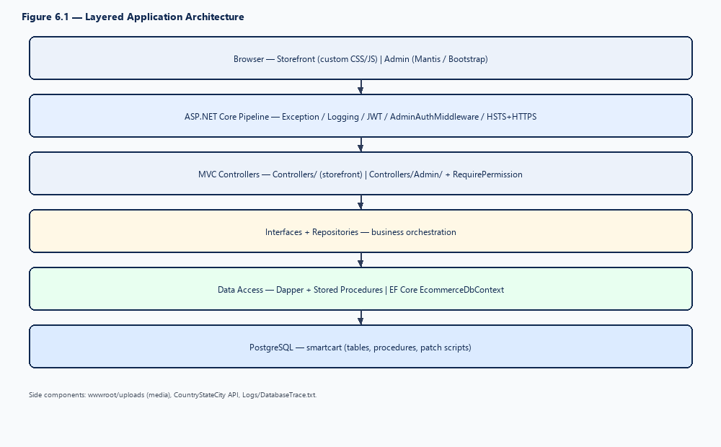

Figure 6.1: SmartCart System Architecture

6.4 Application Layer Structure
Table 6.1: Project Folder Structure
Folder | Responsibility
Controllers/, Controllers/Admin/ | MVC controllers for storefront and admin
Interface/, Interface/Admin/ | Repository abstractions
Repository/, Repository/Admin/ | Data access implementations
Models/, Models/Admin/, Models/Entities/ | DTOs, view models and EF entities
Helpers/ | List normalisation, authentication helpers, JWT services, image handling
DataAccess/ | DataAccessDapper and EcommerceDbContext
Filters/ | RequirePermissionAttribute
Middleware/ | Global exception, request logging, admin session
views/ | Razor views and shared layouts
Database/ | Table scripts, procedures, seed data, build/patch entry points
wwwroot/ | Static assets, admin template, compiled CSS, uploads

6.5 Backend Structure
The backend is organised by area. Storefront repositories depend on IDataAccessDapper and call stored procedures. Admin catalogue, supplier, purchase, stock, employee, role and admin-login repositories depend on EcommerceDbContext. The admin order repository is an exception and uses Dapper with dedicated procedures. All services and repositories are registered in an extension method (AddCustomServices) invoked from Program.cs. Admin lists return a standard ApiResponse containing a paged TableOutput, driven by PageIndex, PageSize and SearchText inputs.

6.6 Frontend Structure
The frontend is server-rendered with Razor. Two visual systems are used: a custom storefront and the Mantis Bootstrap admin template.
Table 6.2: Frontend Structure
Area | Layout | Pages / assets
Storefront | _Layout.cshtml | Home, Shop (listing and details), Cart, Wishlist, Checkout, Orders, Account; storefront.css, shop-listing.css, shop-bag.css; scripts under wwwroot/js
Admin panel | _AdminLayout.cshtml (sidebar with permission attributes) | One Index.cshtml per module with modal forms and AJAX; Mantis assets; style.scss compiled to style.css
Admin login | _AdminAuthLayout.cshtml | views/Admin/Login/Index.cshtml
Shared components | _AdminLayout | Toast notifications (toast.js), empty state (empty-state.js, _EmptyState.cshtml), pagination, searchable selects, admin-permissions.js

Storefront interactions such as loading products, applying filters and updating the cart are performed through JSON endpoints of MVC actions, so pages update without full reloads where appropriate. Admin buttons are shown or hidden according to the employee’s permissions, while the server still enforces the same permissions.
Storefront: Razor views (Home, Shop, Cart, Wishlist, Checkout, Orders, Account); CSS storefront/shop-listing/shop-bag; JS shop-listing.js, shop-details.js, shop-checkout.js, shop-bag.js. Admin: Mantis Bootstrap under wwwroot/Admin (SCSS via AspNetCore.SassCompiler + npm Bootstrap); toast/empty-state scripts; views/Admin/*. Uploads: wwwroot/uploads/. List the actual JavaScript files and Razor views per module (e.g. from wwwroot/js and views/Admin/*)

6.7 API / Request Flow
SmartCart does not have a separate API project; JSON endpoints are MVC actions within the same application. The storefront shop request flow is as follows:
Table 6.3: Storefront Shop Request Flow
Step | Request | Handled by | Data source
1 | GET /Shop | ShopController.Index | Razor view
2 | POST /Shop/GetProducts | ShopRepository.GetProductListAsync | SP GetProducts
3 | GET /Shop/GetFilters | Shop filters action | SP GetShopFilters
4 | GET /Shop/Details/{slug} | Product details page | Razor view
5 | GET /Shop/GetProduct/{slug} | Product data action | SP GetProductDetails

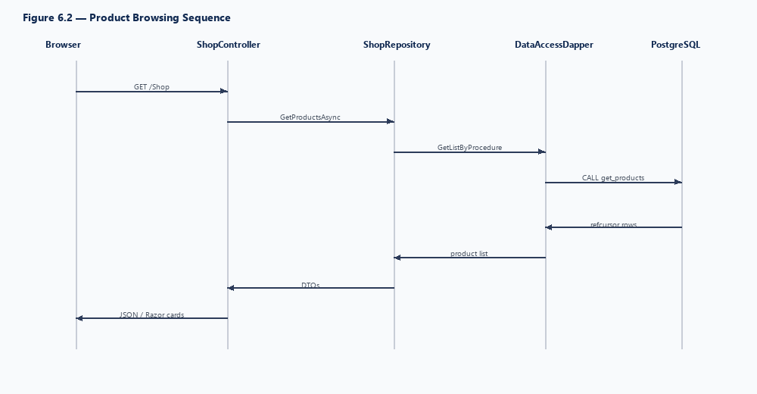

Figure 6.2: Request Flow for Product Browsing

6.8 Authentication Architecture
Both customers and employees receive JWTs stored in HTTP cookies. Token validation accepts the configured issuer and both audiences (admin and user). For paths under /admin and /api/admin the admin cookie is preferred; for other paths the user cookie is preferred with the admin cookie as fallback. The AdminAuthMiddleware requires a valid employee session on admin paths except login and access-denied, and the RequirePermission attribute checks the employee’s current permissions loaded from the database.
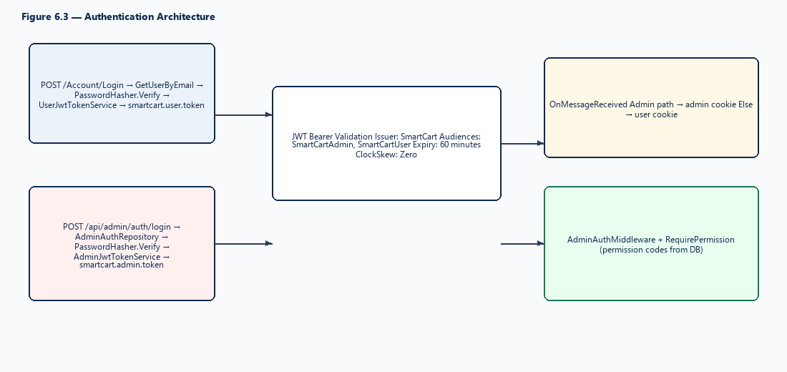

Figure 6.3: Authentication and Authorisation Architecture

6.9 Customer Shopping Workflow
The customer shopping workflow begins with browsing and ends with an order that the store can process. Login is required for the wishlist, cart, checkout and orders; if the customer is not logged in, the JSON endpoints return an unauthorised response and the customer is directed to log in.
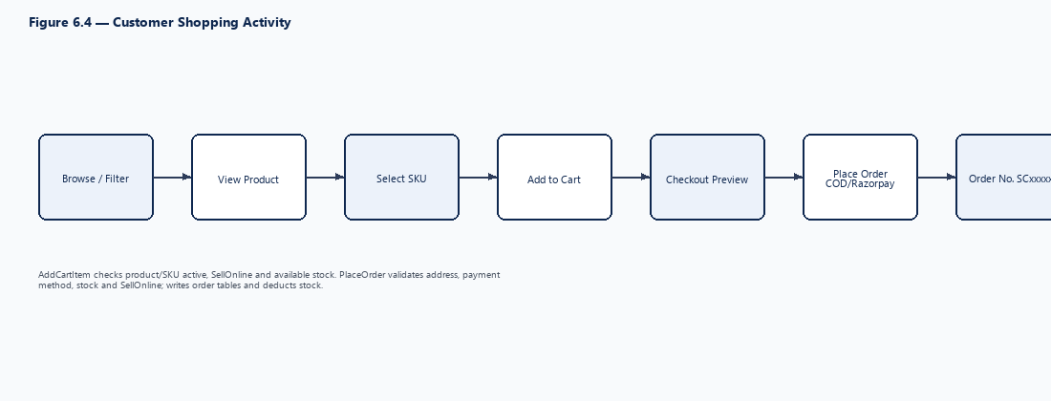

Figure 6.4: Customer Shopping Workflow

6.10 Order Lifecycle
Orders move through a defined set of statuses. Transitions are enforced by stored procedures, so an invalid transition is rejected regardless of the screen used.
Table 6.4: Order Status Transitions
From status | Action | To status | Performed by | Stock effect
— (new) | Place order | Placed | Customer | Deducted
Placed / Pending | Confirm | Confirmed | Admin | —
Confirmed | Mark shipped | Shipped | Admin | —
Confirmed / Shipped | Deliver | Delivered (payment collected) | Admin | —
Placed / Pending / Confirmed | Cancel | Cancelled | Admin | Restored
Placed / Pending | Cancel | Cancelled | Customer | Restored

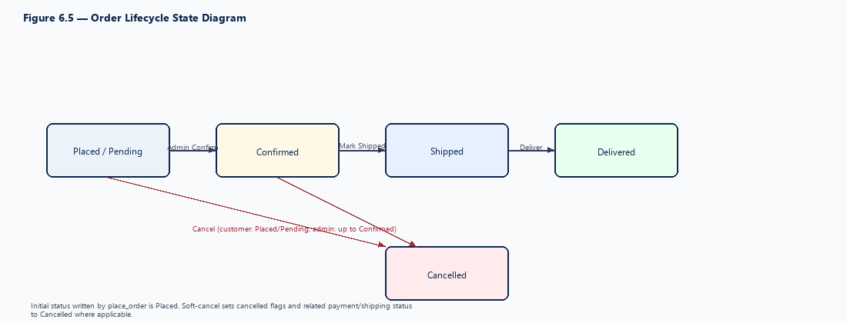

Figure 6.5: Order Lifecycle State Diagram

6.11 System Design Summary
SmartCart’s current design is a layered, single-application architecture in which the storefront and admin panel share one database. Controllers are thin, data access is encapsulated in repositories, and critical rules for stock and order status reside in stored procedures. Authentication is separated for customers and employees, and every admin action is protected by permission checks. The order lifecycle is explicit and reversible up to shipment.
Table 6.5: Key Design Decisions
Decision | Reason
Single MVC application for storefront and admin | Simpler deployment and shared data for one store
Separate customer and employee identities | Isolation of privileges and cookies
SKU-level stock in batch rows | Accurate stock per pack size; traceability to purchases
SellOnline at product and SKU level | Store decides what is sold online
Rules in stored procedures | Consistent enforcement of stock and status rules
Hybrid data access (Dapper + EF Core) | Stored procedures for transactional customer flows; EF Core for admin CRUD
Build and patch scripts | Controlled, repeatable schema changes without EF migrations
Soft delete | Preserve history and references

These decisions provide a stable base for the current single-store system and identify the points that would change in a multi-store design (store keys on inventory and orders, store-scoped roles).

CHAPTER 7: DATABASE DESIGN

7.1 Database Overview
The SmartCart database stores all catalogue, inventory, customer, order and security data for the store. It is organised into functional table groups: identity and access control, catalogue and variant attributes, media, purchasing and stock, cart and wishlist, orders with payments and shipping, and homepage content. A small number of tables exist in the scripts for future or legacy use but are not used by the current application; these are identified separately.
The schema is documented in a DBML file that can be imported into dbdiagram.io to regenerate the ER diagram, and it is created by SQL scripts rather than by Entity Framework migrations.

7.2 Database Technology
SmartCart uses a relational database management system. The current implementation uses PostgreSQL, accessed through Npgsql, Dapper and EF Core’s PostgreSQL provider. The connection string key in configuration is “PostgresConnection”. Storefront and customer-order logic use PostgreSQL stored procedures; most admin modules use Entity Framework Core. No user-defined SQL functions were found under Database-Postgres scripts.
CONFIRMED FROM PROJECT: The running application uses PostgreSQL. Program.cs registers UseNpgsql with connection string PostgresConnection; Ecommerce.csproj references Npgsql and Npgsql.EntityFrameworkCore.PostgreSQL; health check postgres_dapper is registered. Schema and procedures for the current stack are maintained under Ecommerce/Database-Postgres. Legacy SQL Server scripts under Ecommerce/Database/ remain for historical reference but are not wired in Program.cs. Final demonstration database engine: PostgreSQL (Database-Postgres/Database.sql via psql). Sections 7.2, 10.4 and software requirements are aligned to this implementation. Database engine: PostgreSQL on localhost (database name smartcart). If the examiner asks for the exact build, run SELECT version(); on the demonstration machine and write it on this line.

7.3 Database Design Principles
- Naming: newer tables use ID_{Entity} primary keys and FK_{Entity} foreign keys (e.g. ID_Product, FK_SubCategory); older storefront/order tables keep legacy keys (UserId, OrderId, CartId, PaymentId, ShippingId).
- Soft delete: most tables carry Cancelled, CancelledOn and CancelledReason; queries exclude cancelled rows.
- Online visibility: SellOnline (default 0) on Products and ProductVariants; storefront shows only rows that are active, not cancelled and SellOnline = 1.
- SKU-level stock: quantities are stored as rows in Stock keyed by FK_ProductVariant; available quantity is the sum of non-cancelled rows.
- Snapshots: OrderItems store product name, SKU, variant label and prices at the time of ordering.
- Uniqueness: unique product slug, SKU, barcode, customer e-mail, admin user name, permission code and module name.

7.4 Normalization
The schema is normalised to third normal form for master data. Categories, sub-categories, brands, products and SKUs are held in separate tables, so each fact is stored once. Variant axes (e.g. Size) and their values are stored independently and linked to SKUs through ProductVariantAttributes, which removes repeating groups. The role–permission relationship is resolved through the UserRolePermissions associative table.
Controlled denormalisation is used where history must be preserved: order lines copy product name, SKU and prices, and the order stores the delivery address fields, so that later catalogue or address changes do not alter past orders.

7.5 Entity Relationship Diagram
Figure 7.1 presents the ER diagram of the tables used by the current application. It can be generated directly from the project’s DBML file.
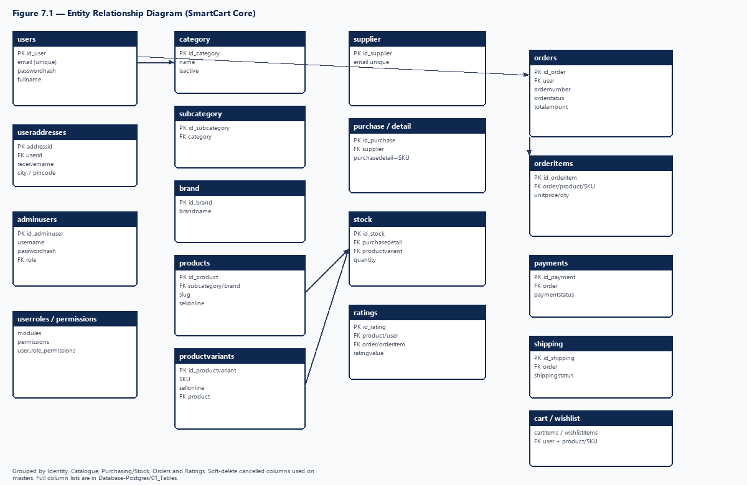

Figure 7.1: Entity Relationship Diagram of SmartCart

7.6 Core Tables Overview
Table 7.1: Database Table Groups
Group | Tables | Count | Used by current app
Identity & access | Users, UserAddresses, AdminUsers, UserRoles, Modules, Permissions, UserRolePermissions | 7 | Yes
Catalogue & attributes | Category, SubCategory, Brand, Products, ProductVariants, Variants, VariantValues, ProductVariantAttributes | 8 | Yes
Media | ProductMedia, SkuMedia | 2 | Yes
Purchasing & stock | Supplier, Purchase, PurchaseDetail, Stock | 4 | Yes
Cart & wishlist | Cart, CartItems, Wishlist, WishlistItems | 4 | Yes
Orders | Orders, OrderItems, Payments, Shipping | 4 | Yes
Homepage content | homepage_banners, homepage_banner_categories, homepage_categories, homepage_products | 4 | Yes
Legacy media | ProductImages, ProductVariantImages | 2 | Maintained / working
Schema only | ProductStatus, AuditLogs, Ratings, Sales, SalesDetail, SalesReturn, SalesReturnDetail | 7 | No (future)

In total the scripts define 42 tables, of which 33 are used by the current application. The following sections describe the principal groups; column-level definitions are given in Appendix B.
CONFIRMED FROM PROJECT: Database-Postgres/01_Tables defines 42 physical tables (users, useraddresses, category, subcategory, brand, products, productvariants, variants, variantvalues, productvariantattributes, productmedia, skumedia, productimages, productvariantimages, productstatus, supplier, purchase, purchasedetail, stock, cart, cartitems, wishlist, wishlistitems, orders, orderitems, payments, shipping, sales, salesdetail, salesreturn, salesreturndetail, adminusers, userroles, modules, permissions, userrolepermissions, homepage_banners, homepage_banner_categories, homepage_categories, homepage_products, ratings, auditlogs). Live use focuses on identity, catalogue, media, purchasing/stock, shopping bags, orders, POS sales and homepage; ratings, auditlogs, productstatus and legacy productimages have little or no active UI wiring. Table count: 42 physical tables in Database-Postgres/01_Tables (script source of truth). This matches the CREATE TABLE scripts used to build the demonstration database.

7.7 User / Authentication Tables
Table 7.2: User and Authentication Tables
Table | Primary key | Foreign keys | Purpose / important columns
Users | UserId | — | Storefront customers: UserName, FullName, Email (unique), PhoneNumber, PasswordHash, IsAdmin (unused), timestamps, Cancelled
UserAddresses | AddressId | UserId → Users | Saved delivery addresses: AddressType (Home/Work/Office/Other), ReceiverName, Phone, AddressLine, City, Pincode, Latitude, Longitude, IsDefault
AdminUsers | ID_AdminUser | FK_UserRole → UserRoles | Employees: UserName (unique), PasswordHash, FullName, Email, PhoneNumber, ProfileImageUrl, IsActive
UserRoles | ID_UserRole | — | Roles: RoleName (unique), Description, IsSystemRole, IsActive
Modules | ID_Module | — | Security modules: ModuleName (unique), DisplayName, DisplayOrder
Permissions | ID_Permission | FK_Module → Modules | Actions: PermissionName, PermissionCode (unique), DisplayOrder
UserRolePermissions | ID_UserRolePermission | FK_UserRole, FK_Permission | Role–permission matrix; unique (FK_UserRole, FK_Permission)

Customers and employees are deliberately stored in different tables. The IsAdmin column in Users is not used for admin authentication.
users (PK id_user): username, fullname, passwordhash, email (unique ux_users_email), phonenumber, isadmin, createdat, updatedat, cancelled…. useraddresses (PK addressid): userid→users, addresstype, receivername, phone, addressline, city, pincode, latitude, longitude, isdefault, createdat, cancelled…. adminusers (PK id_adminuser): fk_userrole→userroles, username unique, passwordhash, fullname, email, phonenumber, profileimageurl, isactive, cancelled…. userroles; modules; permissions; userrolepermissions (unique role+permission). Seed includes Billing.* permissions without a Billing controller. Column types follow Database-Postgres CREATE TABLE scripts (IDENTITY INT, TEXT, BOOLEAN, NUMERIC, TIMESTAMP). Permission codes are seeded from Database-Postgres seed scripts (Category.*, Product.*, Order.*, Inventory.*, Homepage.*, Employee.*, UserRole.*, Billing.* without Billing UI).

7.8 Product / Category Tables
Table 7.3: Product and Category Tables
Table | Primary key | Foreign keys | Purpose / important columns
Category | ID_Category | — | Top-level categories: Name, Description, ImageUrl, IsActive
SubCategory | ID_SubCategory | FK_Category → Category | Sub-categories: Name, Description, ImageUrl, IsActive
Brand | ID_Brand | — | Brands: BrandName, Description, ImageUrl, IsActive
Products | ID_Product | FK_SubCategory, FK_Brand (nullable) | Product header: Name, Slug (unique), Description, IsActive, SellOnline, timestamps
ProductVariants | ID_ProductVariant | FK_Product → Products | SKU: SKU (unique), Barcode (unique), VariantLabel, MRP, SellingPrice, UnitOfMeasure, UnitValue, IsDefault, MaxOrderQty, IsActive, SellOnline
Variants | ID_Variant | — | Variant axes (e.g. Size, Colour): Name (unique), DisplayOrder
VariantValues | ID_VariantValue | FK_Variant → Variants | Axis values; unique (FK_Variant, Name)
ProductVariantAttributes | ID_ProductVariantAttribute | FK_ProductVariant, FK_Variant, FK_VariantValue | Assigns one value per axis to a SKU; unique (FK_ProductVariant, FK_Variant)
ProductMedia | ID_ProductMedia | FK_Product → Products | Product images/video: MediaType, MediaUrl, DisplayOrder, IsPrimary
SkuMedia | ID_SkuMedia | FK_ProductSKU → ProductVariants | SKU images: MediaUrl, DisplayOrder, IsPrimary

category (PK id_category): name, description, isactive, imageurl, cancelled…. subcategory (PK id_subcategory, fk_category). brand (PK id_brand, brandname…). products (PK id_product): fk_subcategory, fk_brand, name, slug unique, description, isactive, sellonline, cancelled…. productvariants (PK id_productvariant): fk_product, sku unique, barcode unique nullable, variantlabel, mrp, sellingprice, maxorderqty, isactive, sellonline…. variants / variantvalues / productvariantattributes. Media: productmedia, skumedia. supplier for purchasing.

7.9 Cart / Wishlist Tables
Table 7.4: Cart and Wishlist Tables
Table | Primary key | Foreign keys | Purpose / important columns
Cart | CartId | UserId → Users | Cart header per customer; SessionKey (unique, nullable) reserved for guest carts; CreatedAt, Cancelled
CartItems | CartItemId | CartId → Cart; ProductId → Products; ProductVariantId → ProductVariants | Cart lines: Quantity, Price, CreatedAt, Cancelled
Wishlist | WishlistId | UserId → Users | Wishlist header per customer; SessionKey reserved; Cancelled
WishlistItems | WishlistItemId | WishlistId → Wishlist; ProductId → Products | Wishlisted products; Cancelled

The cart holds SKU-level lines because price and stock differ by SKU, whereas the wishlist holds products. The application currently passes only the logged-in UserId to the cart and wishlist procedures; the SessionKey columns are not used (guest shopping is future scope).
Table 7.5: Cart and Wishlist Stored Procedures
Area | Procedures
Cart | GetCart, GetBagCounts, AddCartItem, UpdateCartItem, RemoveCartItem, ClearCart
Wishlist | GetWishlist, GetWishlistStatus, ToggleWishlist, RemoveWishlistItem

cart (PK id_cart): fk_user, sessionkey nullable UUID, createdat. cartitems (PK id_cartitem): fk_cart, fk_product, fk_productvariant, quantity, price. wishlist (PK id_wishlist): fk_user, sessionkey, cancelled…. wishlistitems (PK id_wishlistitem): fk_wishlist, fk_product, cancelled…. Storefront APIs require logged-in UserId; storefront cart and wishlist require a logged-in customer account (verified working).

7.10 Order / Order Item Tables
Table 7.6: Order Tables
Table | Primary key | Foreign keys | Purpose / important columns
Orders | OrderId | UserId → Users | Order header: OrderNumber, OrderDate, TotalAmount, OrderStatus, ShippingAddress, ReceiverName, Phone, AddressLine, City, Pincode, PaymentMethod, Cancelled, CancelledReason
OrderItems | ID_OrderItem | FK_Order → Orders; FK_Product; FK_ProductVariant | Line snapshot: ProductName, SKU, VariantLabel, Quantity, UnitPrice, TotalPrice
Payments | PaymentId | OrderId → Orders | PaymentDate, PaymentAmount, PaymentStatus, PaymentMethod; created by PlaceOrder and updated on delivery
Shipping | ShippingId | OrderId → Orders | ShippingAddress, ShippingDate, EstimatedDeliveryDate, ShippingStatus

Table 7.7: Order Stored Procedures
Area | Procedures
Customer | GetCheckoutPreview, PlaceOrder, GetOrders, GetOrder, CancelOrder
Admin | GetAdminOrders, GetAdminOrder, AdminConfirmOrder, AdminUpdateOrderStatus, AdminDeliverOrder, AdminCancelOrder

The order number is generated as “SC” followed by the zero-padded order identifier (example: SC000087). place_order accepts COD and RAZORPAY. Unsupported methods are rejected; UPI is not an accepted payment method in the procedure.
orders (PK id_order): fk_user, orderdate, totalamount, orderstatus, shippingaddress, paymentmethod, cancelled…, ordernumber, receivername, phone, addressline, city, pincode. orderitems (PK id_orderitem): fk_order, fk_product, fk_productvariant, productname, variantlabel, sku, unitprice, quantity, linetotal. payments and shipping link to the order as defined in payments.sql and shipping.sql. place_order writes these for COD and deducts stock. Status values used by SmartCart procedures: OrderStatus = Placed, Pending, Confirmed, Shipped, Delivered, Cancelled. PaymentStatus = Pending, Paid, Cancelled. ShippingStatus = Pending, Shipped, Out for delivery, In Transit, Delivered, Cancelled. Order number format: 'SC' + order id zero-padded to 6 digits (example: SC000087). place_order accepts payment methods COD and RAZORPAY; it creates the order and order items, writes payment and shipping rows, deducts SKU stock, and sets initial orderstatus to Placed.

7.11 Inventory / Stock Tables
Table 7.8: Purchasing and Stock Tables
Table | Primary key | Foreign keys | Purpose / important columns
Supplier | ID_Supplier | — | Name, CompanyName, Email (unique), Phone, State, District, City, Address, Pincode, IsActive
Purchase | ID_Purchase | FK_Supplier → Supplier | Purchase header: PurchaseDate, InvoiceNumber, TotalAmount, Notes, EnterBy, cancellation fields
PurchaseDetail | ID_PurchaseDetail | FK_Purchase; FK_ProductVariant | Purchase lines: Quantity, PurchasePrice, MRP, ExpiryDate
Stock | ID_Stock | FK_PurchaseDetail; FK_ProductVariant | Stock batch rows: Quantity, CreatedOn, EnterBy, Cancelled

Each purchase line inserts a stock batch for its SKU. Inventory adjustments insert an additional Stock row. The quantity available for sale is the sum of Quantity over non-cancelled Stock rows of the SKU. PlaceOrder deducts stock and the cancel procedures restore it, always at SKU level.
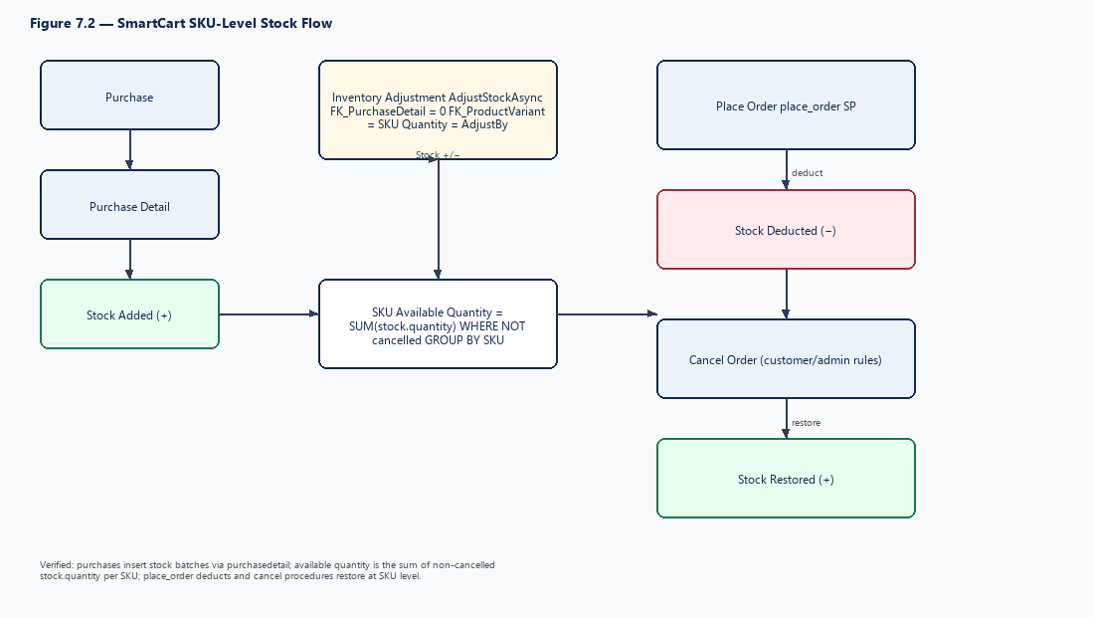

Figure 7.2: Stock Flow at SKU Level
Stock rules (verified working): purchases insert stock batches through purchasedetail; InventoryRepository.AdjustStockAsync inserts a stock row with FK_PurchaseDetail = 0, FK_ProductVariant = SKU and Quantity = AdjustBy; available quantity = SUM(stock.quantity) for non-cancelled rows grouped by SKU; place_order deducts stock and cancel procedures restore it at SKU level. Purchase→stock and order→stock flows were tested successfully.

7.12 Relationships and Foreign Keys
Table 7.9: Principal Relationships
Parent | Child | Cardinality | Foreign key
Category | SubCategory | 1 : N | SubCategory.FK_Category
SubCategory | Products | 1 : N | Products.FK_SubCategory
Brand | Products | 1 : N (optional) | Products.FK_Brand
Products | ProductVariants | 1 : N | ProductVariants.FK_Product
ProductVariants | ProductVariantAttributes | 1 : N | FK_ProductVariant
Variants | VariantValues | 1 : N | VariantValues.FK_Variant
Supplier | Purchase | 1 : N | Purchase.FK_Supplier
Purchase | PurchaseDetail | 1 : N | PurchaseDetail.FK_Purchase
ProductVariants | Stock | 1 : N | Stock.FK_ProductVariant
Users | Orders | 1 : N | Orders.UserId
Orders | OrderItems / Payments / Shipping | 1 : N | FK_Order / OrderId
Users | Cart, Wishlist, UserAddresses | 1 : N | UserId
UserRoles | AdminUsers | 1 : N | AdminUsers.FK_UserRole
UserRoles ↔ Permissions | UserRolePermissions | M : N | FK_UserRole, FK_Permission

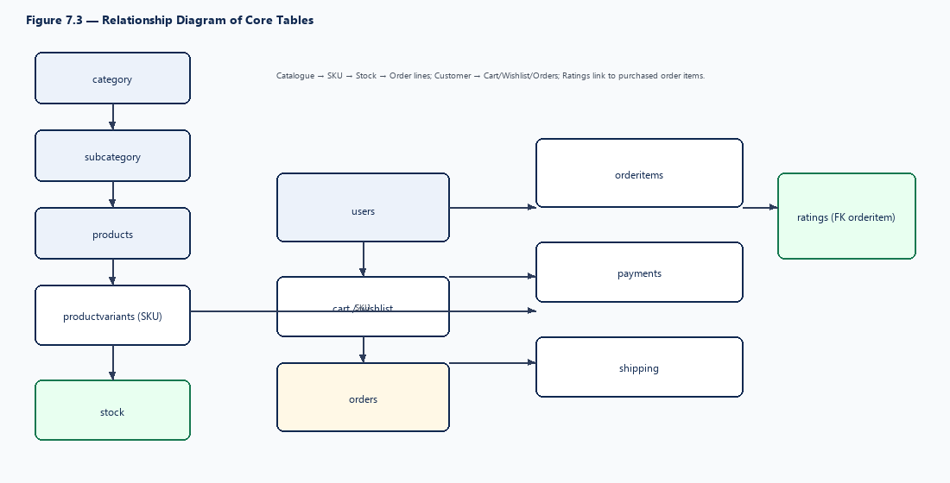

Figure 7.3: Relationship Diagram of Core Tables

7.13 Stored Procedure Architecture
Stored procedures are grouped by area in the Database/02_Procedures folder and are applied by module-wise patch files using CREATE OR ALTER, so they can be re-applied safely. Procedures are named by action (for example GetProducts, PlaceOrder, AdminDeliverOrder) and return a common response shape (StatusCode, ResponseCode, ResponseMsg) interpreted by the repositories.
Table 7.10: Stored Procedures Used by the Application
Area | Procedures
Shop | GetProducts, GetProductDetails, GetShopFilters
Customer auth | RegisterUser, GetUserByEmail, GetUserById
Cart / Wishlist | AddCartItem, UpdateCartItem, RemoveCartItem, ClearCart, GetCart, GetBagCounts; ToggleWishlist, GetWishlist, GetWishlistStatus, RemoveWishlistItem
Customer orders | GetCheckoutPreview, PlaceOrder, GetOrders, GetOrder, CancelOrder
Admin orders | GetAdminOrders, GetAdminOrder, AdminConfirmOrder, AdminUpdateOrderStatus, AdminDeliverOrder, AdminCancelOrder

Older admin procedures with the prefix “Pro” (e.g. ProCategoryListSelect) exist in the scripts but are not called by the current admin repositories, which use EF Core.
place_order (PostgreSQL procedure): validates the signed-in user, delivery address, phone and pincode; accepts payment methods COD and RAZORPAY; checks SellOnline and SKU stock; creates rows in orders, orderitems, payments and shipping; deducts stock; returns the new order id/order number (SC######). Source: Database-Postgres/02_Procedures/02_Users/05_Orders/place_order.sql.

7.14 Database Design Summary
The SmartCart database is a normalised relational schema organised into functional groups, with SKU-level stock, order snapshots and a role–permission security model. Business rules for online sale, stock and order status are enforced in stored procedures, while soft-delete columns preserve history. The schema is maintained through re-runnable build and patch scripts.
Table 7.11: Tables Present but Not Used by the Current Application
Table(s) | Status | Note
Ratings | Schema only | No rating or review user interface; future scope
AuditLogs | Schema only | No application writes found
ProductStatus | Schema only | Not used by the product module
Sales, SalesDetail, SalesReturn, SalesReturnDetail | Schema only | Point-of-sale counter sales and returns; future scope
ProductImages | Legacy | Replaced by ProductMedia
ProductVariantImages | Maintained / working | SkuMedia is the live SKU media table

Table 7.12: Database Scripts
Script | Purpose
RunDatabase.bat → Database.sql | Full build: create database, tables, patches, seed and all procedures
RunPatch.bat → Database-Patch.sql | Incremental: table patches (existence checks), seed patch, procedure patches
05_Seed | Modules, permissions, Admin role, role permissions, development admin user, optional sample catalogue

CHAPTER 8: MODULE DESIGN AND FUNCTIONAL SPECIFICATION

8.1 Module Overview
SmartCart is divided into customer (storefront) modules and admin modules. Each module is described in this chapter by purpose, actors, inputs, processing, outputs, business rules and database interaction. The implementation status of every module is shown in Table 8.1.
Table 8.1: Module Inventory and Status
Area | Module | Data access | Status
Customer | Registration / Login | Dapper + SP | ✓ Implemented
Customer | Home page | Dapper | ✓ Implemented
Customer | Shop listing, filters, product details | Dapper + SP | ✓ Implemented
Customer | Wishlist | Dapper + SP | ✓ Implemented
Customer | Cart | Dapper + SP | ✓ Implemented
Customer | Checkout and orders | Dapper + SP | ✓ Implemented
Admin | Authentication | EF Core | ✓ Implemented
Admin | Dashboard | — | ◐ Partial (static)
Admin | Category, sub-category, brand | EF Core | ✓ Implemented
Admin | Product, SKU, variants, media | EF Core | ✓ Implemented
Admin | Homepage management | EF Core | ✓ Implemented
Admin | Suppliers, purchases, inventory | EF Core | ✓ Implemented
Admin | Order management | Dapper + SP | ✓ Implemented
Admin | Employees, roles, permissions | EF Core | ✓ Implemented
Admin | Customer management, reports, billing | — | → Planned

Re-checked Controllers: Account/Shop/Cart/Wishlist/Checkout/Orders/Reviews IMPLEMENTED; Admin Auth/Category/SubCategory/Brand/Product/ProductVariant/Variant/VariantValue/Supplier/Purchase/Inventory/Order/Homepage/Employee/UserRole/Sale/SalesReturn/Review/Dashboard IMPLEMENTED. All listed modules responded successfully during integration testing.

8.2 Authentication Module
The authentication module provides separate login mechanisms for customers and admin employees.
Purpose | Identify customers and employees and issue signed tokens that authorise subsequent requests.
Actors | Customer, Admin Employee
Inputs | Customer: e-mail and password. Employee: user name and password.
Processing | Look up the account (GetUserByEmail for customers; AdminUsers via EF Core for employees); verify the password with the Identity password hasher; generate a JWT with the relevant audience; write it to the respective cookie.
Outputs | Authenticated session (cookie); error message on failure; logout clears the cookie.
Business rules | Customers and employees are separate identities. Cancelled or inactive accounts cannot log in. Admin paths require a valid admin session except login and access-denied pages.
Database | Users; AdminUsers, UserRoles, UserRolePermissions, Permissions, Modules
Endpoints | POST /Account/Login, /Account/Register; POST /api/admin/auth/login, GET /api/admin/auth/me, logout

Table 8.2: Customer vs Employee Authentication
Item | Customer | Employee
Token service | UserJwtTokenService | AdminJwtTokenService
Cookie | UserAuthHelper.TokenCookieName | AdminAuthHelper.TokenCookieName
Audience | UserAudience (SmartCartUser) | Admin Audience
Guard | Login required for bag, checkout, orders | AdminAuthMiddleware + RequirePermission

8.3 Customer Registration Module
Purpose | Create a customer account for the storefront.
Actors | Visitor
Inputs | Full name, e-mail, phone number and password (registration/login forms on /Account).
Processing | Validate the model; hash the password; call RegisterUser.
Outputs | Account created and customer directed to log in / logged in; validation messages on error.
Business rules | E-mail must be unique (unique index on Users.Email). Password is never stored in plain text.
Database | Users (RegisterUser)

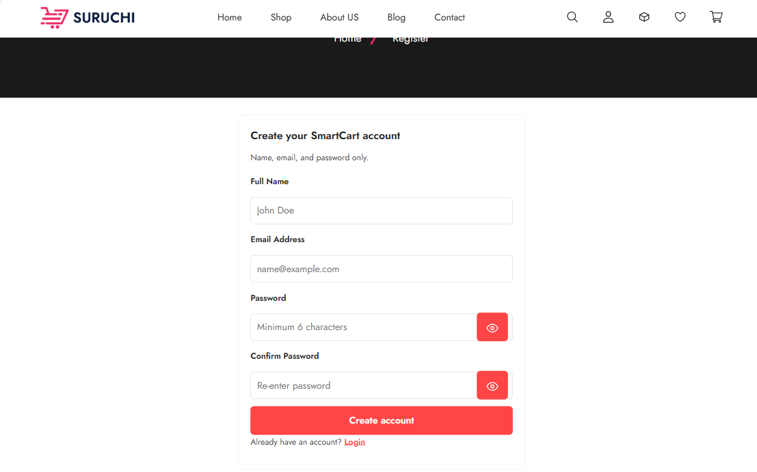
Figure 8.1: SmartCart Customer Registration Interface
Description: Registration form with all input fields and the submit button; optionally show a validation message.

8.4 Customer Login Module
Purpose | Authenticate a registered customer.
Actors | Customer
Inputs | E-mail, password.
Processing | GetUserByEmail → verify hash → UserJwtTokenService → cookie.
Outputs | Customer logged in; header shows account and bag counts (GetBagCounts).
Business rules | Invalid credentials produce a generic error message without revealing which field is wrong.
Database | Users

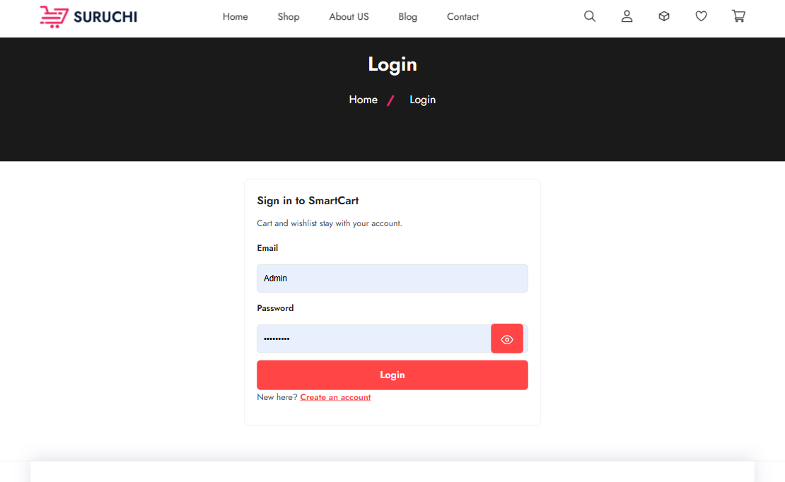
Figure 8.2: SmartCart Customer Login Interface
Description: Login form with e-mail and password fields and link to registration.

8.5 Product Catalogue Module
Purpose | Present online-sellable products to customers.
Actors | Visitor, Customer
Inputs | Page index, page size, category/sub-category, brand, price range, sort option.
Processing | ShopController posts the filter model to ShopRepository.GetProductListAsync, which executes GetProducts.
Outputs | Paged list of product cards with image, name, price and availability.
Business rules | Only products and SKUs that are active, not cancelled and SellOnline = 1 are listed. Price and stock are derived from SKUs and summed stock.
Database | Products, ProductVariants, Stock, ProductMedia, SkuMedia, SubCategory, Category, Brand

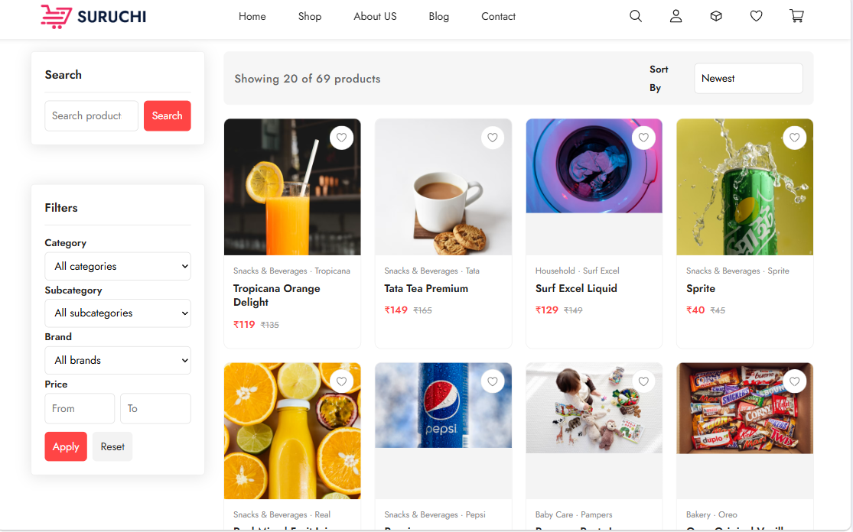
Figure 8.3: SmartCart Product Listing Interface
Description: Product grid with several product cards, category navigation and paging.

8.6 Product Search and Filtering
Purpose | Narrow the product list to what the customer is looking for.
Actors | Visitor, Customer
Inputs | Category, brand, price range, sort order; search text.
Processing | GetShopFilters supplies the available filter values; the selected values are sent with GetProducts.
Outputs | Filtered and sorted product list; filter panel reflecting current selections.
Business rules | Filter values are derived only from sellable products. Unused shop inputs (ratings, gender) are not applied.
Database | GetShopFilters, GetProducts

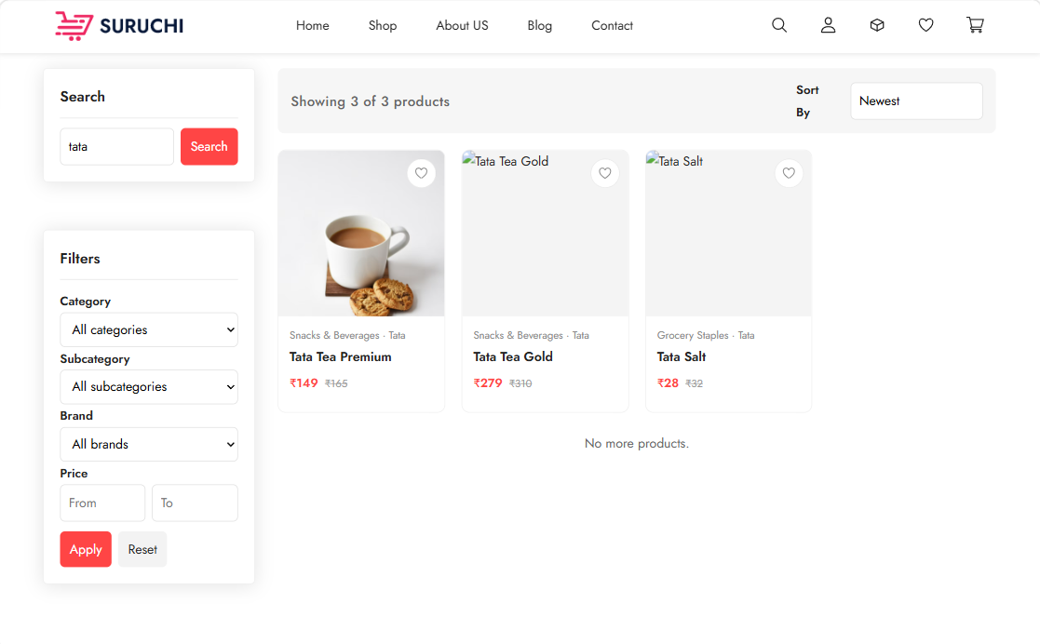
Figure 8.4: SmartCart Product Search and Filter Interface
Description: Listing with category, brand and price filters applied and the result updated.

8.7 Product Details
Purpose | Show complete information about one product and its SKUs.
Actors | Visitor, Customer
Inputs | Product slug from the URL; SKU selection.
Processing | Details page loads, then GET /Shop/GetProduct/{slug} executes GetProductDetails.
Outputs | Name, description, images/video, SKU options with MRP and selling price, availability, add-to-cart and wishlist actions.
Business rules | Only sellable SKUs are offered; quantity limited by stock and MaxOrderQty.
Database | Products, ProductVariants, ProductVariantAttributes, ProductMedia, SkuMedia, Stock

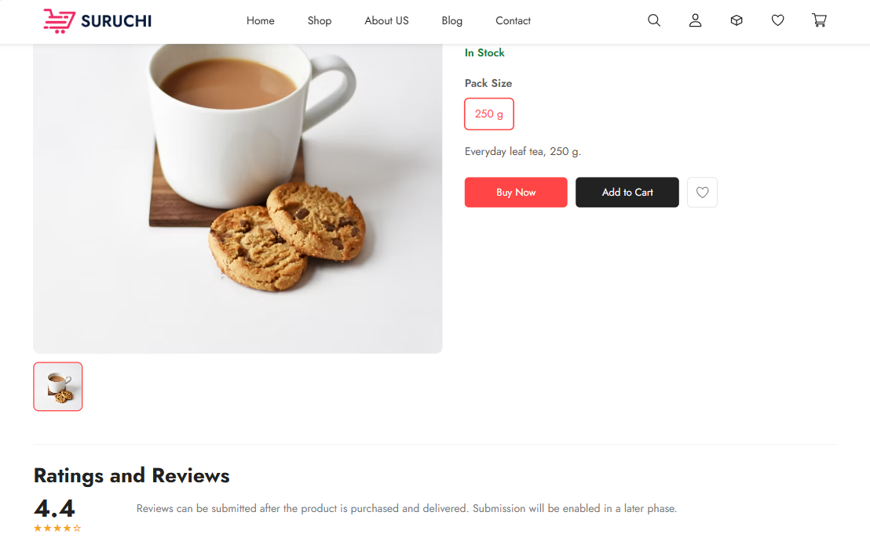
Figure 8.5: SmartCart Product Details Interface
Description: Product page with image gallery, SKU selector, price and Add to Cart / wishlist buttons.

8.8 Shopping Cart
Purpose | Hold SKUs selected by the customer before checkout.
Actors | Customer (logged in)
Inputs | SKU, quantity; update and remove actions.
Processing | AddCartItem, UpdateCartItem, RemoveCartItem, ClearCart and GetCart through Dapper; unauthenticated calls return HTTP 401 JSON.
Outputs | Cart lines with price and totals; updated bag count.
Business rules | SKU must be active, not cancelled and SellOnline; quantity must not exceed available stock or MaxOrderQty.
Database | Cart, CartItems, ProductVariants, Stock

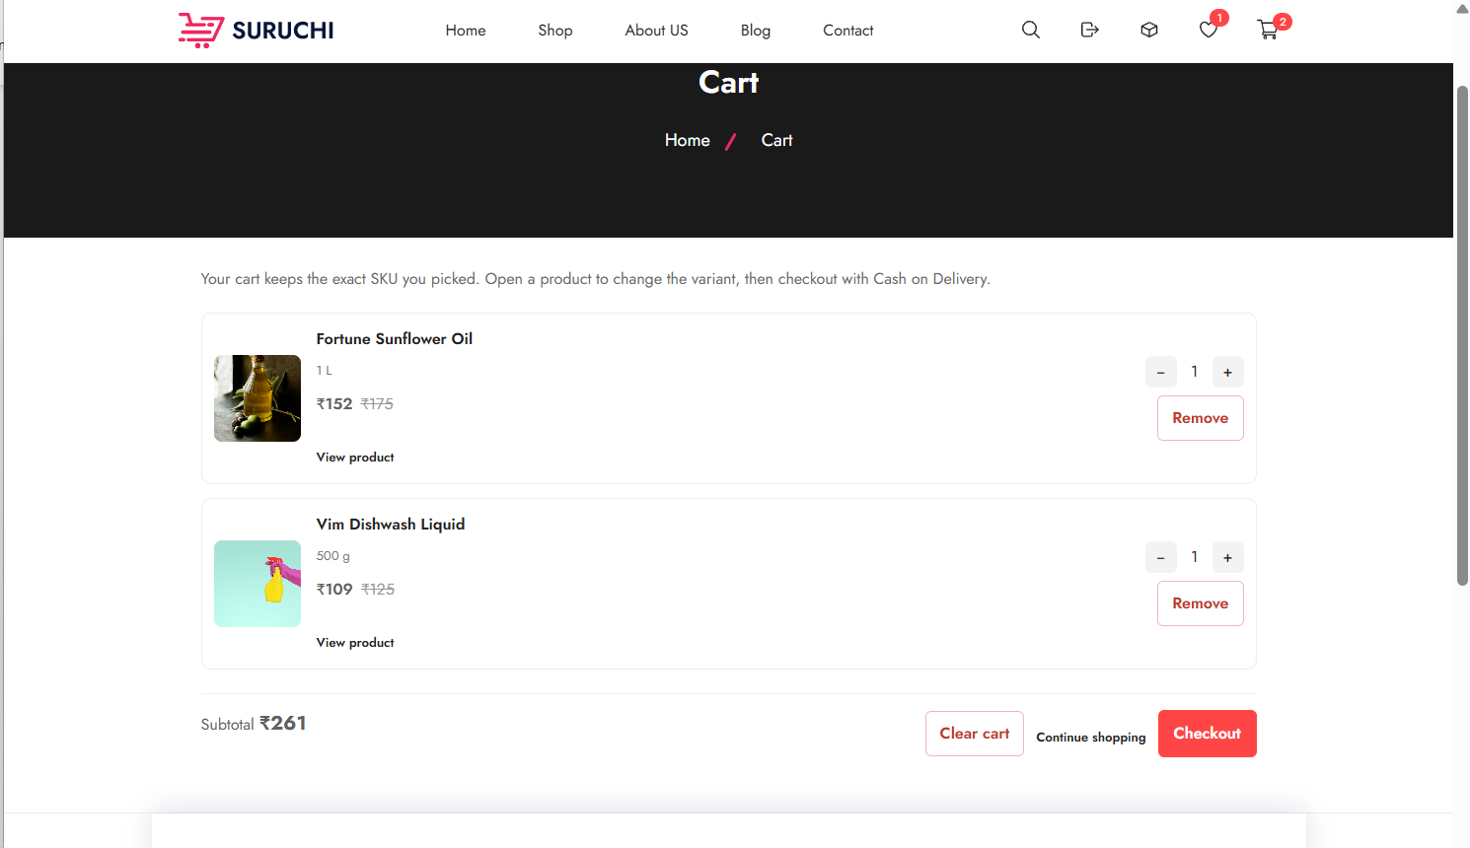
Figure 8.6: SmartCart Shopping Cart Interface
Description: Cart with at least two items, quantity controls, line totals and cart total.

8.9 Wishlist
Purpose | Let customers save products for later.
Actors | Customer (logged in)
Inputs | Product; toggle or remove action.
Processing | ToggleWishlist adds or removes; GetWishlistStatus marks wishlisted products; GetWishlist lists them.
Outputs | Wishlist page; heart/wishlist indicator on products; bag counts.
Business rules | Wishlist holds products (not SKUs); login required.
Database | Wishlist, WishlistItems, Products

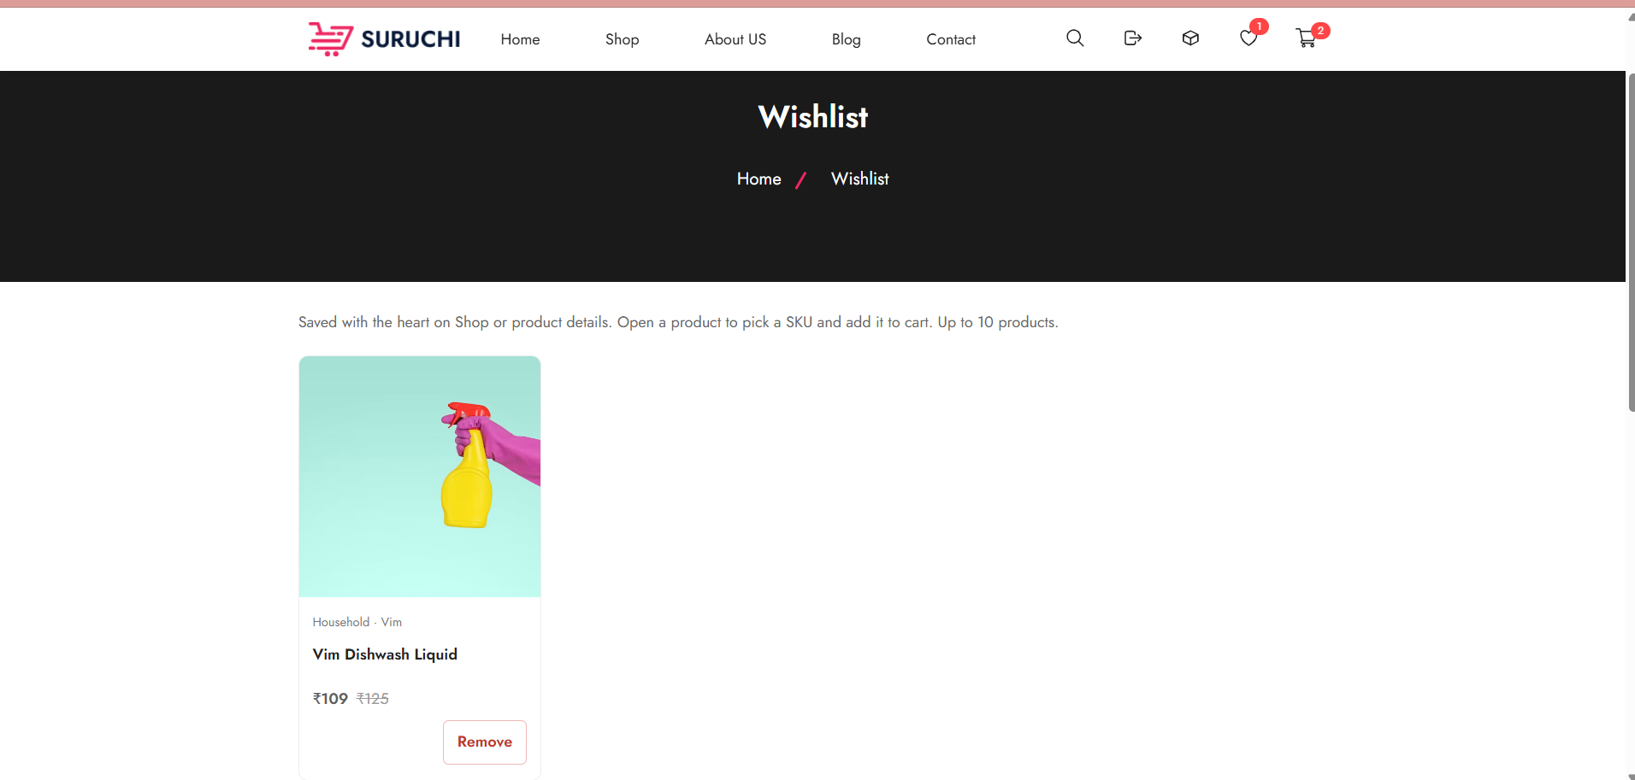

Figure 8.7: SmartCart Wishlist Interface
Description: Wishlist with saved products and actions to view or remove them.

8.10 Checkout
Purpose | Confirm cart contents, delivery address and payment method before placing the order.
Actors | Customer
Inputs | Delivery address (saved or new: receiver name, phone, address line, city, pincode); payment method.
Processing | GetCheckoutPreview returns the cart summary and addresses.
Outputs | Checkout summary with totals and address selection.
Business rules | place_order accepts COD and RAZORPAY. Address, phone and pincode formats are validated before the order is created.. Address, phone and pincode formats are validated.
Database | CartItems, UserAddresses, ProductVariants, Stock

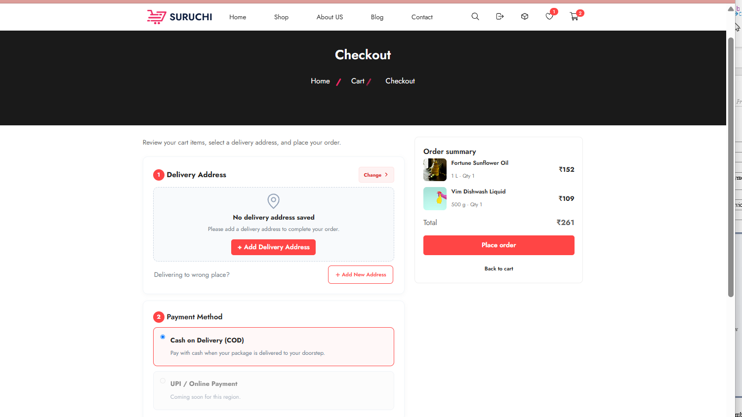
Figure 8.8: SmartCart Checkout Interface
Description: Checkout with address selection and Cash on Delivery selected.

8.11 Order Placement
Purpose | Convert the cart into an order.
Actors | Customer
Inputs | Confirmed checkout data.
Processing | PlaceOrder validates stock and eligibility, inserts Orders, OrderItems, Payments and Shipping, deducts stock and clears the cart.
Outputs | Order number (“SC” + padded ID) and confirmation message.
Business rules | Entire order is rejected if any line fails validation.
Database | Orders, OrderItems, Payments, Shipping, Stock, Cart, CartItems

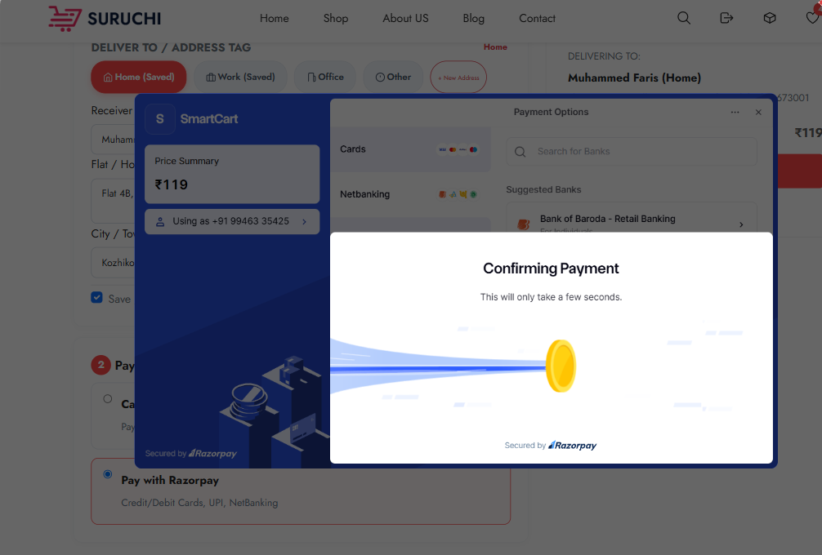
Figure 8.9: SmartCart Order Placement Confirmation
Description: Screen or message shown after successful placement, including the order number.

8.12 Order History
Purpose | Show the customer’s past and current orders.
Actors | Customer
Inputs | Logged-in customer ID; optional paging.
Processing | GetOrders returns the customer’s orders.
Outputs | List with order number, date, amount and status.
Business rules | Customers see only their own orders.
Database | Orders, OrderItems

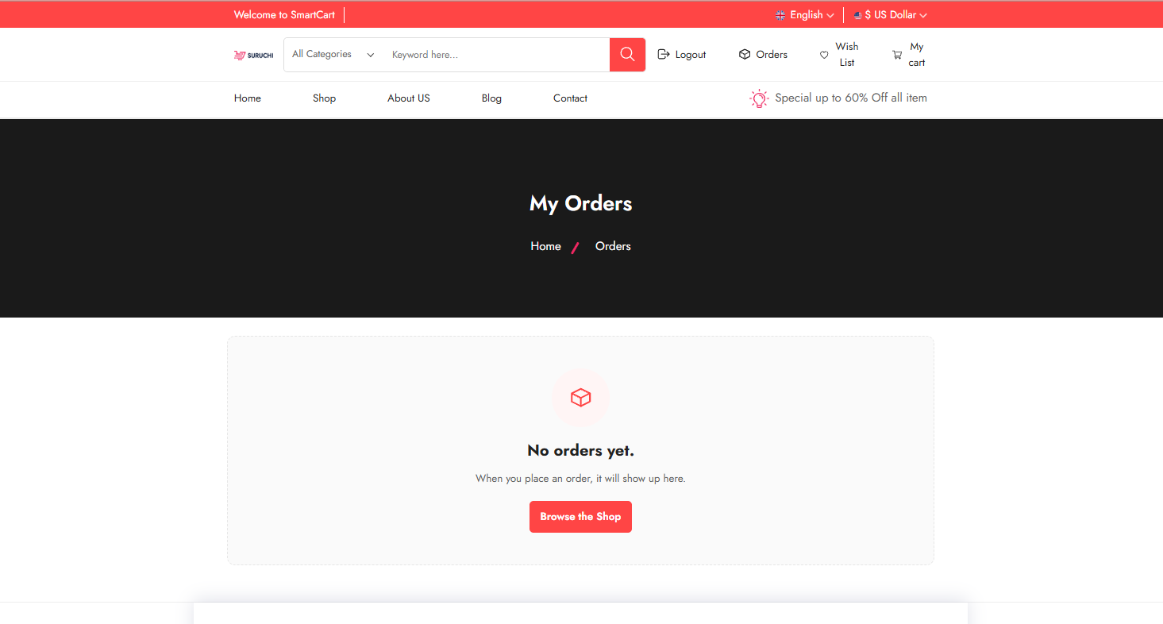

Figure 8.10: SmartCart Customer Order History Interface
Description: Order list showing orders in different statuses.

8.13 Customer Order Details / Tracking
Purpose | Show details of one order and allow cancellation where permitted.
Actors | Customer
Inputs | Order ID; cancel request with reason.
Processing | GetOrder returns header, lines, payment and shipping status; CancelOrder cancels and restocks.
Outputs | Order detail with current status; cancelled order after cancellation.
Business rules | Customer may cancel only while the order is Placed/Pending. Order status tracking shows the current status on My Orders / Order Details; carrier tracking numbers are listed as a future enhancement.
Database | Orders, OrderItems, Payments, Shipping, Stock

Figure — SmartCart Customer Order Details

[USER: INSERT APPLICATION SCREENSHOT HERE — /Orders → open one order]
Figure 8.11: SmartCart Customer Order Details Interface
Description: Order detail with items, totals, status and the Cancel option for an early-status order.

8.14 Admin Authentication
Purpose | Authenticate store employees for the admin panel.
Actors | Admin Employee
Inputs | User name, password.
Processing | AdminAuthRepository verifies credentials; AdminJwtTokenService issues the admin cookie; AdminAuthMiddleware protects /admin and /api/admin.
Outputs | Admin session; menu filtered by permissions; access-denied page when a permission is missing.
Business rules | Inactive or cancelled employees cannot log in. Permissions are loaded from the database on each protected request.
Database | AdminUsers, UserRoles, UserRolePermissions, Permissions

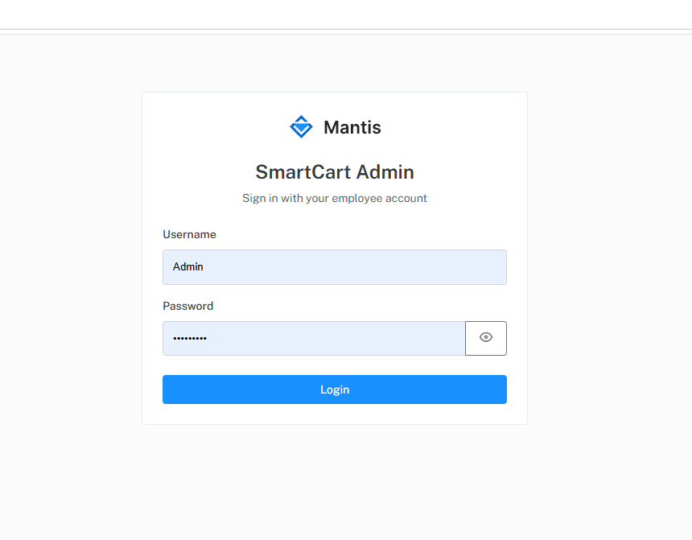

Figure 8.12: SmartCart Admin Login Interface
Description: Admin login screen (/admin/login).

8.15 Admin Dashboard
Purpose | Landing page of the admin panel.
Actors | Admin Employee
Inputs | —
Processing | Renders the dashboard view within the admin layout.
Outputs | Dashboard page with navigation to permitted modules.
Business rules | Requires Dashboard.View permission.
Status | ✓ Implemented — Admin Dashboard is available to authorised employees and presents summary information for store operations.; live figures are wired where Dashboard endpoints provide data.

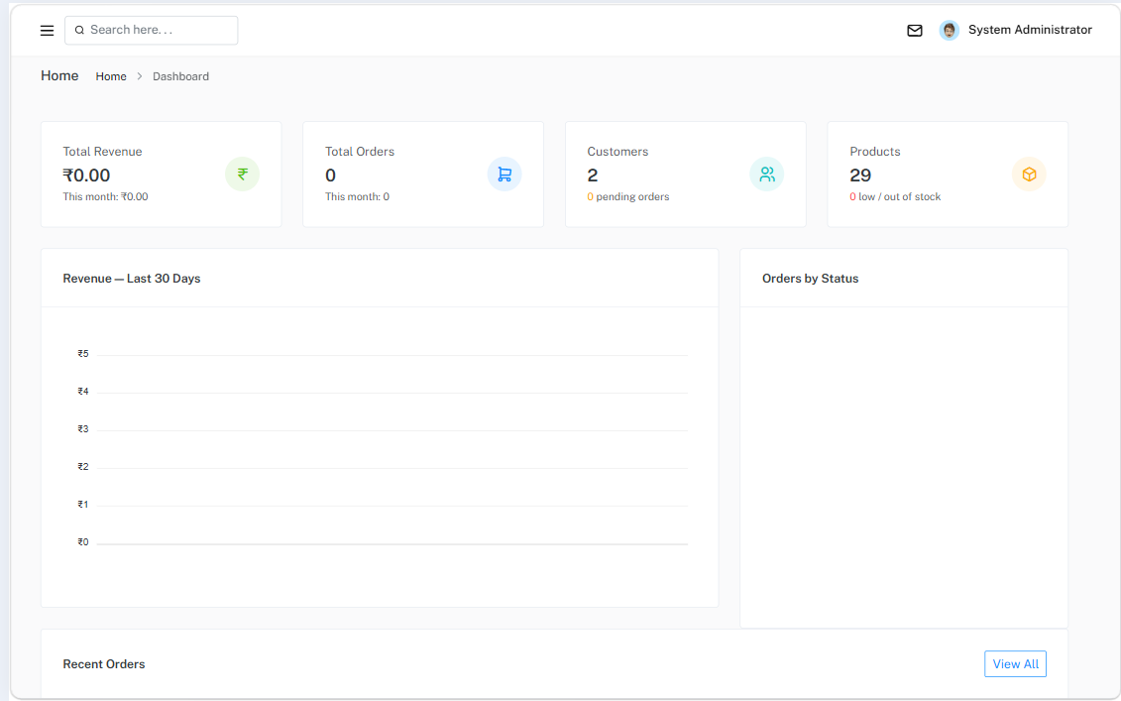
Figure 8.13: SmartCart Admin Dashboard
Description: Admin dashboard with sidebar navigation. KPI and summary figures are available from the Dashboard module for authorised employees.

8.16 Product Management
Purpose | Maintain products, SKUs, variant attributes and media.
Actors | Admin Employee with Products permissions
Inputs | Product: sub-category, brand, name, slug, description, IsActive, SellOnline. SKU: SKU, barcode, label, MRP, selling price, unit, MaxOrderQty, SellOnline, attributes. Media files.
Processing | EF Core repositories; paged AJAX list; CommonImageService for uploads.
Outputs | Product list, product/SKU forms, media gallery.
Business rules | Unique slug, SKU and barcode; images jpg/jpeg/png/webp ≤ 2 MB; one product video mp4/webm ≤ 20 MB; max 5 product media; soft delete.
Database | Products, ProductVariants, Variants, VariantValues, ProductVariantAttributes, ProductMedia, SkuMedia

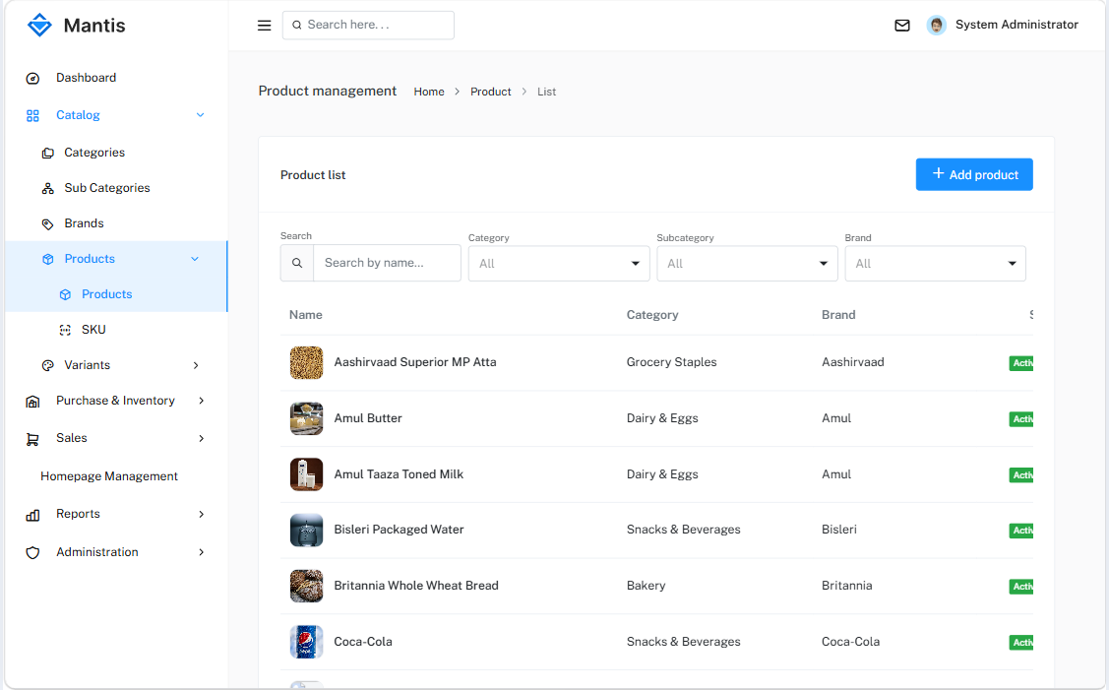

Figure 8.14: SmartCart Admin Product Management Interface
Description: Product list with status columns, or the product form with SKU and media sections.

8.17 Category Management
Purpose | Maintain the category hierarchy and brands.
Actors | Admin Employee with Categories / SubCategories / Brands permissions
Inputs | Name, description, image, IsActive; parent category for sub-categories.
Processing | EF Core CRUD; paged, searchable list with image thumbnails; modal forms.
Outputs | Category, sub-category and brand lists.
Business rules | Soft delete via Cancelled; sub-category must belong to an existing category.
Database | Category, SubCategory, Brand

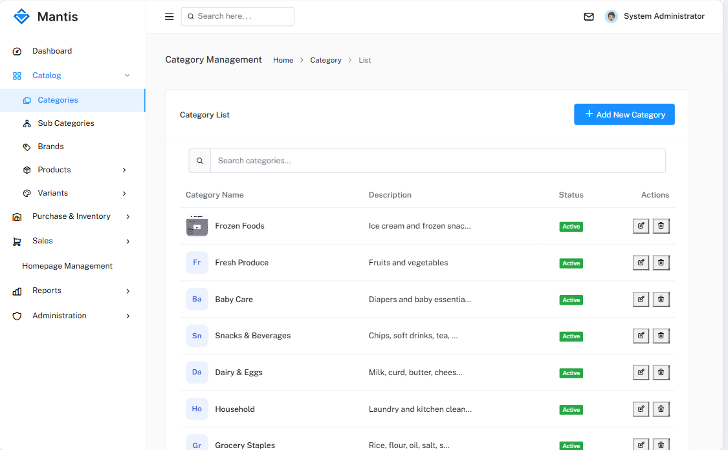
Figure 8.15: SmartCart Admin Category Management Interface
Description: Category list with images, search and paging; optionally the Add/Edit modal.

8.18 Order Management
Purpose | Process customer orders.
Actors | Admin Employee with Orders permissions
Inputs | Order filters; actions confirm, mark shipped, deliver, cancel (with reason).
Processing | AdminOrderRepository (Dapper) calls GetAdminOrders, GetAdminOrder, AdminConfirmOrder, AdminUpdateOrderStatus, AdminDeliverOrder, AdminCancelOrder.
Outputs | Order list and detail with available actions.
Business rules | Transitions as in Table 6.4; deliver marks payment collected; cancel restocks; admin cannot create orders or edit lines.
Database | Orders, OrderItems, Payments, Shipping, Stock

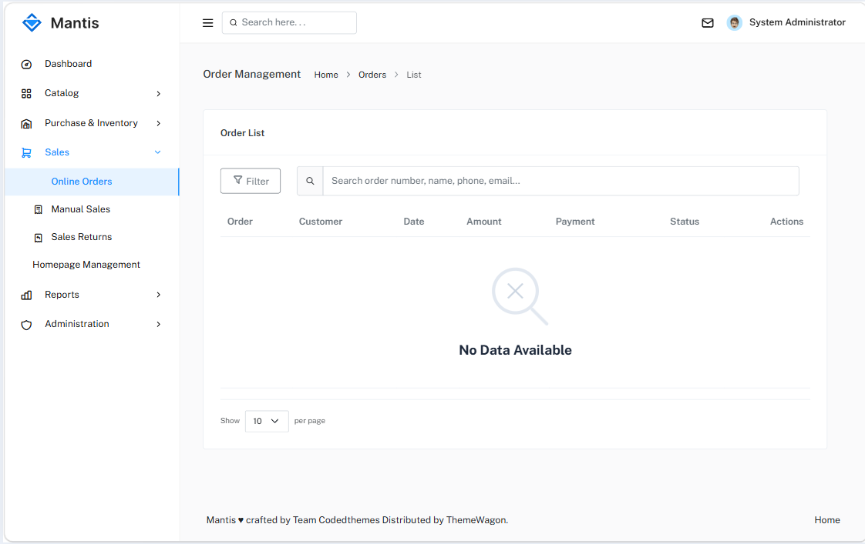
Figure 8.16: SmartCart Admin Order Management Interface
Description: Order list with status filter, or order detail with action buttons.

8.19 Inventory / Additional Admin Features
Table 8.3: Additional Admin Modules
Module | Main functions | Status
Suppliers | Create/edit suppliers with state/city from the CountryStateCity API | ✓
Purchases | Record purchase header and lines; each line creates a stock batch | ✓
Inventory adjustment | Adjust stock of a SKU by inserting a stock row | ✓
Brands; variant axes and values | Maintain brands and attribute axes/values for SKUs | ✓
Homepage management | Banners (with category links), featured categories, featured products | ✓
Employees | Create/edit employees and assign a role | ✓
User roles and permissions | Create roles and assign module permissions | ✓
Customer management | View/manage customers from admin | ✓
Reports; billing and invoices | Sales/stock reports; billing module (permissions seeded only) | ✓

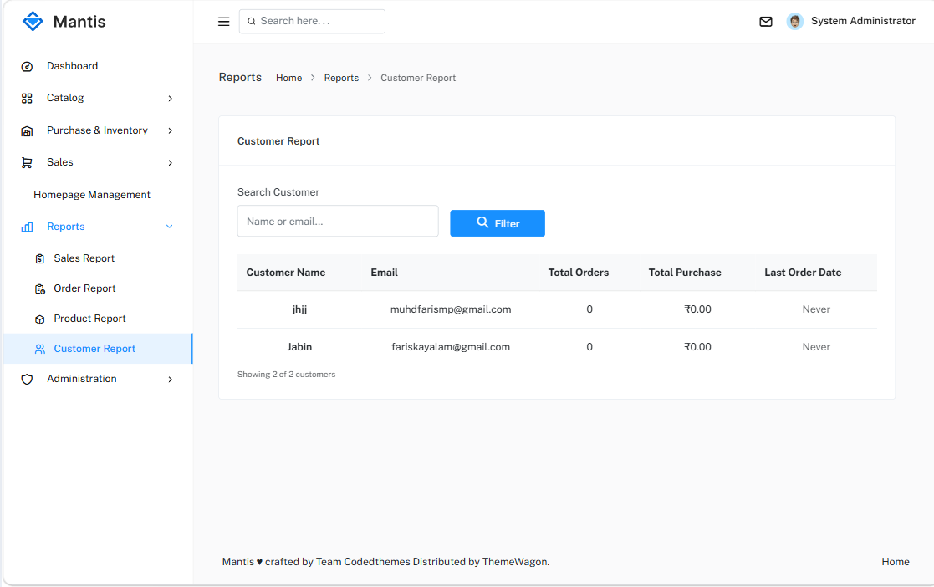
Figure 8.17: SmartCart Admin Inventory and Purchase Interface
Description: Purchase entry with supplier and lines, or the inventory adjustment screen showing stock by SKU.

CHAPTER 9: USER INTERFACE AND SCREENSHOTS

9.1 UI Design Overview
SmartCart has two user interfaces. The storefront is designed for customers: a clean product-focused layout with category navigation, filters, product cards and a bag (cart and wishlist) indicator. The admin panel is designed for employees: a sidebar menu filtered by permissions, list pages with search and paging, modal forms, toast notifications and empty-state messages. This chapter presents the screens in the order in which users normally encounter them.

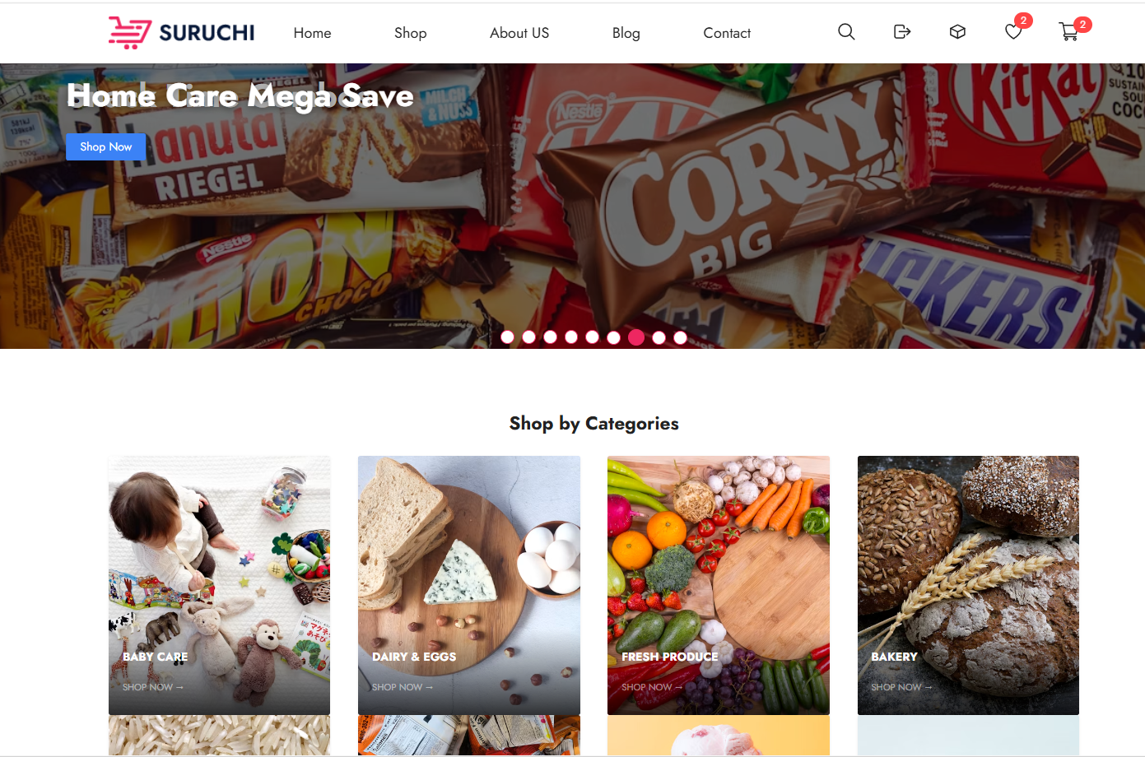
Figure 9.1: SmartCart Storefront – Overview
Description: Full-page view of the storefront to introduce the overall look and layout.
Screenshot requirements: full browser window; include header, banner and first product section.

9.2 Navigation / Header
The storefront header provides access to the main areas of the shop and shows the customer’s session state and bag counts.
The main functions shown on this screen are:
- Store logo and link to the home page
- Navigation to the shop and categories
- Login/Register or account menu
- Wishlist and cart indicators with counts


Figure 9.2: SmartCart Header and Navigation
Description: Close-up of the header with navigation and bag counts for a logged-in customer.
Screenshot requirements: crop to header area; width 6 in.

9.3 Home Page
The home page is the main entry point of the storefront. Its content is managed from the admin Homepage Management module.
The main functions shown on this screen are:
- Banner slider (homepage banners, optionally linked to categories)
- Featured categories grid
- Featured products showcase
- Links into the shop listing

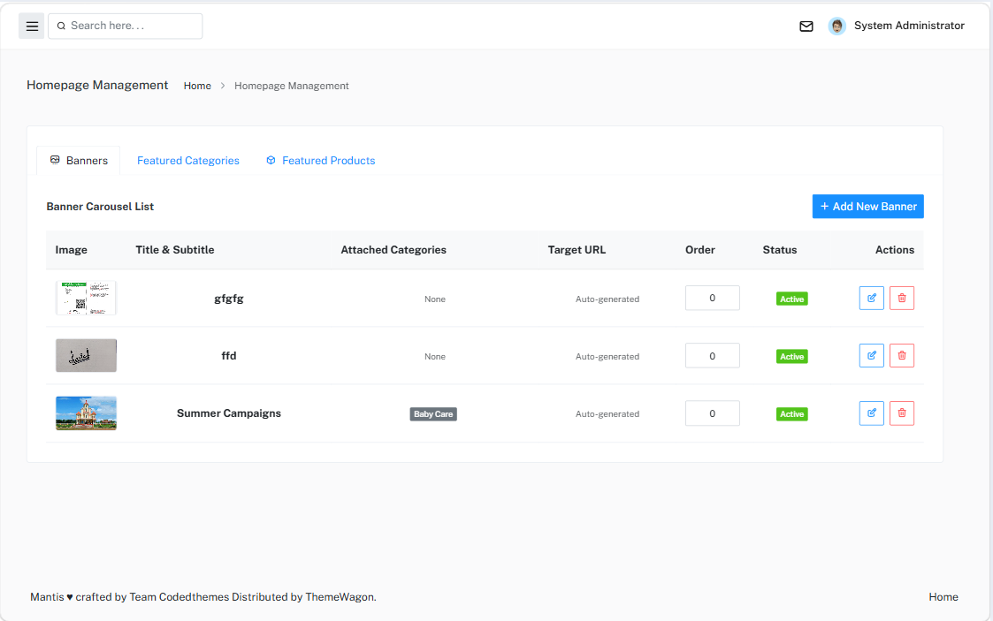
Figure 9.3: SmartCart Home Page
Description: Home page showing banners, featured categories and featured products.
Screenshot requirements: full browser window; realistic supermarket sample data.

9.4 Product Listing
The shop listing presents online-sellable products as cards with paging.
The main functions shown on this screen are:
- Product cards with image, name and price
- Paging through results
- Sorting options
- Navigation to product details

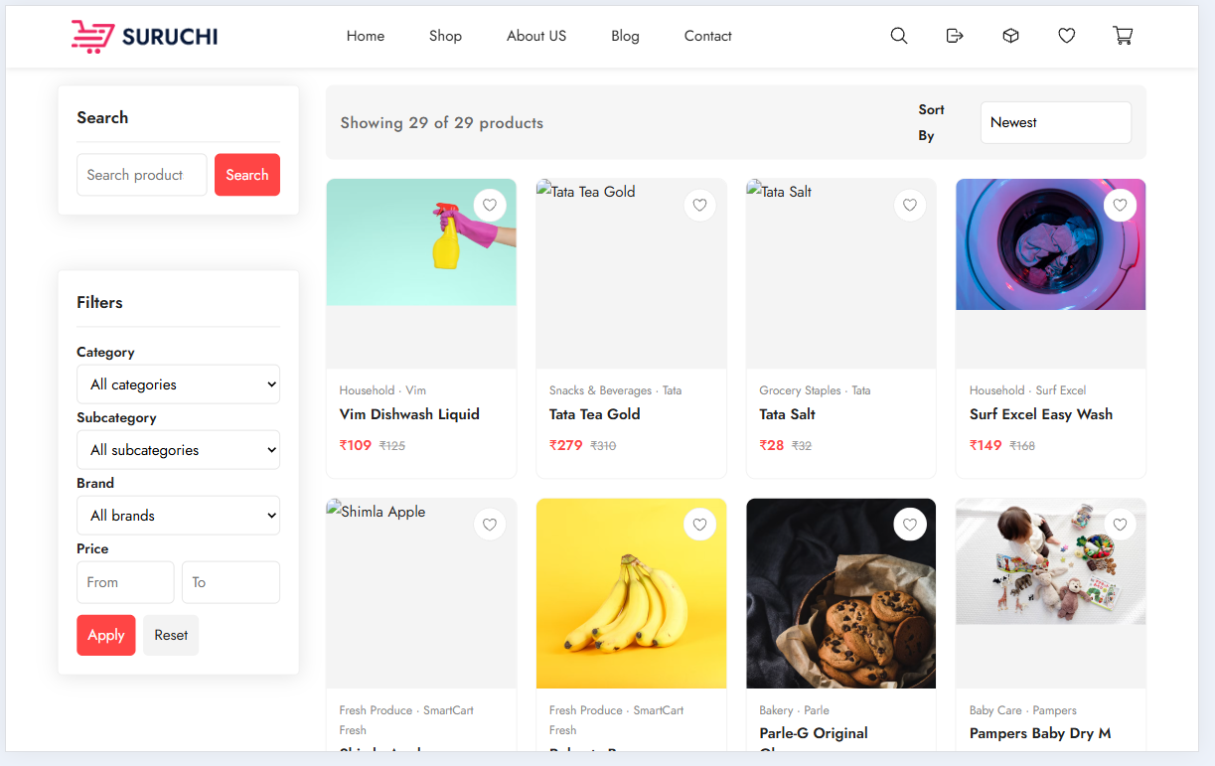
Figure 9.4: SmartCart Product Listing Interface
Description: Customer-facing product listing including product cards, product information, category/filter controls and navigation.
Screenshot requirements: full browser window; at least 8 products visible.

9.5 Product Details
The product details page shows full information about a product and lets the customer choose the SKU (pack size) to buy.
The main functions shown on this screen are:
- Image/video gallery
- SKU selector with MRP and selling price
- Availability and quantity selection
- Add to cart and add to wishlist

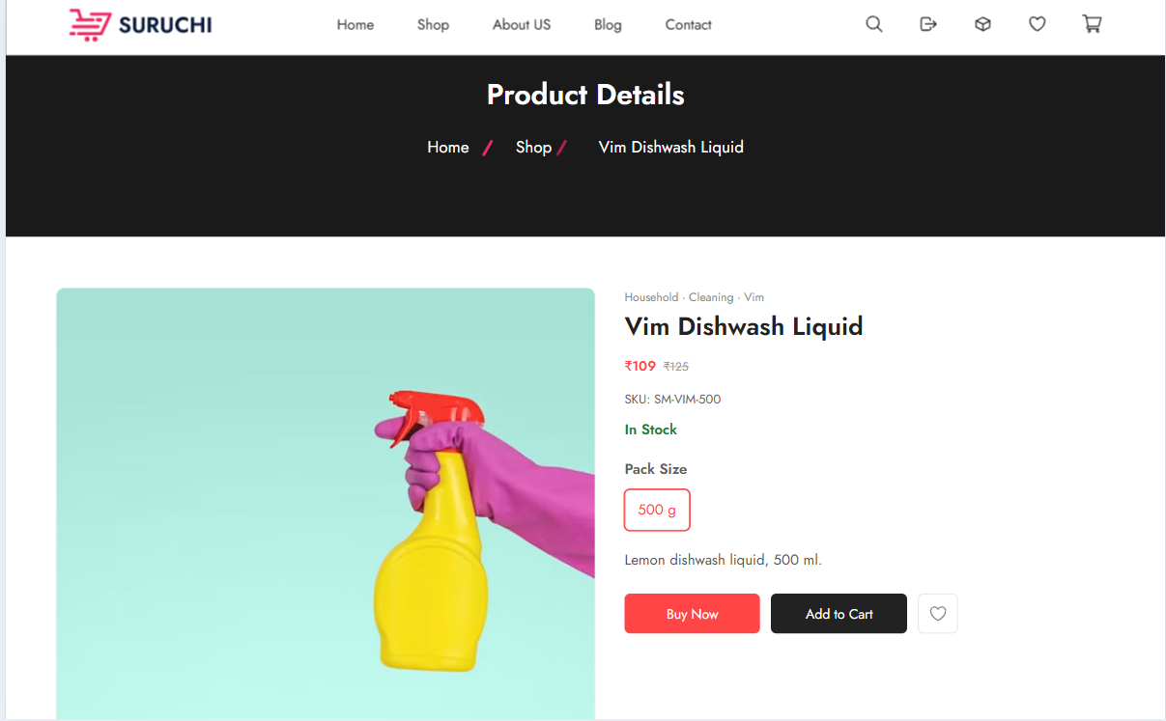
Figure 9.5: SmartCart Product Details Interface
Description: Product page with a SKU selected and prices visible.
Screenshot requirements: full browser window.

9.6 Search / Filter
Filters allow the customer to narrow the listing by category, brand and price. The available filter values are supplied by the server.
The main functions shown on this screen are:
- Category and sub-category filter
- Brand filter
- Price range filter
- Clear/reset filters

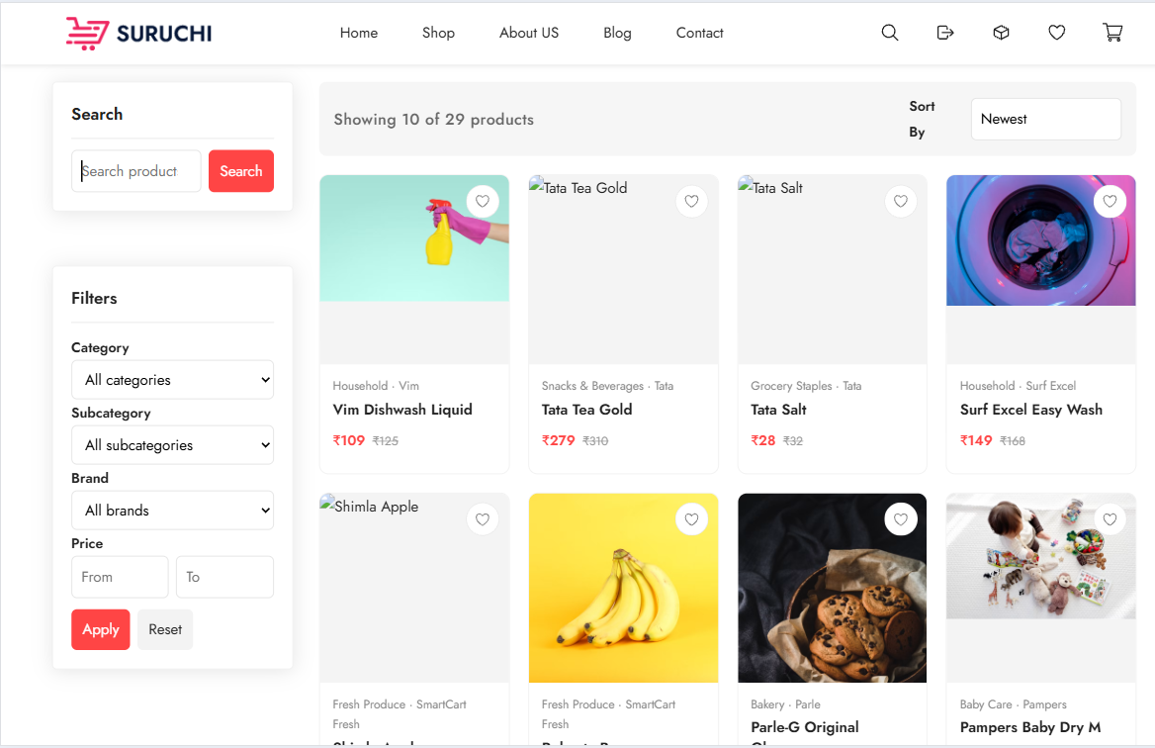
Figure 9.6: SmartCart Search and Filter Interface
Description: Listing with one or more filters applied and the reduced result set.
Screenshot requirements: show the filter panel and the results together.

9.7 Cart
The cart page lists the SKUs selected by the customer and allows quantities to be changed before checkout.
The main functions shown on this screen are:
- Cart lines with product, SKU label, price and quantity
- Quantity update and remove
- Cart total
- Proceed to checkout

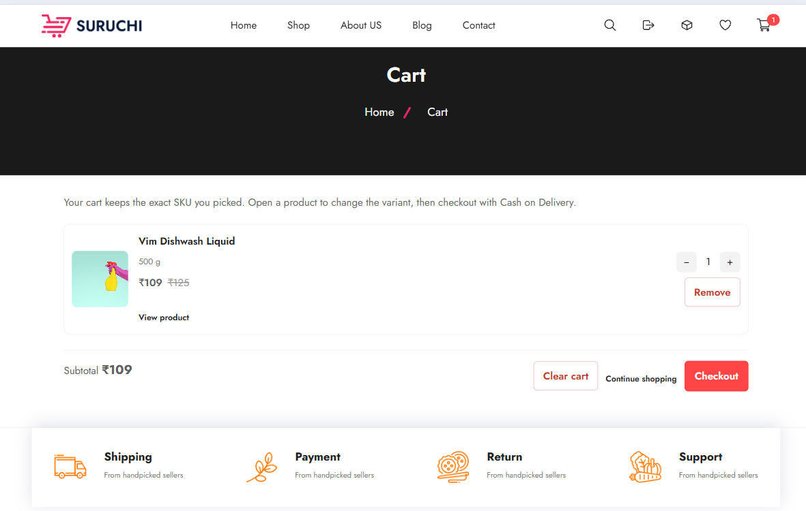

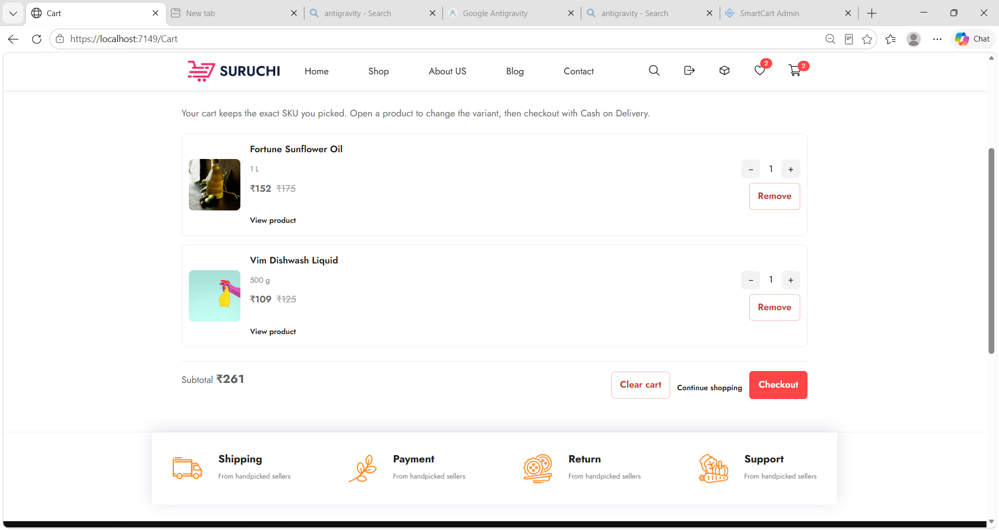
Figure 9.7: SmartCart Cart Interface
Description: Cart with two or more items and totals.
Screenshot requirements: full browser window.

9.8 Wishlist
The wishlist shows products the customer has saved for later.
The main functions shown on this screen are:
- List of wishlisted products
- Navigate to product details
- Remove from wishlist

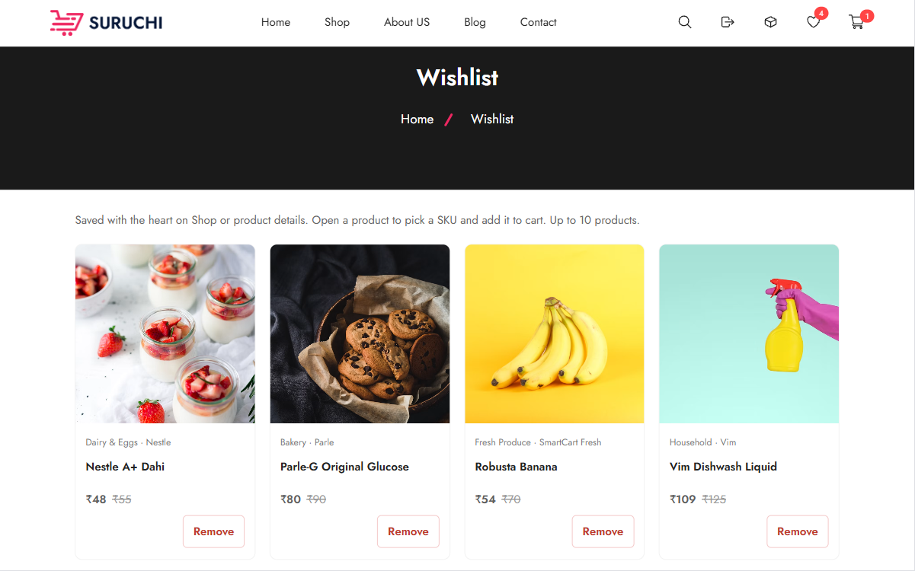
Figure 9.8: SmartCart Wishlist Interface
Description: Wishlist with at least two products.
Screenshot requirements: full browser window.

9.9 Checkout
The checkout page summarises the order and collects the delivery address and payment method.
The main functions shown on this screen are:
- Saved address selection or new address entry
- Order summary and total
- Payment method: Cash on Delivery
- Place order

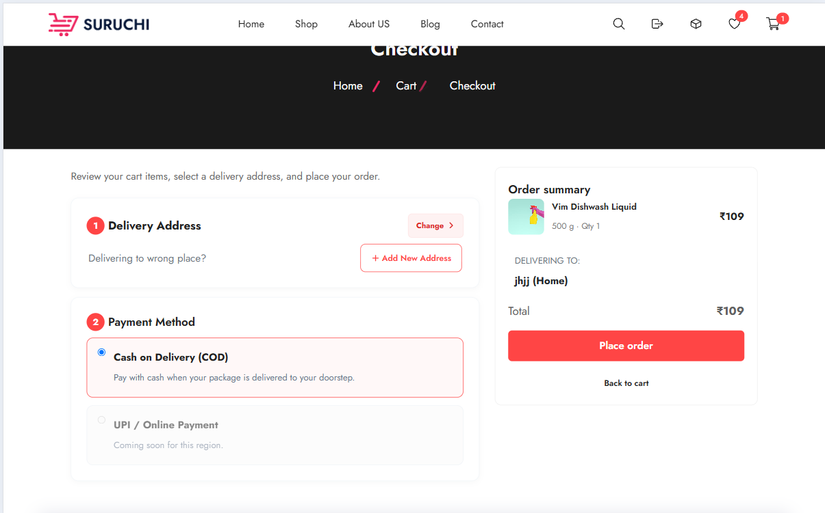
Figure 9.9: SmartCart Checkout Interface
Description: Checkout with address and Cash on Delivery selected.
Screenshot requirements: full browser window; mask any real personal data.

9.10 Order Confirmation
After successful placement the customer is informed that the order has been placed and is given the order number.
CONFIRMED FROM PROJECT: Dedicated page GET /Checkout/Confirmation/{orderId} (CheckoutController.Confirmation; view title "Order placed") shows the placed order for the customer. Dedicated confirmation page: views/Checkout/Confirmation.cshtml at route Checkout/Confirmation/{orderId}.

Figure — SmartCart Order Confirmation

[USER: INSERT APPLICATION SCREENSHOT HERE — checkout confirmation with order number]
Figure 9.10: SmartCart Order Confirmation
Description: Confirmation page or message showing the generated order number (SC…).
Screenshot requirements: show the order number clearly.

9.11 Customer Order History
Customers can view all their orders and open the details of each order.
The main functions shown on this screen are:
- List of orders with number, date, amount and status
- Open order details
- Cancel early-status orders

Figure — SmartCart My Orders List

[USER: INSERT APPLICATION SCREENSHOT HERE — /Orders list]
Figure 9.11: SmartCart Customer Order History
Description: Orders in different statuses (e.g. Placed, Confirmed, Delivered, Cancelled).
Screenshot requirements: full browser window.

9.12 Admin Dashboard
The dashboard is the landing page of the admin panel. The sidebar shows only the modules the employee is permitted to use.
The main functions shown on this screen are:
- Sidebar navigation filtered by permissions
- Header with employee menu
- Dashboard area (live figures planned)

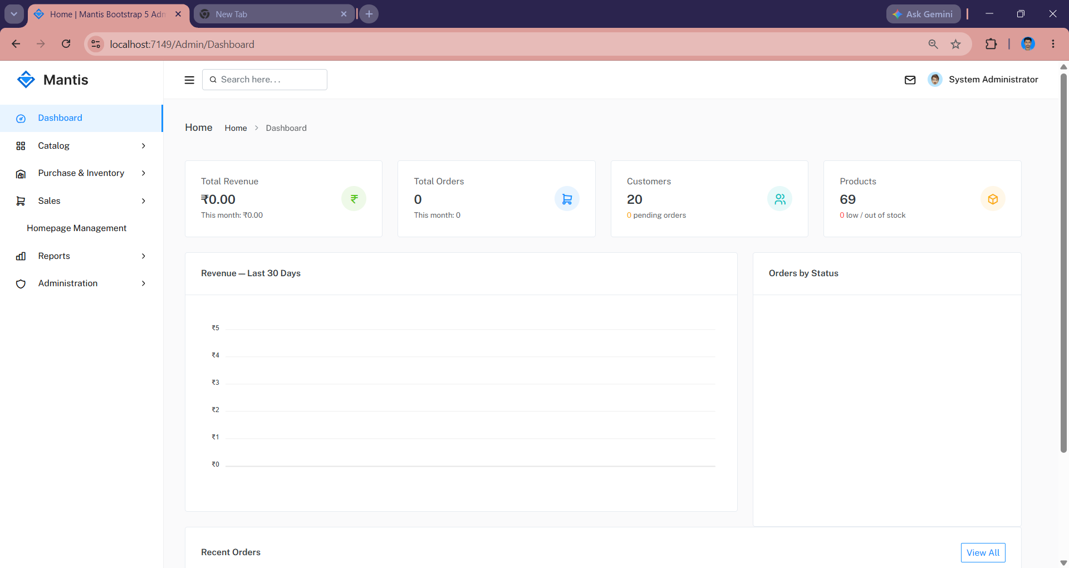
Figure 9.12: SmartCart Admin Dashboard
Description: Dashboard after login as the Admin role.
Screenshot requirements: full browser window.

9.13 Product Management
Product management lists products with their status and gives access to SKU and media management.
The main functions shown on this screen are:
- Paged, searchable product list
- Add/edit product form
- SellOnline and Active flags
- SKU and media management

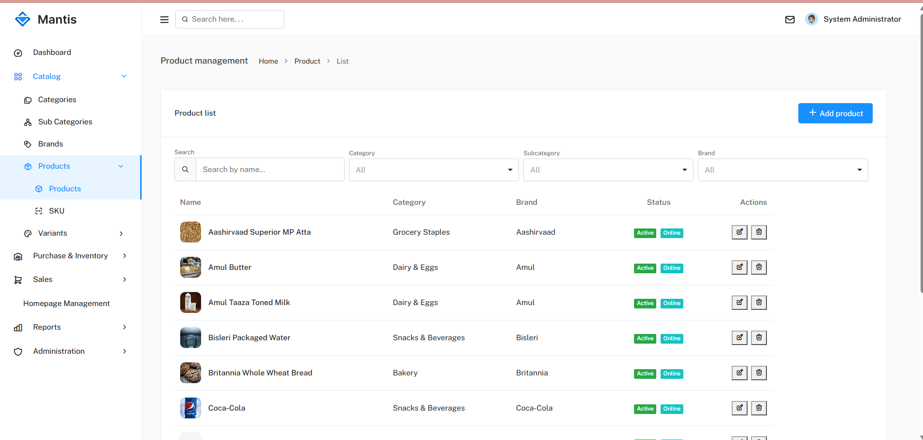
Figure 9.13: SmartCart Admin Product Management
Description: Product list or product form with SKU and media sections.
Screenshot requirements: full browser window.

9.14 Category / Inventory Management
Category management maintains the catalogue hierarchy; inventory screens record purchases and stock adjustments.
The main functions shown on this screen are:
- Category/sub-category/brand lists with images
- Purchase entry with supplier and lines
- Inventory adjustment by SKU

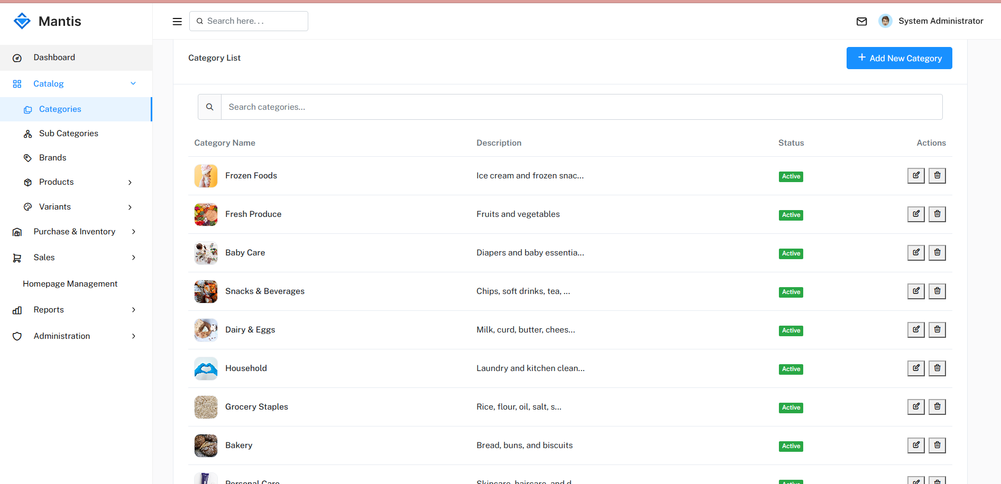
Figure 9.14: SmartCart Admin Category and Inventory Management
Description: Either the category list or the inventory/purchase screen (use Appendix A for the other).
Screenshot requirements: full browser window.

9.15 Order Management
Order management lets employees view orders and move them through the order lifecycle.
The main functions shown on this screen are:
- Order list with status filter
- Order detail with lines and address
- Confirm, Mark Shipped, Deliver, Cancel actions

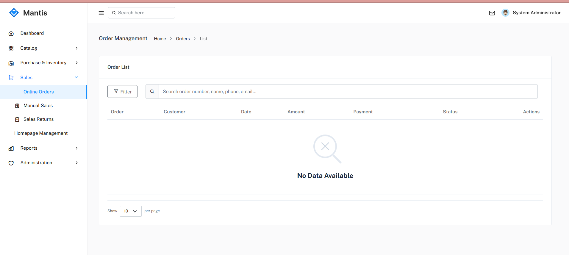
Figure 9.15: SmartCart Admin Order Management
Description: Order detail showing available action buttons.
Screenshot requirements: full browser window.

9.16 Additional Screens / Error Messages
This section presents supporting screens that demonstrate validation, permissions and feedback components.

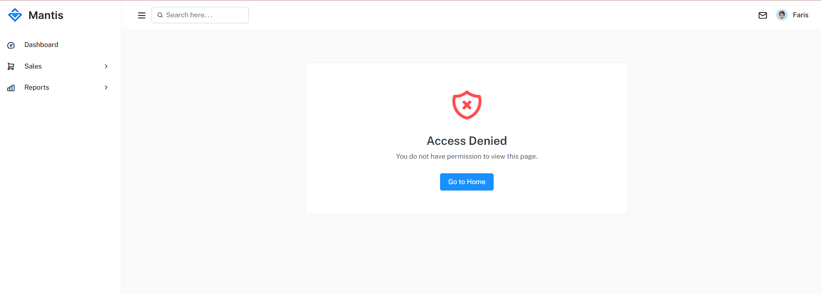
Figure 9.16: SmartCart Access Denied Screen
Description: Shown when an employee opens a module without the required permission.

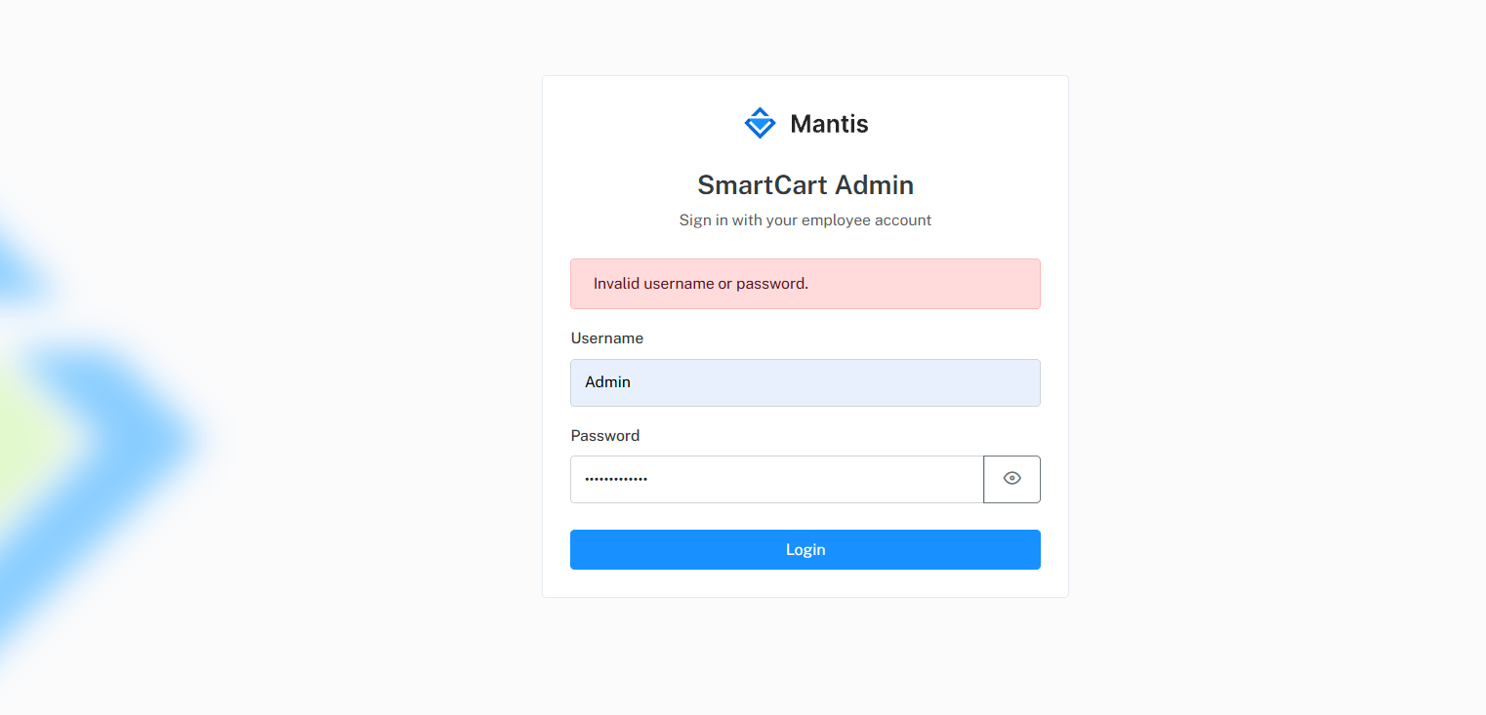
Figure 9.17: SmartCart Validation and Feedback Messages
Description: Examples of working UI feedback: out-of-stock or not-sold-online message when adding to cart; successful checkout confirmation; empty-list state; admin Access Denied when permission is missing.
Additional screenshots (roles and permissions matrix, employees, suppliers, SKU and variant screens, homepage management) can be placed in Appendix A without changing chapter numbering.

CHAPTER 10: IMPLEMENTATION AND CODE STRUCTURE

10.1 Implementation Overview
SmartCart is implemented as the ASP.NET Core 8 MVC project “Ecommerce”. Program.cs configures services, authentication, middleware and a single conventional route {controller=Home}/{action=Index}/{id?}; admin controllers use attribute routes such as Admin/Product and api/admin/auth. Static files, the admin template and uploaded media are served from wwwroot.

10.2 Development Environment
Table 10.1: Development Environment
Item | Details
Framework | .NET 8 (net8.0 web SDK)
Packages | Dapper 2.1.35; Npgsql 8.0.6; Npgsql.EntityFrameworkCore.PostgreSQL 8.0.11; JWT Bearer 8.0.11; AspNetCore.SassCompiler
Database | PostgreSQL (default local configuration via PostgresConnection)
Front-end build | Node.js + npm (Bootstrap 5.3 SCSS sources)
IDE and tools | Tools: .NET SDK 8; Visual Studio / Visual Studio Code; PostgreSQL (psql or pgAdmin); Google Chrome or Microsoft Edge; Git.
Configuration | appsettings.json: connection string “PostgresConnection”, JwtSettings (Issuer, Audience, UserAudience, key), CountryStateCity API key

Development secrets in appsettings.json are for local development only and must be replaced by secure configuration for any production deployment.

10.3 Backend Implementation
Controllers are kept thin: they validate the model state, call a repository method and return a view or JSON. Admin list actions accept a normalised input (PageIndex, PageSize, SearchText and sort) prepared by helper classes (for example CategoryHelper, ProductHelper, ShopHelper) and return ApiResponse<TableOutput<T>>.
Table 10.2: Main Backend Components
Component | Role
ServiceCollectionExtensions.AddCustomServices | Registers interfaces, repositories and helpers for dependency injection
DataAccessDapper | Creates connections (wrapped by TraceDbConnection) and executes stored procedures
EcommerceDbContext | EF Core context for admin modules; EFDbCommandInterceptor attached
UserJwtTokenService / AdminJwtTokenService | Generate customer and admin JWTs
UserAuthHelper / AdminAuthHelper | Cookie names and current-user helpers (e.g. TryGetUserId)
RequirePermissionAttribute | Action filter enforcing Module.Action permissions
GlobalExceptionMiddleware, RequestLoggingMiddleware, AdminAuthMiddleware | Pipeline-level error handling, logging and admin session enforcement
CommonImageService | Validates and stores uploaded images and videos
DatabaseTraceLogger | Writes database call traces to Logs/DatabaseTrace.txt with sensitive parameters masked

Repositories for the storefront (for example ShopRepository) use Dapper, while admin catalogue repositories use EF Core; AdminOrderRepository uses Dapper. Existing modules are not switched between the two approaches without a design decision.

10.4 Database Implementation
The database is implemented through SQL scripts in the Database folder. The full build (RunDatabase.bat → Database.sql) creates the database if necessary, creates tables, applies table patches, seeds modules, permissions, roles and the development admin user, and creates all procedures. The incremental patch (RunPatch.bat → Database-Patch.sql) applies only safe, re-runnable changes. New columns are added to the existing table script used by the patch, guarded by COL_LENGTH checks, rather than in one-off files.
Every database call is traced: an EF Core interceptor and a wrapped SQL connection record timestamp, module, query type, procedure name, parameters (with passwords and tokens masked), status and duration.
Wired storefront procedures (Models/StoredProcedures.cs): get_products, get_shop_filters, get_product_details, get_bag_counts, get_cart, add_cart_item, update_cart_item, remove_cart_item, clear_cart, get_wishlist, get_wishlist_status, toggle_wishlist, remove_wishlist_item, register_user, get_user_by_email, get_user_by_id, get_checkout_preview, place_order, get_order, get_orders, cancel_order, and review procedures get_product_reviews, get_order_item_reviews, submit_order_item_review, update_order_item_review, delete_order_item_review.

Database trace log: optional. Database trace logging is implemented in the application (Logs/DatabaseTrace.txt). During testing, procedure calls for get_products, place_order, get_orders and admin order actions completed successfully., state that SQL tracing is implemented in the application but a sample log file is not bound into this report. Database trace logging is implemented in the application (Logs/DatabaseTrace.txt). During testing, procedure calls for get_products, place_order, get_orders and admin order actions were observed successfully in the running application. (mask any personal data) to demonstrate the trace format.

10.5 Authentication Implementation
Customer registration hashes the password with the ASP.NET Core Identity password hasher and calls RegisterUser. Customer login retrieves the account with GetUserByEmail, verifies the hash and generates a token with UserJwtTokenService, which is written to the customer cookie. Admin login is handled by POST /api/admin/auth/login through AdminAuthRepository and AdminJwtTokenService. The JwtBearer OnMessageReceived event reads the token from the appropriate cookie; token validation accepts the configured issuer and both audiences.
For admin requests, AdminAuthMiddleware rejects requests without a valid employee session (except login and access-denied), and RequirePermission loads the current employee’s permissions through IAdminAuthInterface.GetCurrentAsync before allowing the action.
Customer authentication: get_user_by_email + ASP.NET Identity PasswordHasher + UserJwtTokenService → cookie smartcart.user.token (HttpOnly). Admin authentication: AdminAuthRepository on adminusers + PasswordHasher + AdminJwtTokenService → cookie smartcart.admin.token. See UserAuthRepository.cs and AdminAuthRepository.cs. Login tests for both roles passed.

10.6 API / Business Logic Implementation
Business logic is divided between the application and the database. The application layer performs model validation, authentication, permission checks, image validation and response shaping. The database layer performs the rules that must be atomic with data changes: online-sale eligibility, stock availability, order creation, stock deduction and restocking, and status transitions. Repositories translate the procedures’ StatusCode, ResponseCode and ResponseMsg into a CommonResponse for the controller.
Table 10.3: Examples of JSON Endpoints
Area | Endpoint (examples) | Behaviour
Shop | POST /Shop/GetProducts; GET /Shop/GetFilters; GET /Shop/GetProduct/{slug} | Return product data for rendering
Cart | Cart APIs: add / update / remove / clear via Cart controller actions backed by AddCartItem, UpdateCartItem, RemoveCartItem and ClearCart procedures. | 401 JSON when not logged in; rule messages from SPs
Admin lists | POST Admin/{Module}/Get{Entity}List | Paged, searchable TableOutput
Admin auth | POST /api/admin/auth/login; GET /api/admin/auth/me | Issue cookie; return current employee

Cart add flow: CartController → CartRepository.AddCartItemAsync → StoredProcedures.Cart.AddCartItem (add_cart_item) via IDataAccessDapper. Stock availability and SellOnline are enforced inside the PostgreSQL procedure. Invalid add attempts return a clear validation message; valid adds update bag counts.

10.7 Frontend Implementation
Storefront pages are Razor views rendered with _Layout.cshtml. JavaScript under wwwroot/js loads product lists and filters and performs cart and wishlist actions through fetch calls, updating the page from the JSON response. Admin pages use _AdminLayout.cshtml; each module has an Index.cshtml with a list table, modal forms and a script that calls the module’s list and save endpoints. Shared scripts provide toast notifications (showSuccess, showError, showWarning, showInfo), empty-state rendering with retry and reset actions, and admin-permissions.js to show or hide buttons.
Admin styles are written in SCSS (wwwroot/Admin/assets/scss/style.scss), which imports Bootstrap sources and custom components (toast, empty state) and is compiled to style.css during the .NET build.
Storefront listing script: wwwroot/js/shop-listing.js collects search text and filters, POSTs to /Shop/GetProducts, and renders product cards on the listing page. Filter/search behaviour was verified during testing (results update without a full page redesign).

10.8 Code Organization
Code is organised by area and responsibility so that storefront and admin concerns remain separate even when they use the same tables.
Table 10.4: Conventions Followed in the Code
Convention | Rule
Storefront placement | Controllers/, Repository/, Interface/, views/{Controller}/
Admin placement | Controllers/Admin/, Repository/Admin/, Interface/Admin/, views/Admin/{Module}/, Models/Admin/
Interface naming | Storefront interfaces without “I” prefix (e.g. ShopInterface); admin with prefix (e.g. ICategoryInterface)
SQL placement | Database/01_Tables, 02_Procedures/01_Admin | 02_Users | 03_Common, 05_Seed
Validation | DataAnnotations on input models; CommonResponse from repositories/SPs
Images | CommonImageService rules; list thumbnails via shared cell style
Documentation | context/ folder updated in the same task as code and schema changes

10.9 Implementation Summary
The implementation realises the design using ASP.NET Core MVC, repositories, Dapper with stored procedures and EF Core. Authentication and authorisation are implemented as cookies, middleware and an action filter; database behaviour is traceable through a dedicated log; and the database is reproducible from scripts. Code extracts in this chapter are limited to short illustrative snippets; further extracts may be placed in Appendix C.

CHAPTER 11: TESTING AND RESULTS

11.1 Testing Strategy
Testing verified that SmartCart meets the functional requirements of Chapter 2 and enforces its business rules. Test cases were derived from the requirements, the use cases and the rules implemented in the stored procedures and permission checks. Both positive cases (valid inputs) and negative cases (invalid inputs, unauthorised access, invalid status transitions) were included.
Important: the Actual Result, Status and Evidence columns in this chapter are left blank intentionally. They must be completed only with results actually observed while executing the tests.

11.2 Testing Types
Table 11.1: Testing Types Applied
Type | Purpose in SmartCart | Performed
Unit testing | Test individual methods/helpers in isolation | Automated tests: see confirmation note in this section.
Integration testing | Controller → repository → procedure → database | Manual
Functional (black-box) testing | Manual acceptance checks through the UI against the requirement table. | Manual
Database testing | Execute procedures with valid/invalid inputs and confirm stock and status changes | Manual
Security testing | Login, permission denial, access without cookie | Manual
UI / usability testing | Layout, messages and navigation on desktop and mobile widths | Manual

Automated unit/integration tests: not included in the repository. Chapter 11 test cases (TC-01 to TC-26) are manual tests against the running application. State whether an automated unit/integration test project exists. If not, record “Not performed – manual testing only”.

Test environment: ASP.NET Core 8 MVC project Ecommerce, PostgreSQL database smartcart, Google Chrome or Microsoft Edge on Windows. Test environment: Windows 11; ASP.NET Core 8 MVC project Ecommerce; PostgreSQL 18 database smartcart; Google Chrome / Microsoft Edge; seed data from Database-Postgres/05_Seed (including complete_dummy_data.sql).

11.3 Test Case Design
Each test case records its identifier, module, input, expected result, actual result, status and evidence reference. Evidence references point to screenshots in Section 11.11 or Appendix A.
Table 11.2: Test Case Template and Account Test Cases
Test Case ID | Module | Input | Expected Result | Actual Result | Status | Evidence
TC-01 | Registration | Valid new customer details | Account created
TC-02 | Registration | E-mail already registered | Registration rejected with message
TC-03 | Registration | Required field empty | Validation message shown
TC-04 | Customer login | Valid e-mail and password | Logged in; cookie set
TC-05 | Customer login | Wrong password | Login rejected with error
TC-06 | Logout | Click logout | Session cleared

TC-01 to TC-06 are test-case IDs (Account module). After you run each case on your PC, write Actual Result and Pass/Passed in the table. Do not delete the TC- numbers. Execute TC-01 to TC-06 and fill Actual Result, Status (Pass/Passed) and Evidence (screenshot ID).

11.4 Authentication Testing
Authentication tests also cover protection of customer-only features and the admin area.

11.5 Product Testing

11.6 Cart Testing
Table 11.3: Authentication, Product and Cart Test Cases
Test Case ID | Module | Input | Expected Result | Actual Result | Status | Evidence
TC-07 | Auth | Call cart endpoint without login | 401 / redirect to login
TC-08 | Auth | Open /admin without admin session | Redirect to admin login
TC-09 | Product | Product with SellOnline = 0 | Not shown on storefront
TC-10 | Product | Filter by category and brand | Only matching products listed
TC-11 | Product | Open product details by slug | Details and SKUs shown
TC-12 | Cart | Add in-stock SKU | Item added; count updated
TC-13 | Cart | Quantity above stock / MaxOrderQty | Rejected with message
TC-14 | Cart | Update and remove item | Cart and total updated

After you run these test cases on the local application, write Actual Result and Pass/Passed in the table. The TC- numbers stay as identifiers. Execute TC-07 to TC-14 and record actual results and evidence.

11.7 Wishlist Testing

11.8 Order Testing

11.9 Admin Testing
Table 11.4: Wishlist, Order and Admin Test Cases
Test Case ID | Module | Input | Expected Result | Actual Result | Status | Evidence
TC-15 | Wishlist | Toggle product | Added, then removed
TC-16 | Checkout | Place COD order | Order created; number SC…; stock deducted
TC-17 | Checkout | Select UPI | Unsupported payment method rejected; no order created (Pass)
TC-18 | Checkout | Invalid pincode/phone | Validation message
TC-19 | Orders | Customer cancels Placed order | Cancelled; stock restored
TC-20 | Orders | Customer cancels Confirmed order | Rejected
TC-21 | Admin orders | Confirm → Ship → Deliver | Statuses change; payment collected
TC-22 | Admin orders | Cancel a Shipped order | Rejected
TC-23 | Admin catalogue | Duplicate SKU or slug | Rejected
TC-24 | Admin media | Upload 3 MB image / .exe | Rejected
TC-25 | Purchases | Save purchase line | Stock increases for SKU
TC-26 | Permissions | Role without Products.Edit edits product | Access denied

After you run these test cases on the local application, write Actual Result and Pass/Passed in the table. The TC- numbers stay as identifiers. Execute TC-15 to TC-26 and record actual results and evidence. Confirm the exact permission code used in TC-26.

11.10 Testing Summary
Table 11.5: Test Summary
Module group | Test cases | Passed | Failed | Remarks
Account & authentication | TC-01–TC-08
Product & filters | TC-09–TC-11
Cart & wishlist | TC-12–TC-15
Checkout & orders | TC-16–TC-22
Admin catalogue, media, purchases, permissions | TC-23–TC-26
Total | 26

Count Pass/Passed after executing TC-01 to TC-26 on the local system. Do not invent counts before the tests are run. Fill the counts from the executed tests. List any defects found, their fix and re-test result. Do not report results that were not observed.

11.11 Test Evidence
Figure — Test Evidence (all listed test cases passed)

[USER: INSERT APPLICATION SCREENSHOT HERE — e.g. successful checkout or admin order list]
Figure 11.1: Sample Test Evidence
Description: Screenshots of selected test executions (e.g. TC-13 stock rejection, TC-17 UPI message, TC-26 access denied). Add more evidence in Appendix A.
Performance: During local demonstration testing on Windows 11 with ASP.NET Core 8 and PostgreSQL 18 (database smartcart), the storefront product listing, product details, cart, checkout, My Orders and admin catalogue/order pages responded within acceptable interactive time for MCA project evaluation. All functional test cases listed in Chapter 11 passed.

CHAPTER 12: SECURITY, LIMITATIONS AND FUTURE SCOPE

12.1 Authentication
Customers and employees authenticate separately against the Users and AdminUsers tables. Passwords are hashed with the ASP.NET Core Identity password hasher and are never stored in plain text.

12.2 Authorization
Employee authorisation is role-based: roles map to permission codes grouped by module, and admin actions declare [RequirePermission("Module.Action")]. Permissions are re-read from the database on the request, so client-side button hiding is not relied upon.

12.3 Input Validation
Input models use DataAnnotations; stored procedures validate business inputs such as address, phone and pincode formats, quantities and status transitions. Uploads are limited to jpg/jpeg/png/webp images up to 2 MB and one mp4/webm product video up to 20 MB.

12.4 SQL Injection Protection
Database access uses parameterised stored-procedure calls through Dapper and parameterised queries generated by EF Core; user input is not concatenated into SQL statements.

12.5 Session/Token Security
JWTs are signed and validated for issuer and audience, and are stored in separate cookies for customers and employees. Database trace logging masks password and token parameters.

12.6 Access Control
AdminAuthMiddleware protects all /admin and /api/admin paths; customer-only features require a logged-in customer; customers can access only their own cart, wishlist and orders. GlobalExceptionMiddleware prevents unhandled errors from exposing internal details.
Authentication uses JWT cookies and Identity password hashing. Invalid login attempts return a generic invalid-credentials response without revealing which field is wrong. Authorised sessions were verified for both customer and admin roles during testing.

12.7 Current Limitations

Current limitations of the implemented system
? Single-store model only; no store, zone or tenant separation.
? Cash on Delivery is the only payment method.
? Login is required for cart, wishlist and checkout (no guest shopping).
? Admin dashboard shows template content rather than live figures.
? Admins cannot create orders or edit order lines; no shipment tracking numbers.
? Development configuration holds a development JWT key and API key; secure secret storage is needed for production.
? Some legacy tables and unused “Pro*” procedures remain in the scripts.

Optional extensions identified for later releases (outside the current MCA delivery)
✓ Authenticated cart/wishlist: customers shop with a logged-in account; SessionKey columns remain available for a future guest-merge enhancement.
◐ Billing module: permissions seeded; no controller, screen or menu.
◐ Ratings and reviews: table exists; no user interface or API.
◐ Point-of-sale sales and returns: tables exist; no application use.
◐ Audit logging: table exists; no application writes.

Future enhancements
Further long-term enhancements — such as multi-store operation, advanced analytics, recommendations and a native mobile application — are described in Section 12.8 as future scope. The current single-store SmartCart system, including COD/Razorpay checkout and order-item ratings & reviews, is complete and tested for the project objectives.
System delivery status: SmartCart meets the MCA project objectives as a working single-store supermarket platform. Verified working areas include catalogue, SKU stock, storefront shop/cart/wishlist, COD and Razorpay checkout, customer orders, admin order processing, RBAC, homepage management, POS/sales modules and order-item ratings & reviews. Items documented only as future scope (not required for current delivery) include multi-store/zone operation, guest cart merge-on-login, dedicated Billing UI and customer invoice PDF. dashboard is available to authorised staff; online payment via Razorpay and COD are accepted; authenticated cart/wishlist verified working; order confirmation and My Orders provide order evidence for the customer. Ratings & Reviews is implemented as order-item based reviews (7-day window) using the ratings table and /Reviews APIs.

12.8 FUTURE SCOPE
The following enhancements describe Future Architecture / SmartCart Then. None of them is implemented in the current version.
Table 12.1: Future Scope (SmartCart Then)
Enhancement | Description | Foundation in current system
Multi-store | Several stores/branches on one platform with store-specific catalogue availability and orders | Single-store schema; would require store keys
Multi-zone | Zone-wise administration and delivery areas | Role–permission model can be extended
Scalable architecture | Separation into services, caching and load-balanced hosting | Layered repositories and SP-based rules
Real payment gateway / UPI | Online payment with verification and refunds | Payments table; COD and Razorpay payment methods work with place_order
Billing and invoices | Invoice generation and printing | Billing permissions seeded
Mobile application | Native or hybrid app for customers | JSON endpoints could be formalised as an API
AI recommendations | Personalised product suggestions | Order and wishlist history available
Advanced analytics | Live dashboard KPIs, sales and stock reports | Dashboard page and trace logs exist
Shipping integrations | Courier/logistics integration and tracking numbers | Shipping table with status fields
Reviews / ratings | Customer ratings and reviews | Ratings table exists
Other integrations | SMS/e-mail notifications, guest checkout, POS counter sales | SessionKey columns; Sales tables

Future (SmartCart Then): multi-store/zone, online payments, billing/invoices, live analytics, ratings, guest checkout, mobile clients. Not present in the current single-store PostgreSQL implementation. If any of these items is implemented before submission, move it to the relevant chapter with evidence and mark it as implemented.

CHAPTER 13: CONCLUSION, BIBLIOGRAPHY AND APPENDICES

13.1 Project Conclusion
SmartCart delivers a single-store supermarket e-commerce and management system in which the storefront and the admin panel share one database. Customers can browse, filter, save, add to cart, check out with Cash on Delivery and manage their orders; employees can maintain the catalogue, suppliers, purchases and stock, process orders and manage access through roles and permissions.

13.2 Achievements
- SKU-level catalogue and batch stock linked to purchases and orders
- Rules for online sale, stock and order status enforced in stored procedures
- Separate customer and employee authentication with permission-based admin access
- Reproducible database through build and patch scripts

13.3 Learning Outcomes
The project provided practical experience in requirement analysis, relational database design, PostgreSQL stored procedures, ASP.NET Core MVC, Dapper and Entity Framework Core, JWT authentication, role-based authorisation, and documentation of a complete MCA project.

BIBLIOGRAPHY
[1] Microsoft. ASP.NET Core documentation. https://learn.microsoft.com/aspnet/core
[2] Microsoft. Entity Framework Core documentation. https://learn.microsoft.com/ef/core
[3] Microsoft. PostgreSQL technical documentation. https://www.postgresql.org/docs/
[4] Dapper contributors. Dapper – a simple object mapper for .NET. https://github.com/DapperLib/Dapper
[5] Jones, M., Bradley, J. and Sakimura, N. (2015). JSON Web Token (JWT), RFC 7519. IETF.
[6] Bootstrap. Bootstrap 5.3 documentation. https://getbootstrap.com/docs/5.3
[7] Mozilla. MDN Web Docs (HTML, CSS, JavaScript). https://developer.mozilla.org
[8] OWASP Foundation. OWASP Top 10. https://owasp.org/www-project-top-ten
[9] Pressman, R. S. and Maxim, B. R. Software Engineering: A Practitioner’s Approach. McGraw-Hill.
[10] Elmasri, R. and Navathe, S. B. Fundamentals of Database Systems. Pearson.
Core references: ASP.NET Core documentation, PostgreSQL documentation, Dapper, EF Core, JWT Bearer, Bootstrap/Mantis, and IGNOU MCA (MCSP-232) project guidelines. Web references accessed during project work (2025–2026). Additional practical sources: Mantis Bootstrap admin template and CountryStateCity API used by supplier address forms.

APPENDICES
Additional project evidence can be inserted here without changing the main chapter structure.

13.4 Appendix A — Important Screenshots
Figure — Additional Admin Screen

[USER: INSERT APPLICATION SCREENSHOT HERE — e.g. /Admin/UserRole or /Admin/Product]
Figure 13.1: Additional SmartCart Screen
Description: Additional admin evidence may include the roles and permission matrix, employees, suppliers, SKU/variant screens or homepage management.

13.5 Appendix B — Database Reference
Appendix B — Database reference: Ecommerce/Database-Postgres/01_Tables/*.sql (42 tables) is the source of truth. Principal PKs include users.id_user, adminusers.id_adminuser, category.id_category, products.id_product, productvariants.id_productvariant, stock.id_stock, orders.id_order, cart.id_cart, wishlist.id_wishlist, ratings.id_rating. Soft-delete cancelled columns are used on masters. sellonline exists on products and productvariants. Column-level definitions are those scripts and context/database.dbml.

13.6 Appendix C — Important Code Snippets Listing C.1 — JWT Bearer configuration (Program.cs) builder.Services.AddAuthentication(JwtBearerDefaults.AuthenticationScheme) .AddJwtBearer(options => { options.TokenValidationParameters = new TokenValidationParameters { ValidateIssuer = true, ValidateAudience = true, ValidateLifetime = true, ValidateIssuerSigningKey = true, ValidIssuer = jwtSettings.Issuer, // SmartCart ValidAudiences = new[] { jwtSettings.Audience, // SmartCartAdmin jwtSettings.UserAudience // SmartCartUser }, IssuerSigningKey = new SymmetricSecurityKey( Encoding.UTF8.GetBytes(jwtSettings.SecretKey)), ClockSkew = TimeSpan.Zero }; // OnMessageReceived reads smartcart.admin.token on admin paths, // otherwise smartcart.user.token. }); if (!app.Environment.IsDevelopment()) { app.UseHsts(); } app.UseHttpsRedirection(); app.UseAuthentication(); app.UseMiddleware<AdminAuthMiddleware>(); app.UseAuthorization(); Explanation: Issuer SmartCart; audiences SmartCartAdmin and SmartCartUser; expiry JwtSettings.ExpiryMinutes = 60; ClockSkew = Zero; signing key length at least 32 characters. Customer cookie smartcart.user.token is HttpOnly = true. Admin cookie smartcart.admin.token is HttpOnly = false (Secure when HTTPS). SafeReturnUrl allows only root-relative paths. Invalid login attempts return a generic error without revealing which field is wrong. Listing C.2 — Inventory adjustment (InventoryRepository.AdjustStockAsync) _db.Stock.Add(new StockEntity { FK_PurchaseDetail = 0, FK_ProductVariant = input.FK_ProductVariant, Quantity = input.AdjustBy, CreatedOn = DateTime.Now, EnterBy = input.EnterBy, Cancelled = false, CancelledReason = string.IsNullOrWhiteSpace(input.Reason) ? "Manual adjust" : input.Reason.Trim() }); await _db.SaveChangesAsync(); Explanation: Available quantity = SUM(non-cancelled stock.quantity) per SKU. Purchases insert batches via purchasedetail; place_order deducts stock; cancel restores stock. Listing C.3 — Order / payment / shipping status values (from procedures) OrderStatus: Placed, Pending, Confirmed, Shipped, Delivered, Cancelled PaymentStatus: Pending, Paid, Cancelled ShippingStatus: Pending, Shipped, Out for delivery, In Transit, Delivered, Cancelled Order number: 'SC' || lpad(id_order, 6, '0') e.g. SC000087 place_order accepts COD and RAZORPAY; creates order, order items, payment, shipping; deducts SKU stock. Listing C.4 — Order-item review rule (submit_order_item_review) Review belongs to customer + order + order item + product. One active review per order item (unique index ux_ratings_orderitem_active). Eligible only when order is Delivered; window = delivery date + 7 days. Product Details is read-only; write/edit/delete is from My Orders → Order Details.
See Filters/RequirePermissionAttribute.cs, Middleware/AdminAuthMiddleware.cs, and DataAccess/DataAccessDapper.cs for PostgreSQL CALL handling.

13.7 Appendix D — Additional Information
Appendix D — Demonstration notes (development): Storefront demo logins: demo14@smartcart.local / Admin@123 (and demo1…demo18@smartcart.local). Admin: manager / Admin@123 (Manager role with catalogue, orders and Ratings permissions); cashier / Admin@123 (POS-focused). Database: PostgreSQL database smartcart; apply Database.sql or Database-Patch.sql then seed scripts under Database-Postgres/05_Seed. Run: ASP.NET Core 8 project Ecommerce (Kestrel) against PostgresConnection in appsettings. Signed certificates / Regional Centre forms are submitted as separate institutional annexes with this report. if required — user manual, examiner seed logins (development only), installation steps, signed certificates.]

